**Hydra Data Protection Tool**

Project Documentation Submitted

To the Faculty of School of

Computer Science and Information Technology

Of

Asia Pacific College

In Partial Fulfillment of the Requirements for the subject

Applied Projects 2 or Software Development

By:

Alberca, Reginald John Steven R.

Laureta, Maria Letty M.  
Miculob, Kent Michael P.

**Table of Contents**

[**Project Proponents** 5](#_Toc469480913)

[Project Team 5](#_Toc469480914)

[Project Adviser 5](#_Toc469480915)

[Project Consultant 5](#_Toc469480916)

[Project Professor 5](#_Toc469480917)

[**Abstract** 6](#_Toc469480918)

[**I.** **List of Figures, List of Tables, List of Notations** 6](#_Toc469480919)

[**II.** **Introduction** 8](#_Toc469480920)

[A. Background of the Problem 8](#_Toc469480921)

[B. Statement of the Problem 9](#_Toc469480922)

[C. Project Context 9](#_Toc469480923)

[D. Purpose and Description 10](#_Toc469480924)

[E. Objectives 10](#_Toc469480925)

[a. General Objectives 10](#_Toc469480926)

[b. Specific Objectives 10](#_Toc469480927)

[F. Significance of the Study 10](#_Toc469480928)

[G. Scope and Limitations 10](#_Toc469480929)

[**III.** **Related Literature** 11](#_Toc469480930)

[Data Corruption 11](#_Toc469480931)

[Causes of Data Corruption 11](#_Toc469480932)

[Back Up 12](#_Toc469480933)

[File System 13](#_Toc469480934)

[Hash value 13](#_Toc469480935)

[An Analysis of Data Corruption in the Storage Stack 14](#_Toc469480936)

[**IV.** **Technical Background** 14](#_Toc469480937)

[**V.** **Design and Methodology** 15](#_Toc469480938)

[**VI.** **Results and Discussion** 20](#_Toc469480939)

[**VII.** **Conclusion and Recommendations** 24](#_Toc469480940)

[**VIII.** **Appendices** 25](#_Toc469480941)

[A. Diagrams 25](#_Toc469480942)

[a. Flowchart 25](#_Toc469480943)

[b. Event Table 29](#_Toc469480944)

[c. Context Diagram 29](#_Toc469480945)

[d. Data Flow Diagram 30](#_Toc469480946)

[e. Entity- Relationship Diagram 32](#_Toc469480947)

[f. Data Dictionary 32](#_Toc469480948)

[g. Class Diagram 33](#_Toc469480949)

[h. Object Diagram 34](#_Toc469480950)

[i. Use Case Diagram 35](#_Toc469480951)

[j. Use Case Full Description 36](#_Toc469480952)

[k. Activity Diagram 41](#_Toc469480953)

[l. Sequence Diagram 46](#_Toc469480954)

[m. Communication Diagram 46](#_Toc469480955)

[n. State Diagram 47](#_Toc469480956)

[o. Timing Diagram 48](#_Toc469480957)

[p. Package Diagram 49](#_Toc469480958)

[q. Component Diagram 50](#_Toc469480959)

[r. Composite Structure Diagram 51](#_Toc469480960)

[s. Deployment Diagram 52](#_Toc469480961)

[B. Project Vision and Scope Document 53](#_Toc469480962)

[Business Requirements 53](#_Toc469480963)

[Background 53](#_Toc469480964)

[Business Opportunity 53](#_Toc469480965)

[Business Objectives and Success Criteria 53](#_Toc469480966)

[Customer or Market Needs 54](#_Toc469480967)

[Business Risks 54](#_Toc469480968)

[Vision of the Solution 54](#_Toc469480969)

[Vision Statement 54](#_Toc469480970)

[Major Features 55](#_Toc469480971)

[Assumptions and Dependencies 55](#_Toc469480972)

[Scope and Limitations 55](#_Toc469480973)

[Scope of Initial Release 56](#_Toc469480974)

[Scope of Subsequent Releases 56](#_Toc469480975)

[Business Context 56](#_Toc469480976)

[Stakeholder Profiles 56](#_Toc469480977)

[Project Priorities 57](#_Toc469480978)

[Operating Environment 57](#_Toc469480979)

[C. Project Statement of Work 57](#_Toc469480980)

[Introduction/Background 57](#_Toc469480981)

[Scope of Work 58](#_Toc469480982)

[Period of Performance 58](#_Toc469480983)

[Place of Performance 58](#_Toc469480984)

[Work Requirements 59](#_Toc469480985)

[Schedule/Milestones 60](#_Toc469480986)

[Acceptance Criteria 61](#_Toc469480987)

[Other Requirements 61](#_Toc469480988)

[D. Work Breakdown Structure (WBS) 62](#_Toc469480989)

[E. Activity List 63](#_Toc469480990)

[F. Gantt Chart 63](#_Toc469480991)

[G. Software Requirements Specification 65](#_Toc469480992)

[I. Introduction 65](#_Toc469480993)

[II. Overall Description 67](#_Toc469480994)

[III. External Interface Requirements 69](#_Toc469480995)

[IV. System Features 69](#_Toc469480996)

[V. Other Nonfunctional Requirements 71](#_Toc469480997)

[VI. Other Requirements 73](#_Toc469480998)

[Appendix A: Glossary 73](#_Toc469480999)

[Appendix B: Analysis Models 74](#_Toc469481000)

[H. Change Management Plan 79](#_Toc469481001)

[Introduction 79](#_Toc469481002)

[Change Management Approach 79](#_Toc469481003)

[Definitions of Change 80](#_Toc469481004)

[Change Control Board 81](#_Toc469481005)

[Roles and Responsibilities 82](#_Toc469481006)

[Change Control Process 83](#_Toc469481007)

[I. Quality Plan 84](#_Toc469481008)

[Introduction 84](#_Toc469481009)

[Project Contractual Information 84](#_Toc469481010)

[Scope of Work and Quality Objectives 84](#_Toc469481011)

[Project Organization 85](#_Toc469481012)

[Project Duration and Scheduling 85](#_Toc469481013)

[Deliverables 85](#_Toc469481014)

[Review of Quality Plan 86](#_Toc469481015)

[Document and Record Control 86](#_Toc469481016)

[Documented Procedures 87](#_Toc469481017)

[J. User/Admin Manual 87](#_Toc469481018)

[K. Project Status Reports 88](#_Toc469481019)

[a. Status Report – September 24, 2016 88](#_Toc469481020)

[b. Status Report – October 3, 2016 94](#_Toc469481021)

[c. Status Report – October 10, 2016 100](#_Toc469481022)

[d. Status Report – October 17, 2016 106](#_Toc469481023)

[e. Status Report – October 24, 2016 112](#_Toc469481024)

[f. Status Report – November 14, 2016 118](#_Toc469481025)

[g. Status Report – November 21, 2016 124](#_Toc469481026)

[h. Status Report – November 28, 2016 131](#_Toc469481027)

[i. Status Report – December 5, 2016 138](#_Toc469481028)

[L. Bibliography 145](#_Toc469481029)

**Project Proponents**

## Project Team

|  |  |  |
| --- | --- | --- |
| **Name** | **Position** | **Email** |
| Kent Michael P. Miculob | Project Manager/Developer | [kpmiculob@student.apc.edu.ph](mailto:kpmiculob@student.apc.edu.ph) |
| Reginald John Steven R. Alberca | Project Researcher | rralberca@student.apc.edu.ph |
| Maria Letty M. Laureta | Project Editor/Developer | mmlaureta@student.apc.edu.ph |

## Project Adviser

|  |  |  |
| --- | --- | --- |
| **Name** | **Position** | **Email** |
| Mr. Justin David Pineda | Professor | justinp@apc.edu.ph |

## Project Consultant

|  |  |  |
| --- | --- | --- |
| **Name** | **Position** | **Email** |
| Mr. Jacob Catayoc | Professor | jacobc@apc.edu.ph |

## Project Professor

|  |  |  |
| --- | --- | --- |
| **Name** | **Position** | **Email** |
| Mr. Manuel Sebastian Sanchez | Professor | manuels@apc.edu.ph |

# **Abstract**

This project aims to create a forensic tool capable of preventing data corruption. The existence of data corruption began since the beginning of the automated technologies. In the world manipulated by virtual information, it is necessary for people to secure the information that they have. Information stored virtually are so fragile that in fact a single error or point of failure could cause your information to be corrupted. Data corruptions are something one would definitely hate if he/she is one of those people who doesn’t do backup. The efforts that one has given and the time allotted for the file or document would put to waste. The researches of this paper would want to create a solution on this. they figured out that the data corruption itself are inevitable since there are external factors that are not preventable. As the researchers continue the study, they have realized that data corruption prevention is not just limited to how could a person avoid the event of corruption, but he/she could minimize or neglect the impact by considering the fact that it is unavoidable, there for he/she must always be prepare for it.

# **List of Figures, List of Tables, List of Notations**

* Figure 1: Flowchart
* Figure 2: Event Table
* Figure 3: Context Diagram
* Figure 4: Data Flow Diagram
* Figure 5: Entity-Relationship Diagram
* Figure 6: Data Dictionary
* Figure 7: Class Diagram
* Figure 8: Object Diagram
* Figure 9: Use Case Diagram
* Figure 10: Use Case Full Description
* Figure 11: Activity Diagram
* Figure 12: Sequence Diagram
* Figure 13: Communication Diagram
* Figure 14: State Diagram
* Figure 15: Timing Diagram
* Figure 16: Package Diagram
* Figure 17: Component Diagram
* Figure 18: Composite Structure Diagram
* Figure 19: Deployment Diagram
* Work Breakdown Schedule
* Activity List
* Gantt Chart

# **Introduction**

## Background of the Problem

Nowadays, technology is inevitable. From personal matter all the way to school works to professional works, researchers are inputting information to computers and other gadgets; thus, safeguarding is vital and crucial. They need to protect it not just from the hackers, who wanted to steal information for their own benefit, but also from being corrupted that will steal all the hard works they did and left them nothing but despair. These scenarios wherein the data itself becomes corrupted are due to hardware and software failures. Computers do not have the ability to prevent nor retrieve because to them, it appears as the same data.

There are applications such as File Repair which identifies the corrupted data in the hard drive and creates a new usable file where it extracts much of the recovered data as possible. There is also an application called BadCopy pro where it recovers deleted files, formatted drive, or data loss due to damage, media errors, bad sectors and other reasons for flash drives. And It will save the recovered files into a directory you specify. Another application that offers safeguard is Microsoft Document, the approach that the Microsoft document does is deferent from file repair & other recovery applications such as BadCopy pro, since the Microsoft Document provides backup for the document in case it might be corrupted if the computer suddenly turns off, and it is a good practice since prevention is greater than cure. (BadCopy Pro - Flash Drive Data Recovery Software, n.d.) , (File Repair, n.d.)

As the researchers have read the information, they can conclude that there are a lot of applications which fix and recover corrupted data, there are also applications where they provide prevention mechanism to avoid having corrupted data; nevertheless, the researches still think that all of this applications is not enough to combat data corruption.

## Statement of the Problem

Corrupted data had always been a problem in the computing industry, since most of the information are now stored in a mechanical device. A lot of factors can result to data corruption, such as software and hardware failures. There are identified tools or applications that can be used in case of having corrupted data such as specified above. The researchers would like to know, how could they enhance the existing applications and how could they provide a better way in safeguarding the file from corruption.

## Project Context

Data corruption has always been a problem in computing. With the imminent implementation of internet of things, solutions on data corruption must be address to avoid future complications regarding data loss.

## Purpose and Description

People are expose to different security issues that revolve around the security, integrity and accessibility. The main essence of this research is to address availability issues that concerns data corruption. And to produce a tool capable of preventing the occurrence of corrupted data that can be easily used by non-IT people.

## Objectives

### General Objectives

* This Project aims to create a security algorithm that could save critical information from data loss.

### Specific Objectives

* To be able to provide an algorithm that could save someone’s information
* To be able to give confidentiality control on the user’s information.
* To be able to innovate a low-learning curve security algorithm that is applicable to most people

## Significance of the Study

A lot of applications that were made related to this project are mostly for corrupted data fixation and retrieval. The essence of this research is to provide a way on how to prevent having corrupted data by means of having an application that is capable of detecting and fixing corrupted data, preventing having corrupted data by providing a way to backup, and minimizing the existence of corrupted information in real-time. The issue of corrupted data already exists along with the advancements of mechanical technology. As said by Microsoft “No computer is failure proof, but preventive measurements and strategic planning can make a computer more failure resistant”. - this innovation offers more than that.

## Scope and Limitations

This project aims to help students and/or office-workers who are using windows OS- 7 and higher version to secure their information or data with regard to availability issues. The project primarily focuses on data corruption and prevention. It also assumes that the interaction is just between the players of the system such as the admin, system, and user. The prevention of data corruption is only focus on text documents, and it is beyond the systems capability if the flash drive itself became corrupted since it should be the users’ responsibility to protect the hardware itself.

The flash drive that will be used should have a NTFS file structure with a memory space not below 4 gigabytes. The optimal performance of the application could be achieved if the memory space of the flash drive is less than 90%.

# **Related Literature**

## Data Corruption

The data corruption is commonly the problem of people who uses computer such as programmers, office workers and even students. The data corruption can identify when files and folders are relocated or missing, open file error such a file invalid error in which one cannot be opened, file name renamed by a gibberish file name, file permission and attribute are modified, computer frequently crashing without any reason, slow disk operation and disk activities appear to be very busy even there is not much going on in the computer. (Data Corruption Info, 2009)

## Causes of Data Corruption

Data corruption is caused by different factor that affects the computer. Factors are classified into three major reasons which are software failures, hardware failures and Malwares. An example of software failure is a scenario where you are currently working your file, and suddenly the software stopped working and needs to be restarted, which didn’t give him/her time to save his/her file. Another caused are hardware failure, a good example would be power outage which suddenly occurred on one’s computer which cut the electricity running through the computer and the person did not have enough time to save the file. Last will be malwares which is often created by people with bad intention, such as intentionally destroying one’s file.

These kinds of malware can enter to the computer that would cause many hardware failures. Lastly, the poor software and hardware, these issue can also affect the data because even in these modern age technologies, it is still rapidly changing so fast that some file that people try to save into their computer cannot be compatible, which would also lead to hardware and software failure. (Rita, 2004)

## Back Up

People in this modern technology are more dependent to computers, and often used this device to store information. Back-up is an operation or procedure of having multiple copies of one file to an alternative remote location, so that if corruption happened the copy of the file is still there.(Stepanovska, 2015)

Checksum

The checksum is used to ensure the integrity of the file with which it can transmit from one device to the other. This can happen through the internet or simply through two different computers that are connected into a single network by simply ensuring the transmitted file to be exact as the source file. Checksum is the best option to use also not only to secure the transmission of the file between two or more devices but also it is responsible for calculating the hash function which is normally posted when downloading.

This is also responsible for verifying and calculating the downloaded file for making sure that they are the same. The most common checksum algorithms that can be seen in the computer are MD5 and SHA-1. they both have a weak point, this means that any malicious tampering can lead to two different files having same computed hash. Due to this issue the newer SHA-1 is the best cryptographic hash function so far since there were no issues that have been attacked. (Kishore, 2015)

## File System

File system is a method which the operating system follow to track and manage file inside the hard disk of the computer. There are different types of file system and the commonly used ones are FAT, FAT32, NTFS. The newest one is the NTFS or the New Technology File System which is supported by Microsoft Windows OS. The technology allows the user to gain maximum benefit. It satisfies the needs of today’s enterprise business environment. By using this file system, it will maximize the performance of the hard drive, the larger the hard drive, the larger the default cluster size.

## Hash value

A hash value is a numerical value of a fixed length that uniquely identifies data. Hash value represents a bigger amount of data as much as a smaller numeric values, so they are used with a digital signature. This can put a hash value more efficiently than signing a large amount of its value. Also this is more useful in verifying the integrity of the data that send through the insecure channels. The hash value of received data can be compared to the hash value of the sender to determine what data is altered (Ensuring Data Integrity with Hash Codes).

## An Analysis of Data Corruption in the Storage Stack

The paper talks about the difficult part of creating and designing a storage system and how it provides the reliability and the availability that the user expects which used to be persistent and perpetually available. But the machines are not perfect but full of flaws, there will always be a problem that will appear. These problem if not address will cause the data to be corruption in the storage system. Which is often caused by disk drive unreliability.

# **Technical Background**

Nowadays, due to the fast evolving modern technology, things are easier to access and control. As the people continue to make life easy, convenient, and comfortable, different security issues occur in the global community, that can risk someone’s life or even threaten the national security. When we talk about security everyone is involve and everyone are at risks of losing their future. Improving security from different aspects could help us reduce our exposure to threats that might end up taking all our assets or even our lives.

The most powerful tool in today’s society are computers, they are multi-purpose gadgets that are capable of manipulating binary’s, which are used to communicate to all types of gadgets, but even though it’s powerful it is still vulnerable to data loss or corruption.

The researchers conducted a survey on how many college students have experience data corruption, and the results shows that 88% of the students have experience data loss due to factors such as hardware failures, software failures, malwares, and Unintentional deletion of file. 29% of the corrupted files was caused by a malware, 27% are due to software failures and 44% was caused by hardware failures.

# **Design and Methodology**

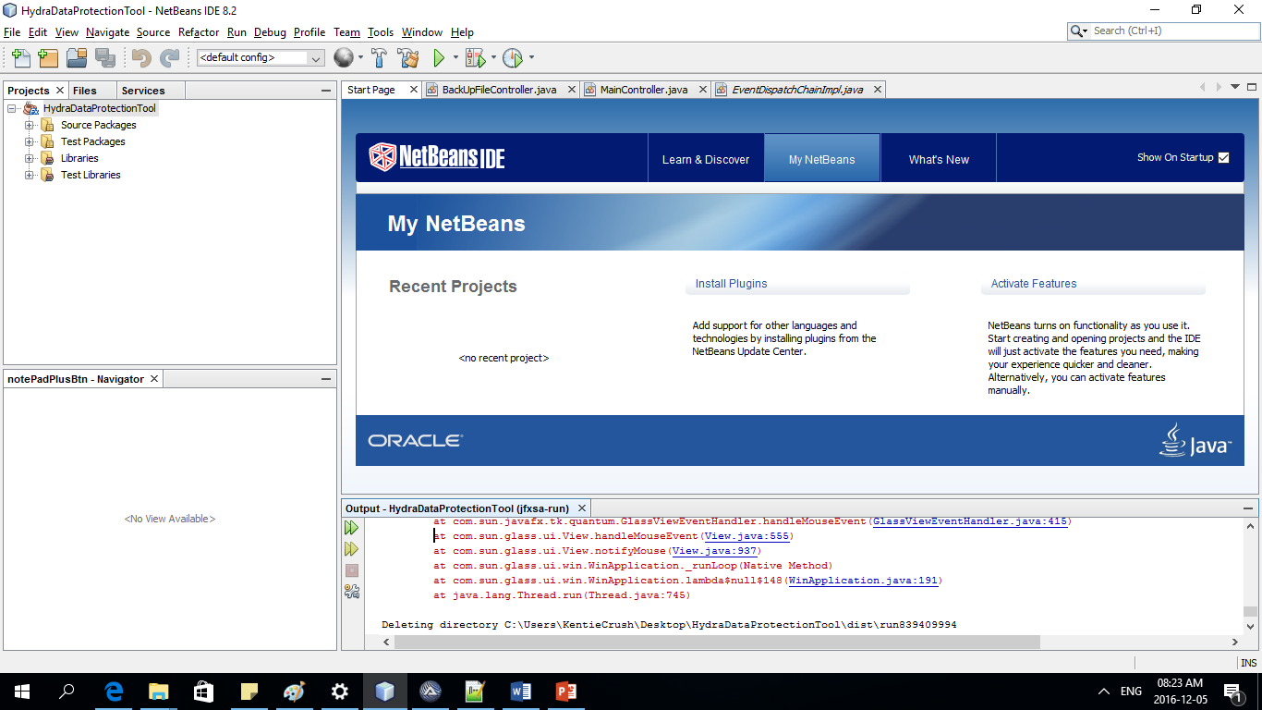

Net beans IDE is framework used by programmers to code, this IDE will also be used as a platform for the System.

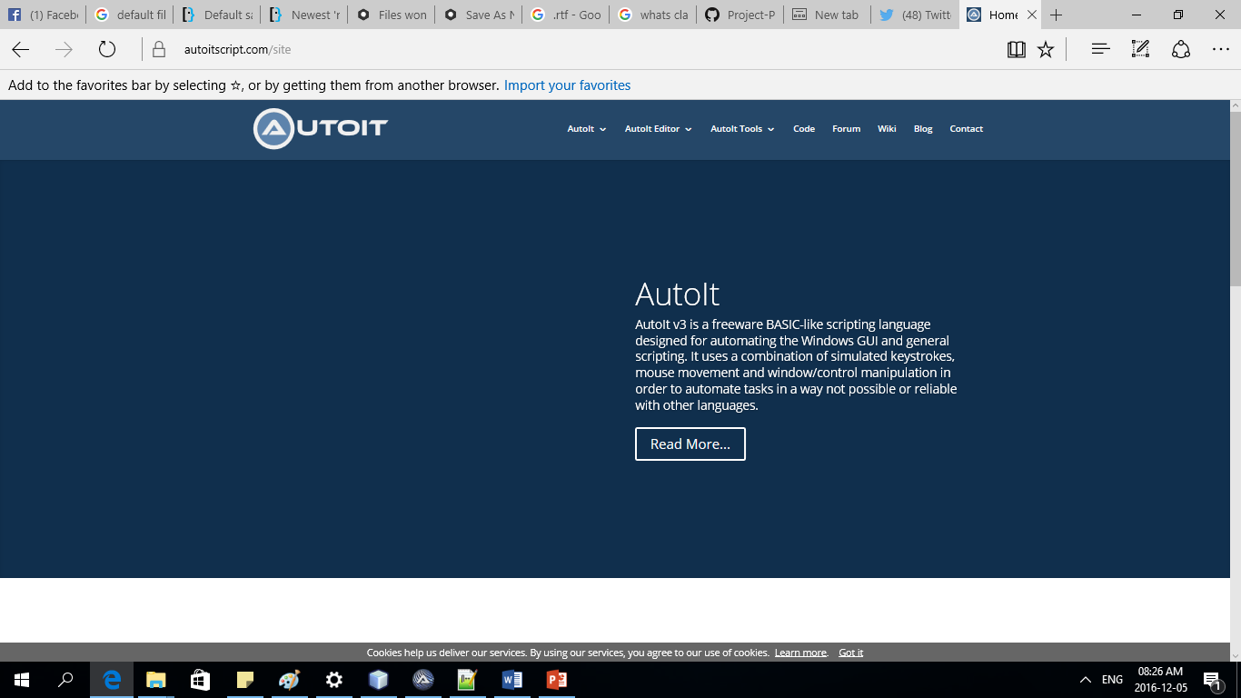

AutoIt is a scripting language which will be used in the program where coding and executing of scripts will take place.

This is the initial design of the Hydra Data Protection Tool.

Upon running the software, the first thing that the user sees is the retrieve module of the system.

As the picture shown below.

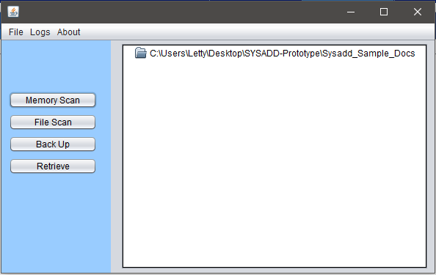

Upon clicking the memory scan, the system will calculate the Memory’s Space.

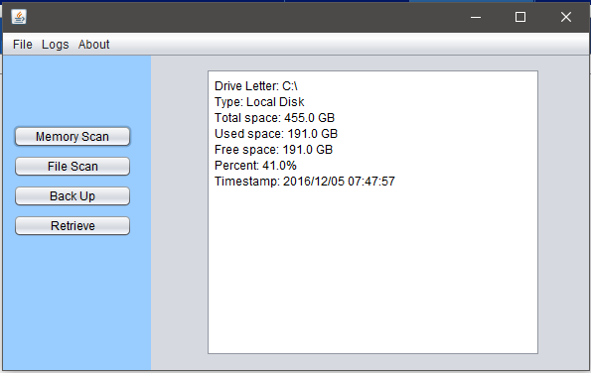

This is the back-up interface.

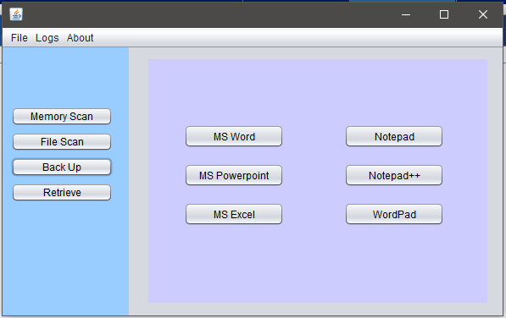

During this phase, the team did not focus on the GUI of the system. Their focus was to complete the functionality of their system. After they have finished all the functionalities, they return to the design phase of the system, and the new interface is here:

Upon execution, the home page will be the first thing to appear in the GUI.

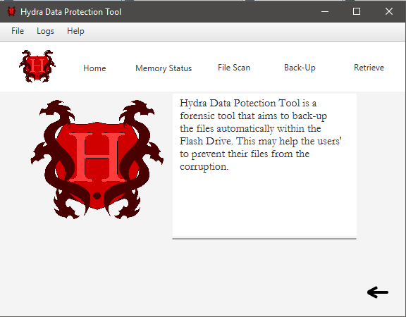

Then if the user checks the memory status of the USB this will appear:

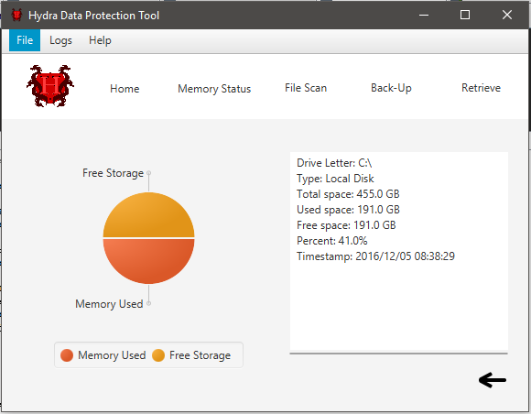

The back-up interface now looks like this.

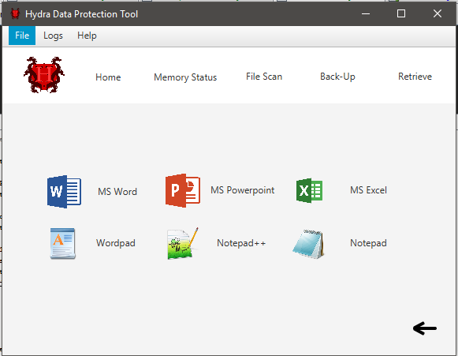

And the Retrieve interface now looks like this.

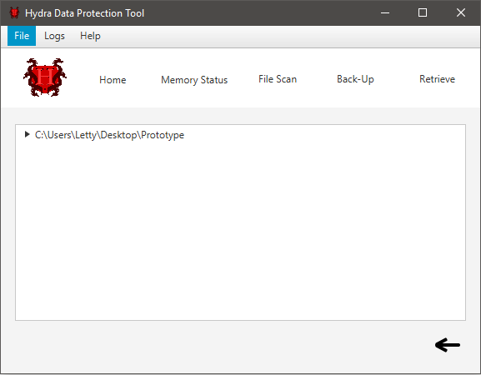

# **Results and Discussion**

The researchers conducted a survey to quantify the effects of data corruption, and to determine how much of the sample population was severely affected by it, meaning they have not back-up their file, not even once. And as a result the researchers came up with the following statistics:

**Figure 1.1**

Percentage of people who experienced data corruption

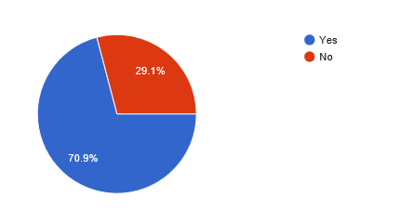

This figure 1.1 represents the percentage of the sample population that experienced data corruption. The figure shows that 70.9% of them experienced data corruption, and the remaining 29.1% haven’t experience data corruption yet.

**Figure 1.2**

Causes of Data Corruption which the Sample Population Experienced.

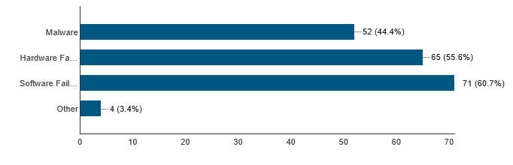

This Figure 1.1 shows that, 60.7 % of the people have experience data corruption due to malfunctions or code errors in the system which caused the data to be corrupted. 55.6% experience hardware failure which is often caused by a sudden shutdown or power outage. 44.4% also experienced data corruption due to malicious programs or malwares that targeted the users file and became corrupted.

**Figure 1.3**

Percentage of sample population who does back-up.

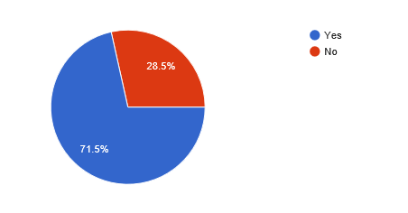

Figure 1.3 represents the number of people who had backed-up their data, 71.5% of the sample population was doing back-up and the remaining 28.5% does not practice back-up in their data.

**Figure 1.4**

Frequency of how often the sample population do back-up.

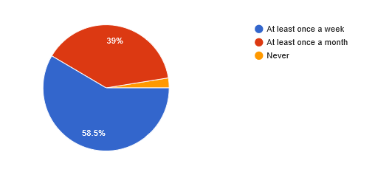

Figure 1.4 presents the percentage of people having back-up, this statistics show how do they often back-up their file. The graph shows that, 58.5% of the population are doing back-up at least once a week, 39% of them are doing back-up at least once a month.

As the figures shown above, we can observe that the number of people not doing back-up is quite large with 28.5%, this means that if these people were affected by data corruption, they will be the ones devastated the most. Although there are people who does routinely backup, some of them just do it for at least once a month, meaning if they were to be affected by data corruption before the month ends, then we could at least assume that the effect of it is still devastating. Same with those people who do backup at least once a week, although the difference is that they’re not that much affected but it is subjective to the contents of the file affected by data corruption.

# **Conclusion and Recommendations**

Only few people do back-ups and there are some who do not even do it, if they were to be affected by data corruption, they would suffer emotionally and it would also cause their resources to turn to waste. Figure 1.4 in the results and discussion can also interpret that people tend to perceive that “doing back-up” is a chore based on the frequency of when they do back-up. These people will be the main benefactor of the Hydra Data Protection Tool.

# **Appendices**

## Diagrams

### Flowchart

Main Program of Hydra Data Protection Tool

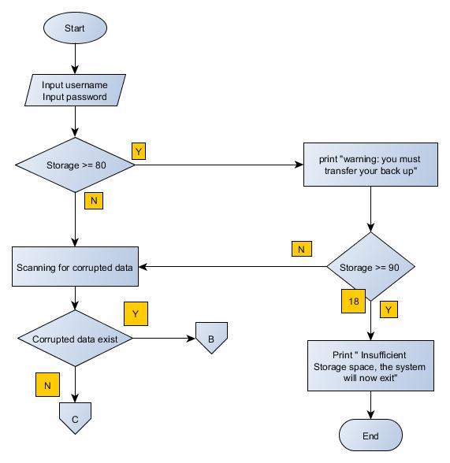

Fixation of Corrupted Text file

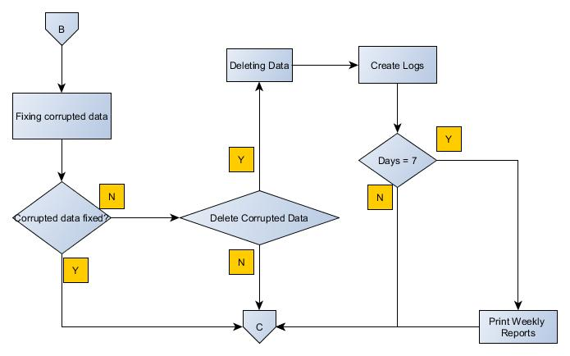

Continuation of Back-up

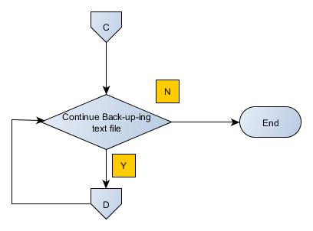

Flash Drive Space

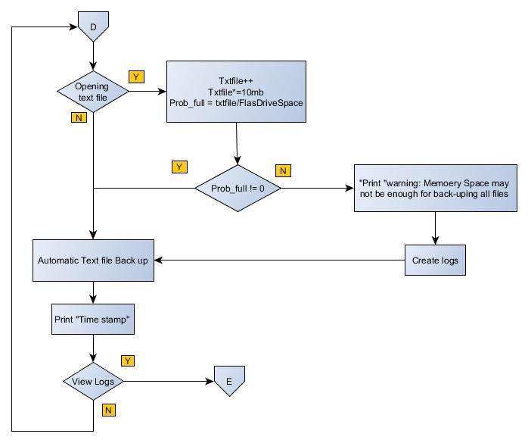

View Logs

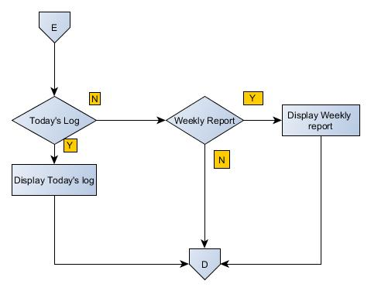

### Event Table

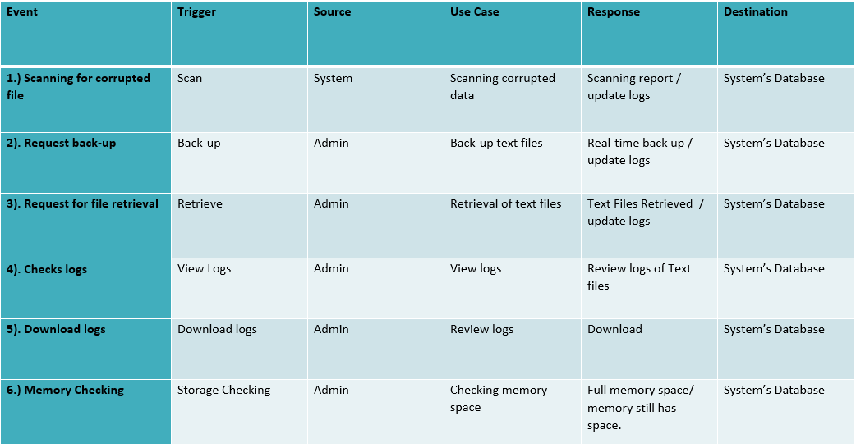

### Context Diagram

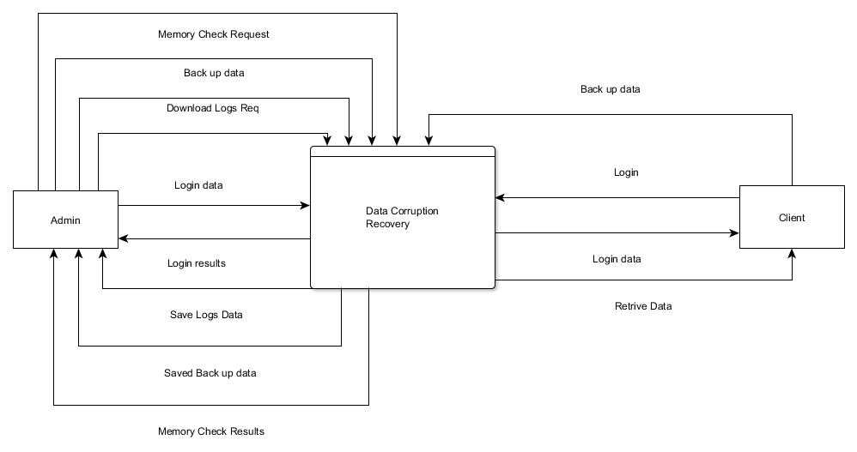

### Data Flow Diagram

#### Level 0

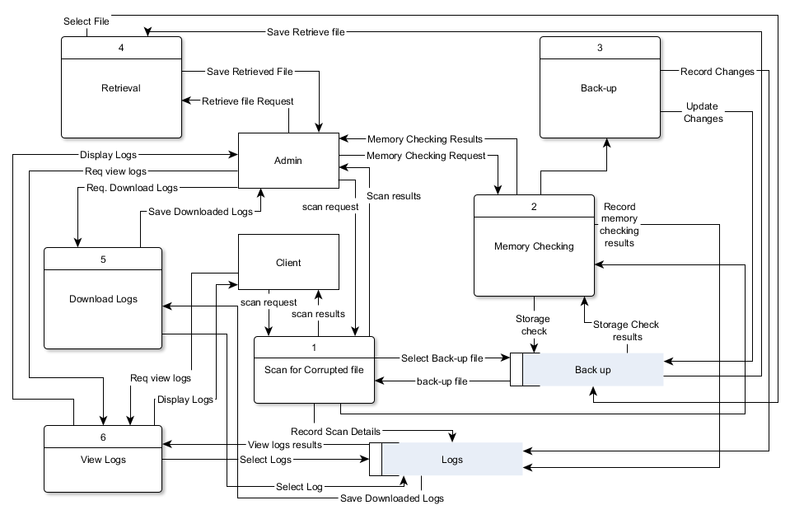

#### DFD Fragments

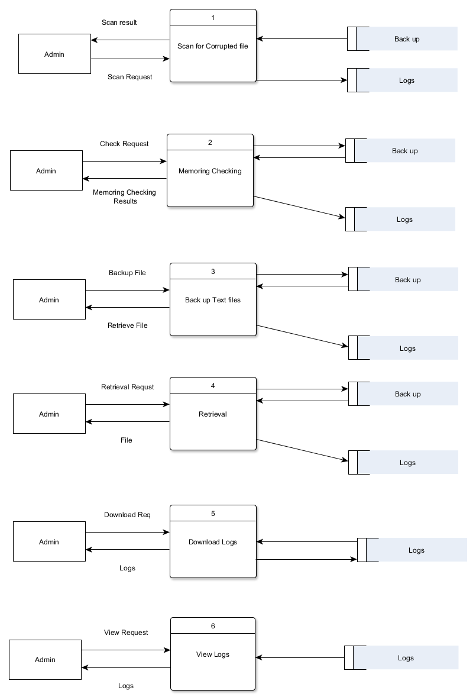

### Entity- Relationship Diagram

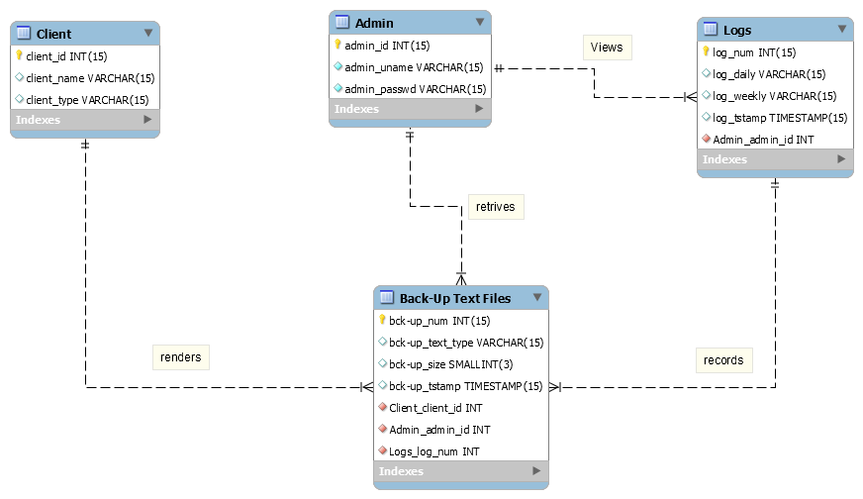

### Data Dictionary

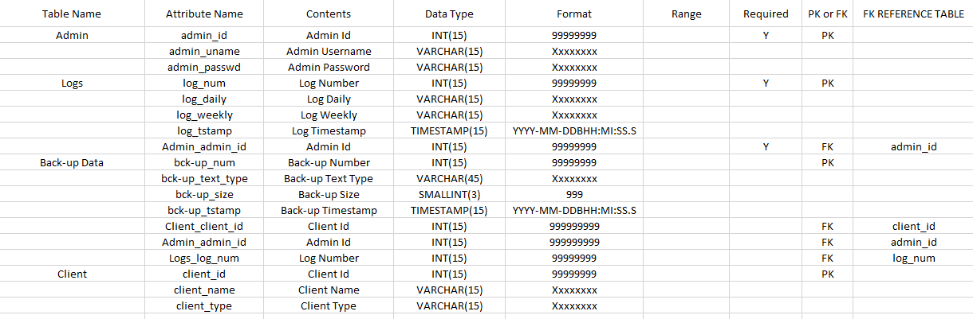

### Class Diagram

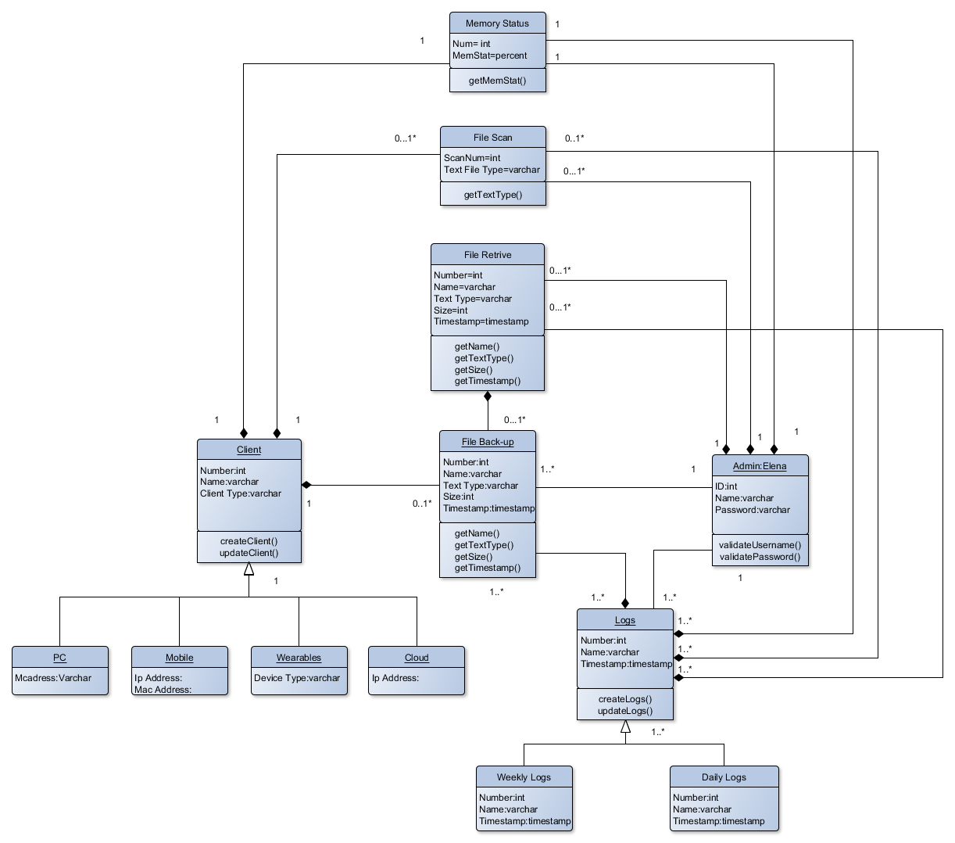

### Object Diagram

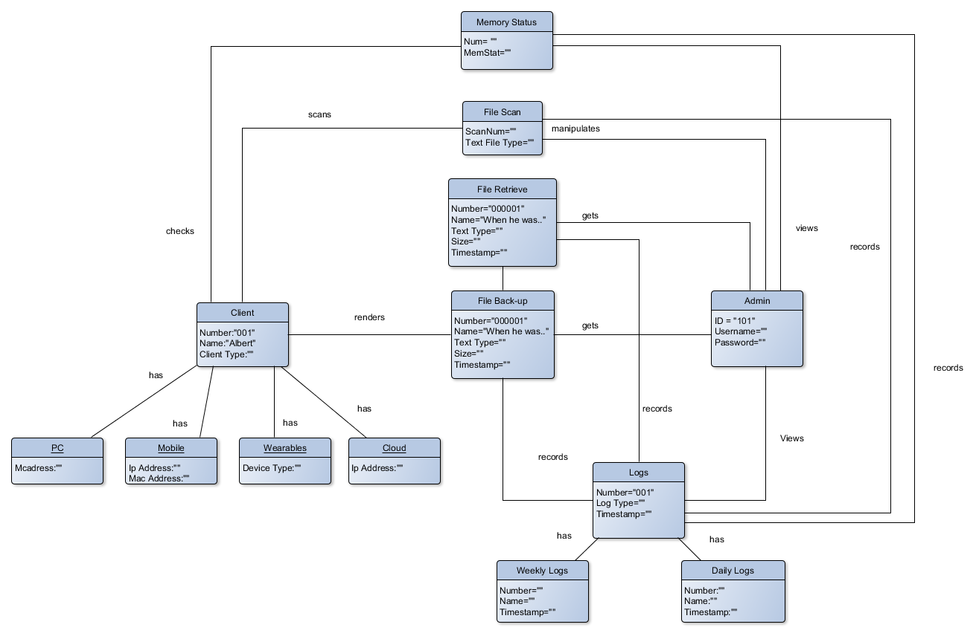

### Use Case Diagram

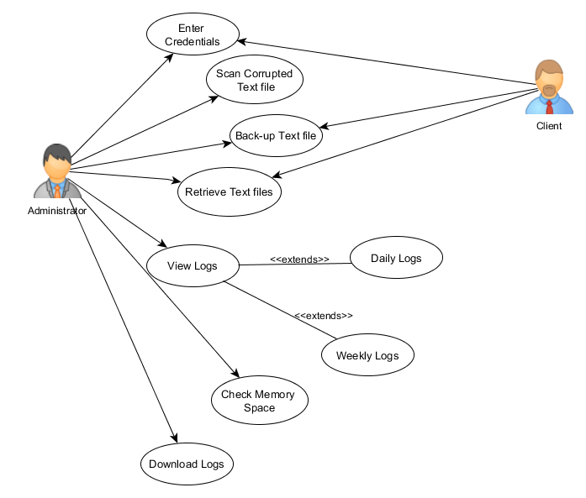

### Use Case Full Description

|  |  |  |
| --- | --- | --- |
| Number | PICDS-UC01 | |
| Use Case Name | User Authentication | |
| Scenario | User wants to Log in to the system | |
| Triggering Event | Log In | |
| Brief Description | When the admin access his files authentication is required. | |
| Actor(s) | Administrator | |
| Related Use Cases | ---- | |
| Stakeholders | Administrator, Client | |
| Precondition | User must plugin the Flash drive to the PC | |
| Post Condition | Administrator must able to access the system | |
| Basic Flow: | Actor’s Action | System’s Response |
|  | 1: Opens the application | 1.1: System displays the login page of the application |
| 2: User types its username/password |  |
| 3: User clicks login button | 3.1: System checks the database if the username and password is correct |
|  | 3.2: username and password matched System will message (SM01) |
|  | 3.3: System appears the main page of the application |
|  | 3.4: System scans for corrupted text file |
|  |  |  |
| Alternative Flow: |  | 3.2: If username and password of Administrator didn’t match |
|  |  | 3.3: System displays message (SM02) |

|  |  |  |
| --- | --- | --- |
| Number | PICDS-UC02 | |
| Use Case Name | User back-ups text files | |
| Scenario | User request for back-up | |
| Triggering Event | Back-up Text files | |
| Brief Description | As a prevention mechanism on data corruption, an automatic real-time backup is running on background. | |
| Actor(s): | Administrator | |
| Related Use Cases | User Authentication | |
| Stakeholders | Administrator, Client | |
| Precondition | User opens an text application | |
| Post condition | User was able to back-up the text file automatically while working on text application | |
| Basic Flow: | Actor Action | System Response |
|  | Step 1: User Plug’s in the Flash Drive | 1.1: System checks if the flash drive is less than 80% of the storage |
|  | 1.2: System scans for corrupted text file |
|  | 1.3: System will identify If the corrupted data can be fixed or not. |
|  | 1.4 Fix corrupted data |
| 2: User opens text file application | 2.1: System will start executing automatic real-time back up |
|  | 2.2: System will calculate if the storage can accumulate the back-up file. |
|  | 2.3: System backed-up text file |
|  |  |
|  |  |  |
| Alternative Flow: |  | 1.3: System will identify If the corrupted data can be fixed or not. |
|  | 2. User Agrees to delete corrupted data | * 1. Delete Corrupted data. |

|  |  |  |
| --- | --- | --- |
| Number | PICDS-UC03 | |
| Use Case Name | User views log | |
| Scenario | Admin views logs | |
| Triggering Event | View Logs | |
| Description | The changes made in the Flash drive are recorded in the logs. | |
| Actor(s) | Administrator | |
| Related Use Case | Use Authentication | |
| Stakeholders | Administrator | |
| Precondition | User is logged in as Admin | |
| Post Condition | User is able to view the in/out of text file | |
| Basic Flow: | Actor Action | System Response |
|  | 1: User view logs. | 1.1: System displays “Daily logs” and “Weekly logs” |
| 2. User select “Daily logs” | 2.1: System displays “Daily logs” page |
| 3. User select “Weekly logs” | 3.1: System displays “Weekly logs” page |
|  |  |  |

|  |  |  |
| --- | --- | --- |
| Number | PICDS-UC04 | |
| Use Case Name | User retrieve text file | |
| Scenario | User wants to get the back-up text file | |
| Triggering Event | Retrieve Text File | |
| Brief Description | Admin retrieves files that were backed up. | |
| Actor(s) | Administrator | |
| Related Use Case | User Authentication, User Back-Up | |
| Stakeholders | Administrator, Client | |
| Precondition | User has a back-up text files | |
| Post condition | Admin was able retrieve the back-up files | |
| Basic Flow: | Actor Action | System Response |
|  | 1. Admin will Select & Copy the file to retrieve |  |
| 1. Admin will Paste the retrieved file. |  |

|  |  |  |
| --- | --- | --- |
| Number | PICDS-UC06 | |
| Use Case Name | Download Log | |
| Scenario | User wants to review logs | |
| Triggering Event | Logs | |
| Brief Description | To review the systems activity | |
| Actor(s) | Administrator | |
| Related Use Case | User Authentication, View logs | |
| Stakeholders | Administrator, Client | |
| Precondition | User must have logged in as Administrator | |
| Post condition | Admin was able to download the logs | |
| Basic Flow: | Actor Action | System Response |
|  | 1. Admin clicks “View Logs” | 1.1 Displays the View Logs page |
| 1. Admin clicks “Download Logs” | * 1. System download logs |

|  |  |  |
| --- | --- | --- |
| Number | PICDS-UC05 | |
| Use Case Name | Scan Corrupted Text file | |
| Scenario | User wants to know if there’s any corrupted text file | |
| Triggering Event | Scan | |
| Brief Description | System scans for the corrupted text file | |
| Actor(s) | Administrator | |
| Related Use Case | User Authentication | |
| Stakeholders | Administrator, Client | |
| Precondition | Admin is logged in | |
| Post condition | Admin was able to log out the system | |
| Basic Flow: | Actor Action | System Response |
|  | 1. Log In’s the application |  |
|  | 1. Automatically scans for the corrupted text file |

|  |  |  |
| --- | --- | --- |
| Number | PICDS-UC07 | |
| Use Case Name | Memory Check | |
| Scenario | User wants to know the memory space of the flash drive | |
| Triggering Event | Memory Checking | |
| Brief Description | Able to identify the available memory space of the flash drive | |
| Actor(s) | Administrator, client | |
| Related Use Case | User Authentication | |
| Stakeholders | Administrator, Client | |
| Precondition | User must have logged in | |
| Post condition | User was able to know the memory space of the flash drive | |
| Basic Flow: | Actor Action | System Response |
|  | 1. Enter credentials | 1.1 Automatically Scans for the corrupted text file |
|  | 1. Scanned Complete |
|  |  | 1. Checks the memory space |

|  |  |  |
| --- | --- | --- |
| Number | PICDS-UC08 | |
| Use Case Name | Log out | |
| Scenario | User wants to log out from the system | |
| Triggering Event | Log out | |
| Brief Description | Log out from the system | |
| Actor(s) | Administrator | |
| Related Use Case | User Authentication | |
| Stakeholders | Administrator, Client | |
| Precondition | Admin is logged in | |
| Post condition | Admin was able to log out the system | |
| Basic Flow: | Actor Action | System Response |
|  | 1. Clicks the Logout button |  |
|  | 1. Destroys the session and logs out from the system 2. Displays the Log In page |

|  |  |
| --- | --- |
| System Message | |
| SM01 | You logged in successfully! |
| SM02 | Username or password is incorrect! |

### Activity Diagram

Back- up

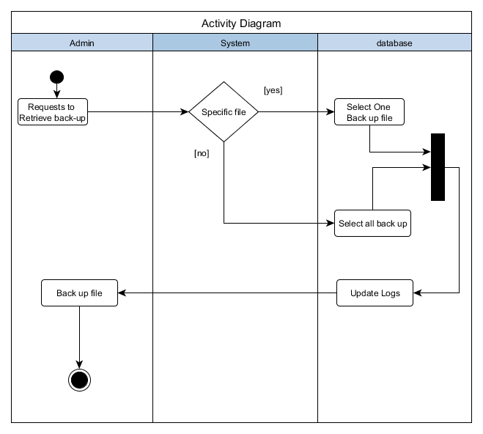

Memory Check and Scanning

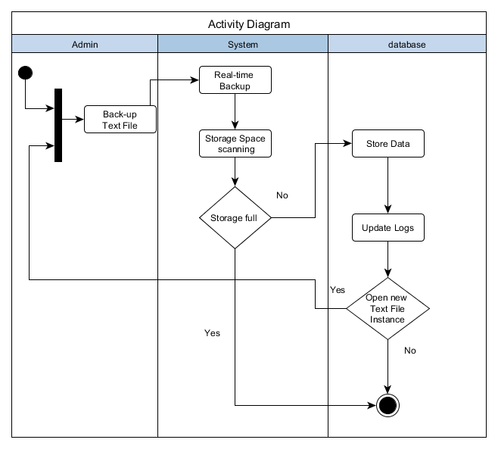

File Scanning

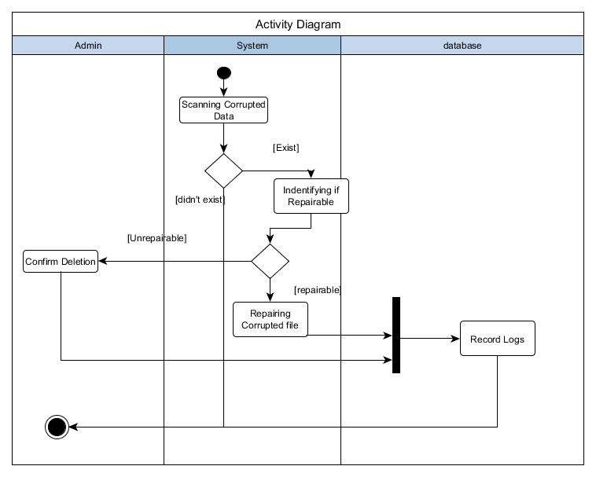

View Logs

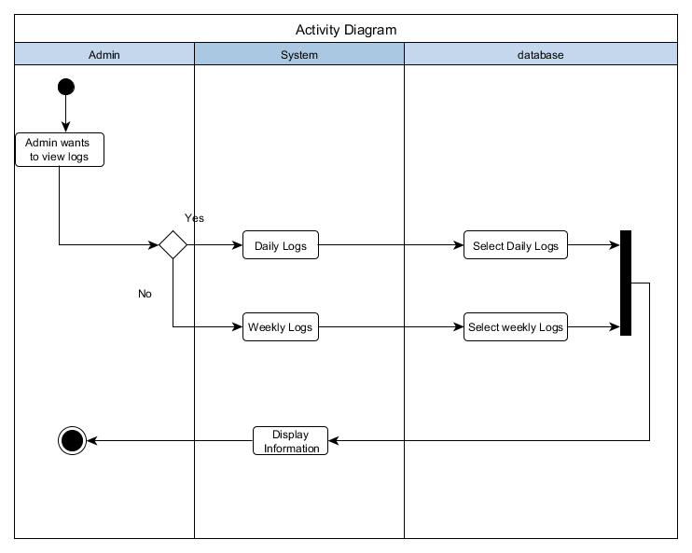

Download Logs

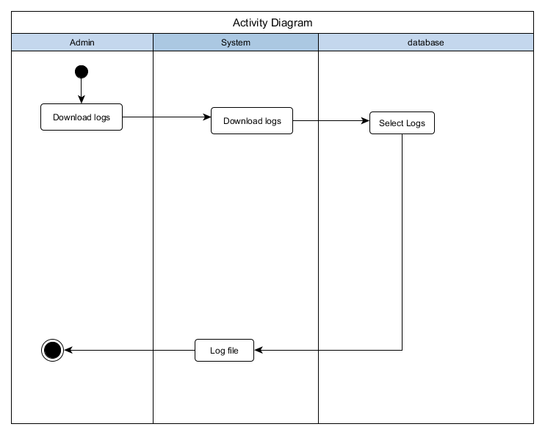

### Sequence Diagram

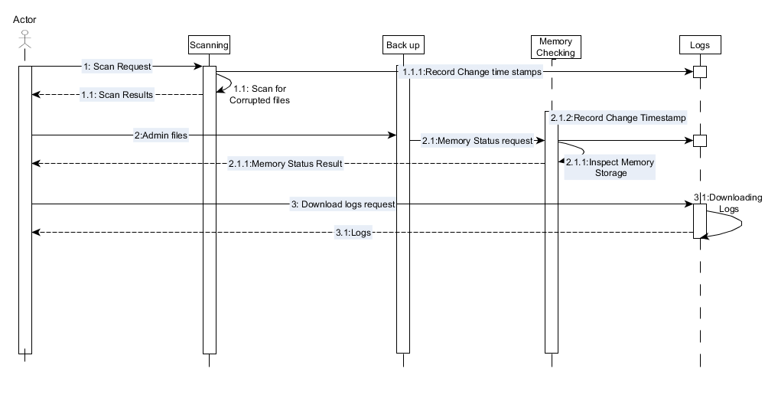

### Communication Diagram

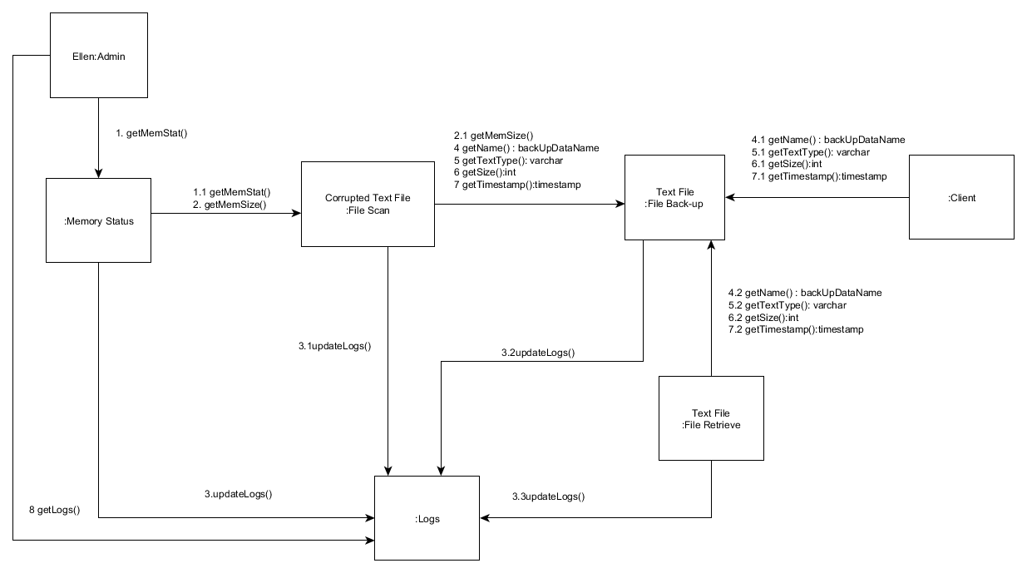

### State Diagram

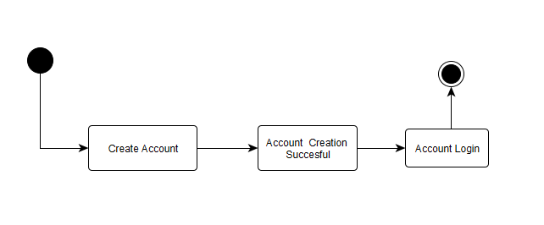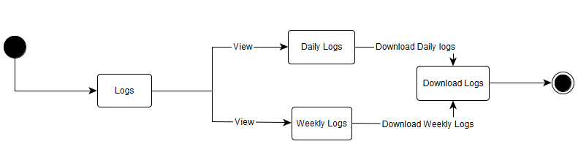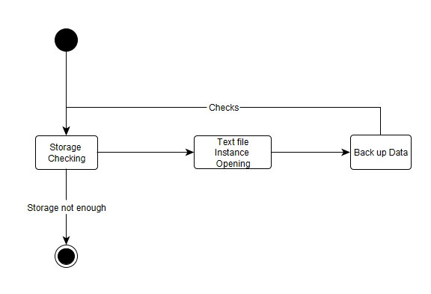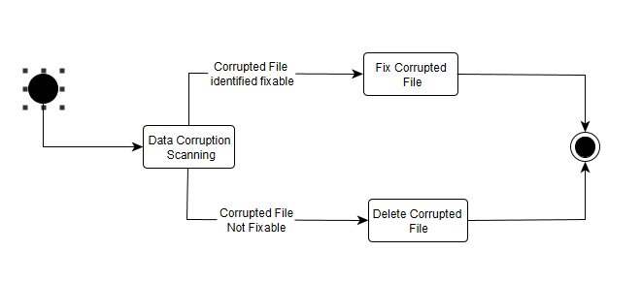

### Timing Diagram

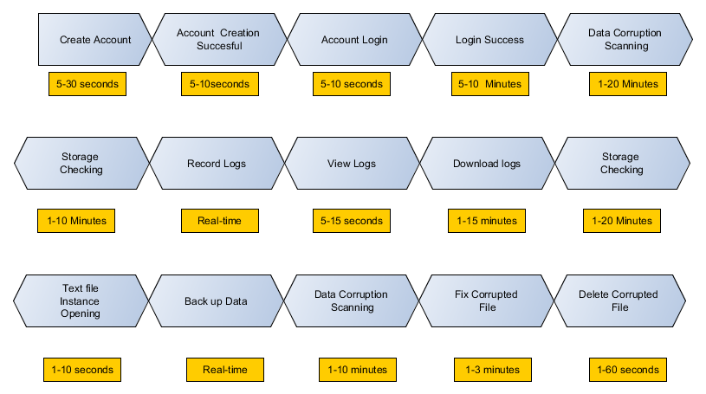

### Package Diagram

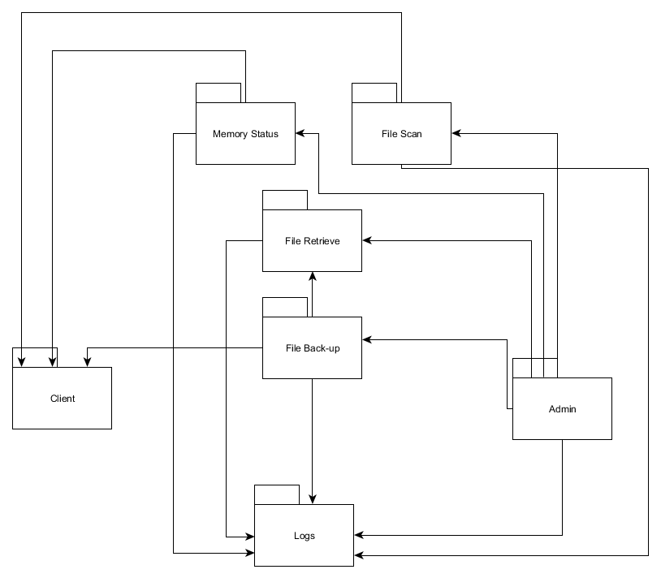

### Component Diagram

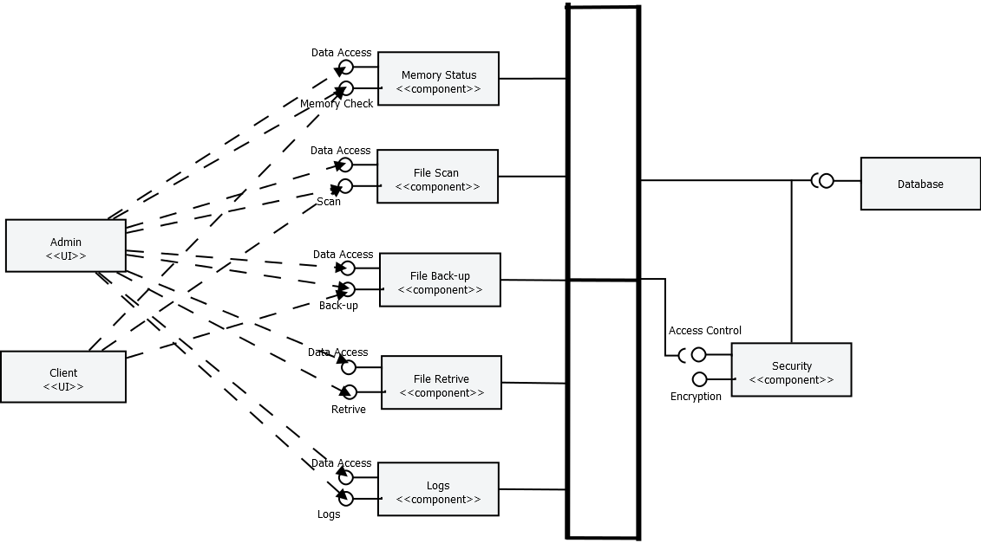

### Composite Structure Diagram

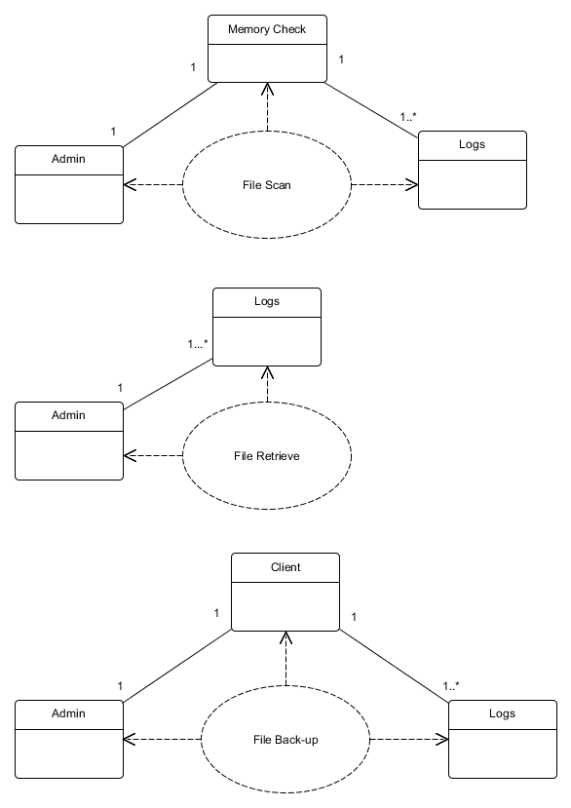

### Deployment Diagram

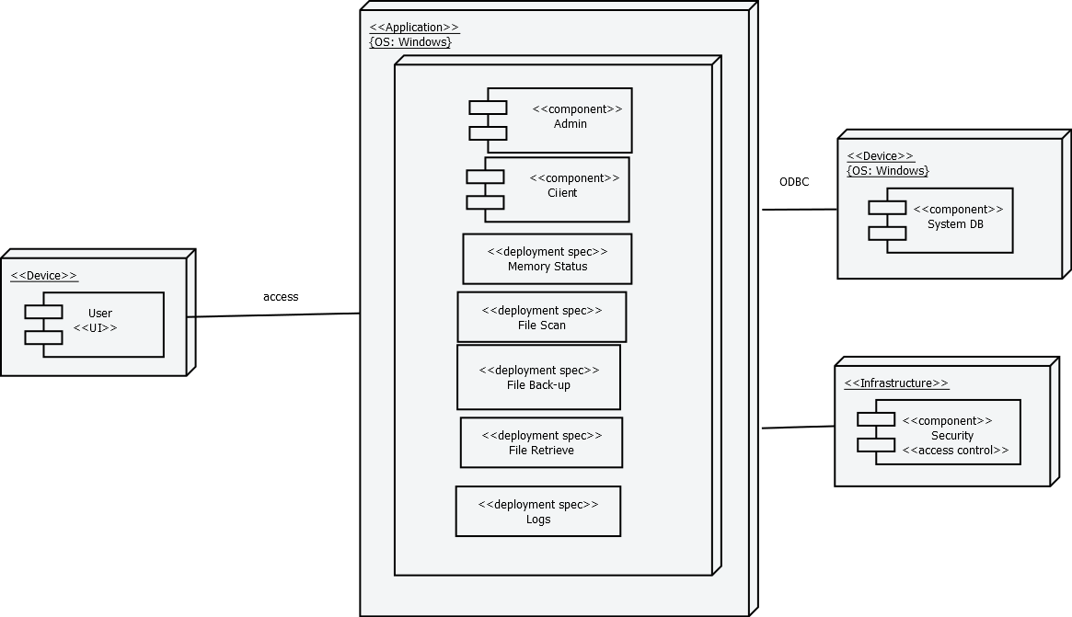

## Project Vision and Scope Document

## Business Requirements

Since the application is completely researched based, the teams together with its adviser, established the requirements needed, which as follows:

* To provide a real-time back-up
* To store changes in logs
* To monitor memory capacity
* To detect data corruption in the back-up storage

### Background

The research idea came from an experience of one of the team member’s experience on data corruption. As he was creating a text document for his class a sudden power outage occurs, and that all the effort exerted in making that document turned to waste and he felt despair. Then the conceptualization of data corruption prevention came into his mind.

### Business Opportunity

The potential market of this innovation are those people who use external storage devices or flash drives, which contents are often, made up of text documents.

Most people thought that maintaining back-up is a chore. These is a problem that can be considered as an opportunity, since the innovation offers real-time back-up, people would consider using a much easier tool such as this innovation, as compared to a manual back-up.

### Business Objectives and Success Criteria

The objective of this innovation is to provide a handy tool that can be easily used by the consumers. The tool should be capable of real-time back up, monitoring changes that are stored in logs, scanning for data corruptions. Success is achieved if the three main functions are working properly.

### Customer or Market Needs

In the time and aged we have, most of the people keep their documents in soft copies and have had own personal laptops or desktop computer, but some people are not doing back-up of their files as a practice or routine. The system introduces real-time back up and it’s embedded in the flash drive that can be brought anywhere. With this, the issue on manual back-up is addressed, such as maintaining a weekly or monthly routine to back-up file. It provides security on data in event of corruption.

### Business Risks

One of the risk that the developers tried to manage is the lack of knowledge since the area of data corruption has a wide range of variations, and the researchers require vast knowledge on data corruption. Another risk is that the time constraint of the team developers.

## Vision of the Solution

The solution would gradually evolve and later include other file type that contains video and music to be backed-up in real-time. The system should be further developed to be more efficient.

### Vision Statement

The team tend to provide users an easy way to protect their files or information from sources of corruption, with the least learning curve needed, with real-time capabilities, and handy.

### Major Features

1. **Real-Time Back Up** – while the user is currently working on a file, that file will automatically be saved- as one of the features of the system.
2. **Synchronization** - While the user is working on the file, the work that has been done is saved gradually.
3. **Mobile** – The application can be with the user anywhere and anytime.

### Assumptions and Dependencies

There are assumptions made during the creation of the project and it is necessary since it is out of the scope of the project but could probably have an impact to the system.

* It is assumed that the computers are properly equipped with anti-virus such that the storage device wouldn’t be affected by any malicious program.
* The user is responsible enough to protect the hardware, where the software is stored.

## Scope and Limitations

This Project aims to help students and/or office-workers to secure their information or data on availability issues. They must use windows OS- 7 and higher versions. The project primarily focuses on data corruption and prevention. It also assumes that the interaction is just among the players of the system such as the admin, system, and user. The prevention of data corruption is only focus on text documents, and it is beyond the systems capability if the flash drive itself became corrupted since it should be the users’ responsibility to protect the hardware itself.

The flash drive that will be used should have a NTFS file structure with a memory space not below 4 gigabytes. The optimal performance of the application could be achieved if the memory space of the flash drive is less than 90%.

### Scope of Initial Release

During the initial release of the system, a handy flash drive is produced which is capable of real-time back up of text file. It also records any changes stored in logs and capable of scanning data corruption that exist in the back-up flash drive.

### Scope of Subsequent Releases

In subsequent release, the software capabilities will include other file types to be backed-up in real-time. The bugs or problems during the initial release would be fixed.

## Business Context

### Stakeholder Profiles

|  |  |  |  |  |
| --- | --- | --- | --- | --- |
| **Stakeholder** | **Major Value** | **Attitudes** | **Major Interests** | **Constraints** |
| User | Improves the system | Reports errors and bugs | error correction; ease of use; high reliability | Limited access |
| Administrator | Monitors the overall system | Keen in detecting errors and bugs and has a lot of patience | Determining and fixing inconsistencies; easy to use | Budget |

### Project Priorities

|  |  |  |  |
| --- | --- | --- | --- |
| **Dimension** | **Driver (state objective)** | **Constraint (state limits)** | **Degree of Freedom (state allowable range)** |
| Schedule | release 1.0 to be available at the end of the course | Time constraint | 90-100% of the utility functions must be done |
| Features | The main functions must properly work | Real-time back up is focused on text-files only at release 1.0 | 70-80% of high priority features must be included in release 1.0 |
| Quality | Provides easy tool for the consumers to use | Errors and bugs are expected to occur at release 1.0 | 90-95% of user acceptance tests must pass for release 1.0, 95-98% for release 1.1 |
| Staff | Objective oriented persons that aim for completion | maximum team size is 6 developers + 4 testers | 90-100% of the allowable time should be achieve for release 1.0 |
| Cost | Expenses should not exceed the maximum budget | Maximum budget | budget overrun up to 15% acceptable without executive review |

### Operating Environment

The application would be placed in an external storage device or flash drives. The foundation of the software will be scripts and java language. The users of the system will often be students or office workers; this also means that the software will function 24 hours regardless of geography since the target are office workers, which office hours are during day and night, though it will be expected to have more work load during days since both students and office workers are present.

## Project Statement of Work

### Introduction/Background

The existence of data corruption has always been an issue in technology. Data that traverses through devices are important in today’s society. Most of the transactions right now is converted to a much easier mechanize system. The number of people who is using automation increases together with their data usage while there are only few ways to protect themselves from data corruption. The most popular is the back-up of data. Usually data back-up is done as a weekly routine so that if failure occurs in some point in time, then one can at least recover the files that he/she has during the past week.

Since this practice can actually consume a lot of time and effort, the team of data corruption conceptualizes an idea of creating a software application that could offer a real-time back up capability - to address the problem that could potentially harm a lot of people.

### Scope of Work

The scope of work for the innovation includes all planning, execution, implementation, testing, and training that would outperform the existing solutions on data corruption. Each stage of the project will be documented and will properly be guided by its adviser. The feedback would be acquired through series of survey after the application was created.

### Period of Performance

Since time is of the essence, each day should properly be scheduled to ensure that the final product would be finished on time. The period of performance is one year (365 days) beginning on July 17, 2016 to July 18, 2017.

### Place of Performance

The areas where the researchers and developers will work are mostly on the vicinity of Asia Pacific College and in the Villamor air base. The researchers are required to have a meeting at least once a week, to monitor the overall progress of the system to prevent delays from happening.

### Work Requirements

As part of the data corruption project, the team will be responsible for performing tasks throughout various stages of this project. The following is a list of these tasks which will result in the successful completion of this project:

Kickoff:

* The researchers will research and educate themselves on different ways on how to solve the issue of data corruption.
* The researchers will create a schedule of task that can be presented through a WBS.
* The researchers will present the plan to their adviser for approval.

Design Phase:

* Create site design based on collected requirements
* Develop site design proposal for the panel to review and aprove
* Present written status during weekly meeting

Build Phase:

* Researchers will complete all coding for approved site design
* Researchers will provide their adviser with a detailed testing plan
* Researchers will include all content provided by the adviser on redesigned software
* Researchers will resolve any coding and site issues identified in testing
* Researchers present written status during weekly meeting

Implementation Phase:

* Researchers will implement the newly redesigned software in an external storage device or flash drive.
* Researchers present written status during weekly meeting

Training Phase:

* Researchers will provide training in accordance with approved training plan provided in the kickoff
* Researchers Present written status during weekly meeting

Project Handoff/Closure:

* Researchers will provide the adviser with all documentation in accordance with the approved project plan.
* Researchers will present project closure report to the adviser for review and approval.
* Researchers will complete the project requirements checklist showing that all project tasks that have been completed.
* Researchers present written status during weekly meeting.

### Schedule/Milestones

The list below consists of the initial milestones identified for the Website Redesign Project:

RFP/SOW Release Oct 13, 2016

Period of performance begins Oct 26, 2016

System Design Review November2, 2016

Website Implementation Review November 10, 2016

Implementation Complete November 20, 2016

Development November 20 – Feb 19, 2017

Training Complete February 20, 2017

Project Completion Review February 25, 2017

Project Closure/Archives Complete March 3, 2017

### Acceptance Criteria

For the data corruption project the acceptance level of the project is accomplishing at least 90-100 % of the mile stone deliverable. Each milestone would be checked and consulted by the projects consultant and advisor, to check if there are existing inconsistencies that should be check or corrections to be addressed. Any problem that would be identified during the creation would be solved by the team’s developer. This project would be considered accepted if all the main functions were observed and all the task and miles stones were finished.

### Other Requirements

All programming and testing will be done in the vicinity of Asia Pacific College or in the Villamor Air Base. A network outage will be scheduled for the implementation phase of this project. Prior to the network outage, all servers will be backed-up and a notification will be distributed to all users.

## Work Breakdown Structure (WBS)

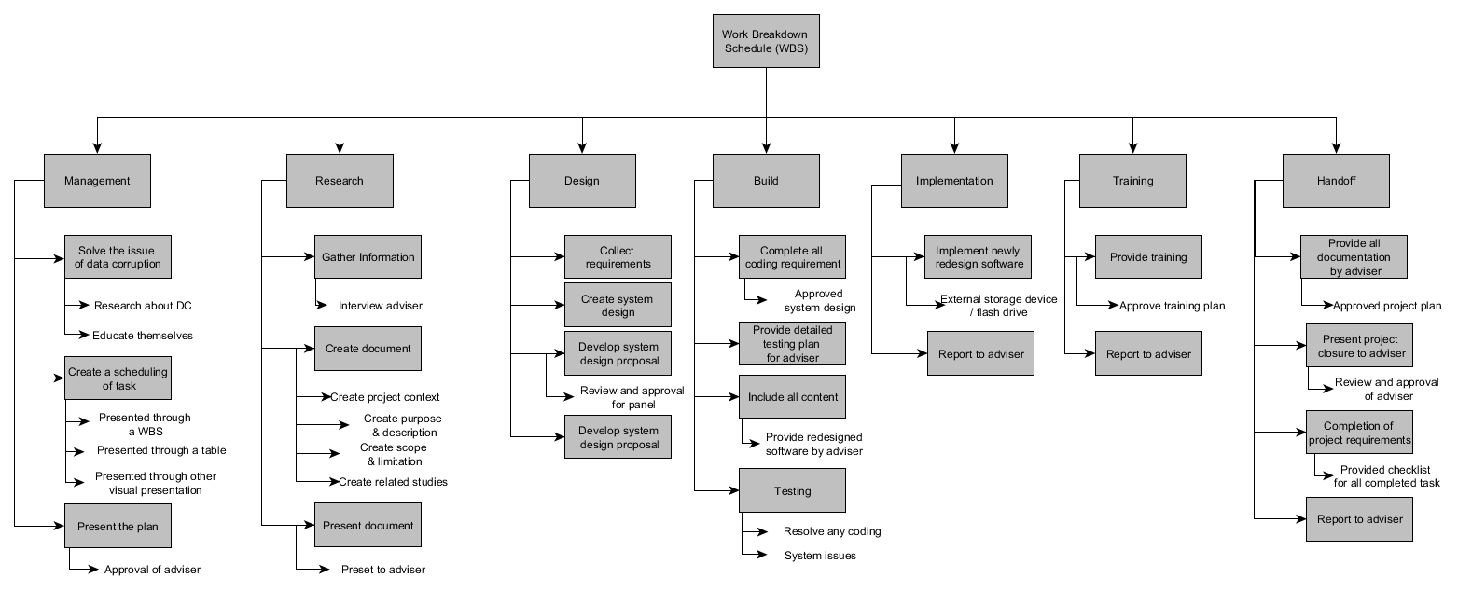

## Activity List

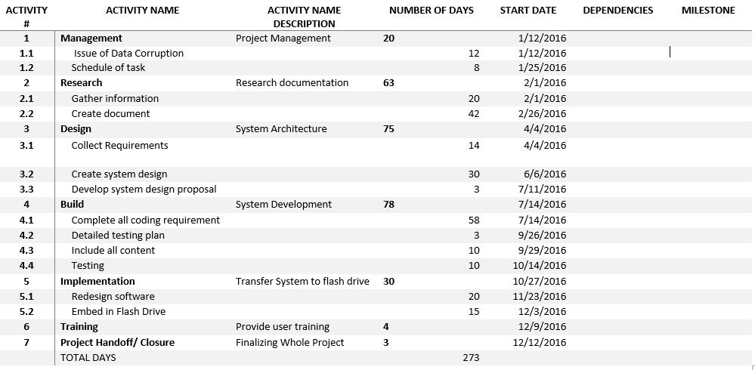

## Gantt Chart

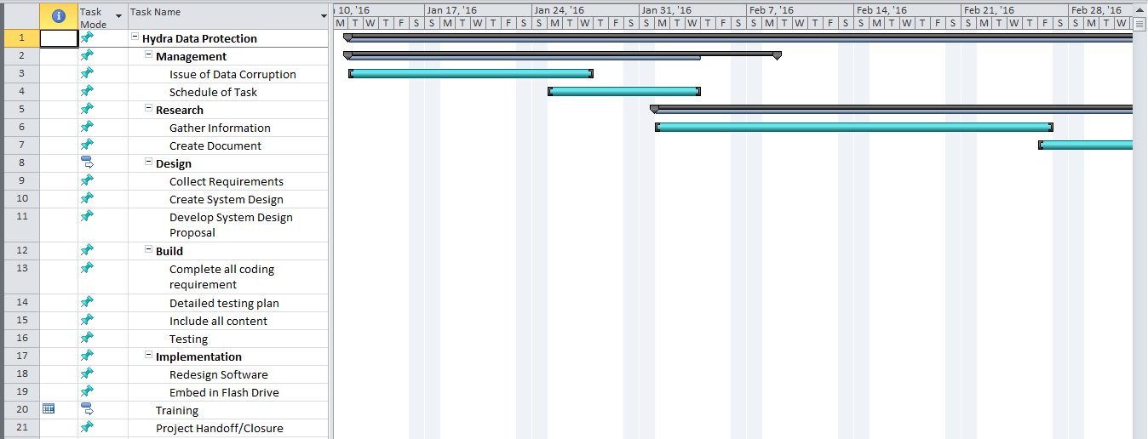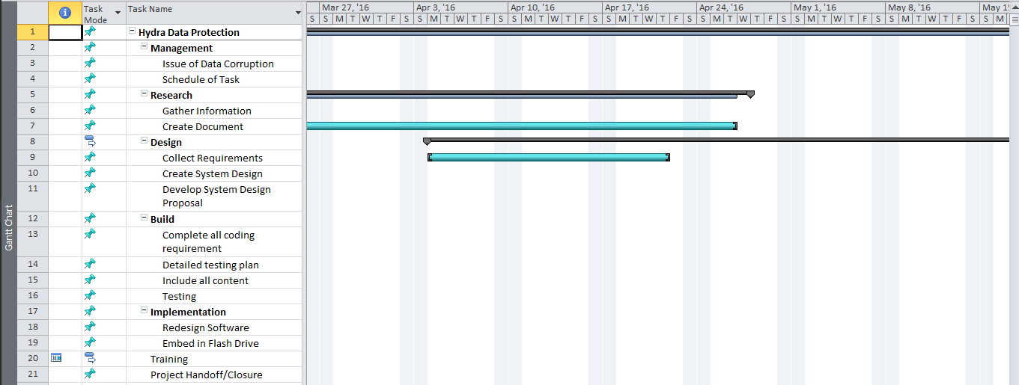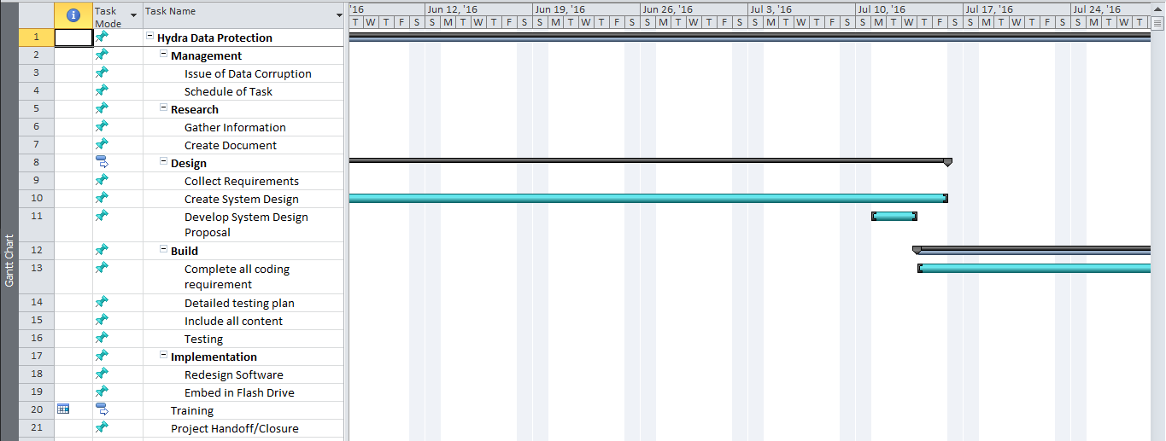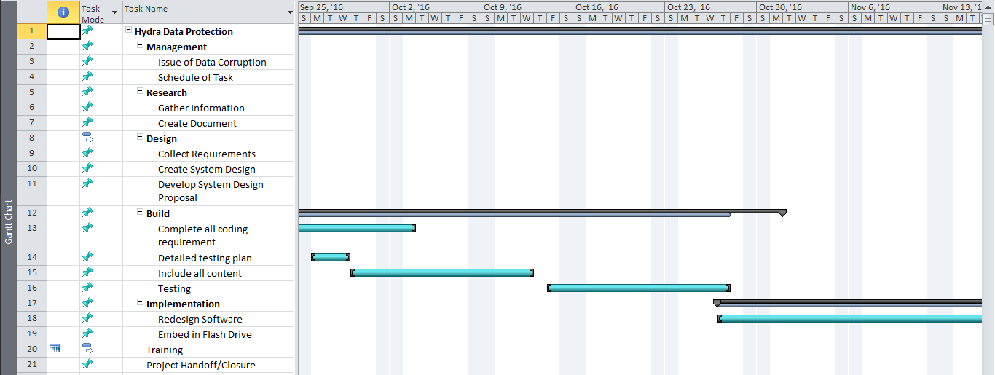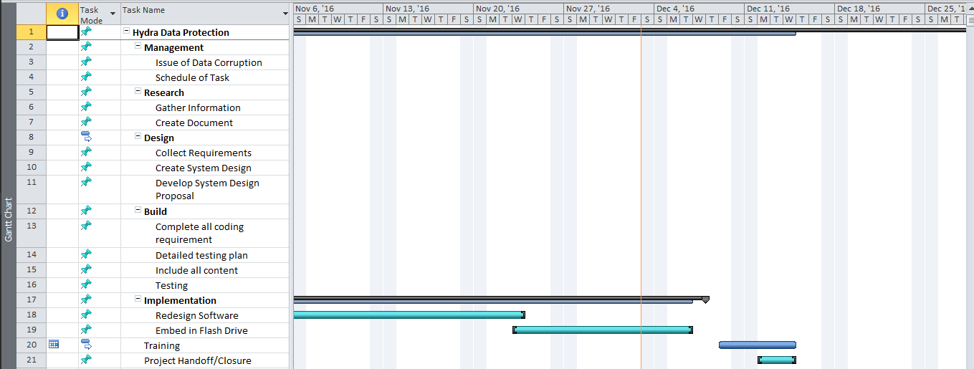

## Software Requirements Specification

### Introduction

#### Purpose

The purpose of the Software Requirement System is to clearly define the system under development, namely Hydra Data Protection Tool (HDPT). The HDPT is a tool embedded in a flash drive, which main purpose is to protect the data that is currently being worked on, and to mitigate the effects of data corruption to the end-users.

#### Document Conventions

Upon reading this paper, technical terms might be encountered, the terms will be defined as the following:

* Checksum: act of comparing the hash value of the file, to check for its integrity.
* Hash Value: one-way encryption for the main purpose of maintaining the file integrity
* Data Corruption: a state where your file gets unusable due to certain causes.
* Flash drive: external storage device
* End-Users: The users of the final product.

#### Intended Audience and Reading Suggestions

The intended audience of this document are the end-users which includes students and office workers. Other intended audience are the HDPT Project Manager, HDPT Project Developer, and HDPT Adviser.

#### Product Scope

The product will be used to protect the files of the end-users from events of data corruption, and aims to be more efficient and helpful than the existence similar tools. The product’s protection will be mainly focused on the ones existing in the Back-up folder located at the flash drive.

#### References

These documents are for the reference of the product in projects2.apc.edu.ph/wiki and GitHub. The following are some of the references for this document:

* Change Management Plan
* Project Vision and Scope
* Statement of Work
* Quality Plan

All documents listed above were documented together by the project team.

### Overall Description

#### Product Perspective

The product is a tool that aims to help the end-users maintain a back-up data of their files, which some users find a bit stressful to maintain back-up each and every time, and often they do it casually. The product wants to maintain a back-up of their file without being a burden for the end-users’ perspective.

#### Product Functions

The product itself has three major function which are:

* Real-time Back-up – Where the file is automatically backed up in real-time.
* Synchronization – Where the user is working on the file, the last activity of the user will automatically be saved
* Mobility – The user can bring the tool anywhere does it go.
* Corruption scanning – which detect if there is an existing corrupted data in the back-up folder.
* Corruption Fix – The system will attempt to fix the corrupted data.

#### User Classes and Characteristics

The HDPT has two main users namely the normal users, and the privilege users. The normal users are allowed to scan and fix the identified corrupted data, they could also back-up their file anytime they want to. Privilege users are the only ones allowed to retrieve back-up data.

#### Operating Environment

The system will operate in a windows based platform with a NTFS file architecture, the system will be stored in a flash drive, and the system will also use java platform and AutoIt Scripting tool.

#### Design and Implementation Constraints

Design and Implementation constrains were identified as the following:

* The memory of the flash drive should at least be less than 90 percent to attain the systems optimal performance.
* The system will be using Java language.
* It is also assumed that the end-users will take the responsibility for protecting the hardware in cases where the flash drive itself becomes corrupted.

#### User Documentation

This SRS document will be delivered along with the User Manual Document, which contain the steps on how to use the software. Help and tutorial would also be included there.

#### Assumptions and Dependencies

There are assumptions made during the creation of the project and it is necessary since it is out of the scope of the project but could probably have an impact to the system.

* + - * It is assumed that the computers are properly equipped with anti-virus such that the storage device wouldn’t be affected by any malicious program.
      * The user is responsible enough to protect the hardware, where the software is stored.

### External Interface Requirements

#### User Interfaces

In the product’s system, the UI is where the user and system can interact with. The system has buttons where these buttons are made up of functionalities of scanning, memory checking, retrieving the back-up files, viewing logs, and downloading logs. The UI also shows the files are inside the tool.

#### Hardware Interfaces

The hardware interface that can be involved in the project is the Flash Drive where the Flash Drive is a tool that can be used to embed the system.

#### Software Interfaces

In software interface, the team used Java Language to build the system also we used the Netbeans IDE I used as a compiler where the team can run the system prototype. Also, the team used the AutoIt, where the team can do the scripting.

### System Features

The product has 3 main features that work together to protect the user’s data, namely Real-time back-up, Scan for corrupted data, and repair corrupted data. Some minor features like being handy and mobile, would encourage the users to back-up, since it is easy to use and doesn’t distract the users from what he/she is doing.

#### Real Time Back-Up

* Description and Priority

The Real-time back-up feature is highly prioritized, since the best way to protect each and everyone’s documents from data corruption, is through data redundancy, which makes this feature more important. This would also encourage people to back-up their file since the method is much easier to use from the end-users’ perspective.

* Stimulus/Response Sequences

Real-time back-up: After the user executed a file, the system would duplicate the file, and would incrementally save every 2 seconds.

* Functional Requirements

Conditions must be met, before the user can use the necessary functions, such as, the memory space should at least less than 90 percent full, so that optimum performance and real-time back-up is established

REQ-1: Storage space is less than 90 percent

REQ-2: The user’s environment must be Windows OS with NTFS file structure

REQ-3: The Flash must also have a NTFS file structure.

#### Scan for Data Corruption

* Description and Priority

This feature, would conduct a checksum on the file’s hash value, which would detect if data corruption has occurred.

* Stimulus/Response Sequences

The user must execute the “Scan for Corruption” button before the system conducts checksum on the file’s hash value.

* Functional Requirements

REQ-1: Storage space is less than 90 percent

REQ-2: The user’s environment must be Windows OS with NTFS file structure

REQ-3: The flash must also have a NTFS file structure.

#### Fix for Data Corruption

* Description and Priority

This feature would conduct a checksum on the file’s hash value, which would detect if data corruption has occurred.

* Stimulus/Response Sequences

The user must have identified a corrupted data, and must execute the repair function.

The user must execute the “Scan for Corruption” button before the system conducts checksum on the file’s hash value.

* Functional Requirements

REQ-1: Storage space is less than 90 percent

REQ-2: The user’s environment must be Windows OS with NTFS file structure

REQ-3: The flash must also have a NTFS file structure.

REQ-4: The scan for corruption must be issued before this can be executed.

REQ-5: There is a detected file corruption.

### Other Nonfunctional Requirements

#### Performance Requirements

The HDPT product requires that the storage device (flash drive) must be less than 90% full, since the system also occupied space in the flash drive, and real-time back-up cannot be issued if the flash drive is almost full.

#### Safety Requirements

Due to physical causes, the corruption might occur to the flash drive itself. The user must keep it safe as always to avoid this kind of scenario from happening.

#### Security Requirements

Upon retrieving the data, the user needs to acquire the password to authenticate whether he has an admin privilege or none.

#### Software Quality Attributes

The software helps the users to protect their data with ease, since some tools are too complicated for them to use, and some find back-up data as a chore that is often done once a week.

#### Business Rules

The following are the rules of each involved including the system itself.

* The user’s file is automatically back-up in the Flash Drive
* The user can view and download its logs
* The user may retrieve the files from the back-up data
* The system will scan for the corrupted text fil

### Other Requirements

There are no more required for the system. If there are bugs, it must be checked by the admin, so that the bugs of the system are fixed. Always keep the Flash Drive secure in order to keep data safe.

### Appendix A: Glossary

* Hash Value - is a numeric value of a fixed length that uniquely identifies data, which serve as its finger print.
* Real Time Back-Up - refers to back-up of computer data, which method is by automatically saving a copy of every change made to the file, essentially capturing every version of the data that the user append.
* Java Language - a general-purpose, concurrent, strongly typed, class-based object-orientedlanguage
* Netbeans IDE - a free and open source integrated development environment for application development on Windows, Mac, Linux, and Solaris operating systems
* AutoIt - is a freeware BASIC-like scripting language designed for automating the Windows GUI and general scripting.

### Appendix B: Analysis Models

Data Flow Diagram

Level 0



DFD Fragments



Class Diagram



State Diagram



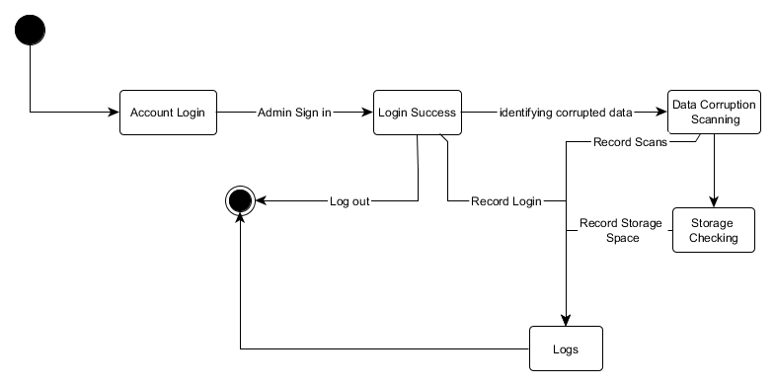







Entity- Relationship Diagram



## Change Management Plan

### Introduction

The Change Management Plan was created for the Hydra Data Protection Tool (HDPT) Project in order to set expectations on how the approach to changes will be managed, what defines a change, the purpose and role of the change control board, and the overall change management process. All Team members will be expected to submit or requests to the HDPT Project in accordance with this Change Management Plan and all requests and submissions will follow the process detailed in this paper.

### Change Management Approach

The Change Management approach for the HDPT Project will ensure that all proposed changes are defined, reviewed, and agreed upon so they can be properly implemented and communicated to all team members. This approach will also ensure that only changes within the scope of this project are approved and implemented.

The Change Management approach is not to be confused with the Change Management Process which will be detailed later in this plan. The Change Management approach consists of three areas:

* Ensure changes are within scope and beneficial to the project
* Determine how the change will be implemented
* Manage the change as it is implemented

The Change Management process has been designed to make sure this approach is followed for all changes. By using this approach methodology, the HDPT Project Team will prevent unnecessary changes from occurring and will focus its resources only on beneficial changes within the project scope.

### Definitions of Change

There are several types of changes which may be requested and considered for the HDPT Project. Depending on the extent and type of proposed changes, changes project documentation and the communication of these changes will be required to include any approved changes into the project plan and ensure all stakeholders are notified. Types of changes include:

* **Scheduling Changes:** Changes which will impact the approved project schedule. These changes may require fast tracking, crashing, or re-baselining the schedule depending on the significance of the impact.
* **Budget Changes:** Changes which will impact the approved project budget. These changes may require requesting additional funding, releasing funding which would no longer be required, or adding to project or management reserves. May require changes to the cost baseline.
* **Scope Changes**: changes which are necessary and impact the project’s scope which may be the result of unforeseen requirements which were not initially planned for. These changes may also impact budget and schedule. These changes may require revision to WBS, project scope statement, and other project documentation as necessary.
* **Design changes:** GUI of the HDPT requires further improvement, consistency of each module’s design must be observed.

The project manager must ensure that any approved changes are communicated to the team members. Additionally, as changes are approved, the project manager must ensure that the changes are captured in the project documentation were necessary. These document updates must then be communicated to the project team and stakeholders as well.

### Change Control Board

The Change Control Board (CCB) is the approval authority for all proposed change requests pertaining to the HDPT Project. The purpose of the CCB is to review all change requests, to determine their impacts on the project risk, scope, cost, and schedule, and to approve or deny each change request. The following chart provides a list of the CCB members for the HDPT Project:

|  |  |  |
| --- | --- | --- |
| **Name** | **Position** | **CCB Role** |
| K. Miculob | Project Manager/Developer | CCB Co-Chair |
| M. Laureta | Project Editor/Developer | CCB Member |
| R. Alberca | Project Researcher | CCB Member |
| J. Pineda | Adviser | CCB Chair |

As change requests are submitted to the Project Manager by the project team members, the Project Manager will log the requests in the change log and the CCB will convene every other week to review all change requests. For a change request to be approved, all CCB members must vote in favor. In the event more information is needed for a particular change request, the request will be deferred and sent back to the requestor for more information or clarification. If a change is deemed critical, an ad hoc CCB meeting can be called in order to review the change prior to the next scheduled bi-weekly CCB meeting.

### Roles and Responsibilities

The following are the roles and responsibilities for all change management efforts related to the HDPT Project:

Project Adviser:

* Reviews the change in product system and document
* Approves all changes to schedule baseline
* Approves any changes in project scope
* Chairs the CCB

Project Manager:

* Receives and log all change requests from project stakeholders
* Conducts preliminary risk, cost, schedule, scope analysis of change prior to CCB
* Seeks clarification from change requestors on any open issues or concerns
* Makes documentation revisions/edits as necessary for all approved changes
* Participates on CCB.yy312z

Project Team:

* Submits all change requests on standard organizational change request forms
* Provides all applicable information and detail on change request forms
* Does prepared to address questions regarding any submitted change requests
* Provides feedback as necessary on impact of proposed changes.

### Change Control Process

The Change Control Process for the HDPT Project will follow the structural standard change process for all projects. The project manager has overall responsibility for executing the change management process for each change request.

1. Identify the need for a change (Stakeholders) – Change requestor will submit a completed change request form to the project manager.
2. Log change in the change request register (Project Manager) – The project manager will keep a log of all submitted change requests throughout the project’s lifecycle.
3. Evaluate the change (Project Manager, Team, Requestor) – The project manager will conduct a preliminary analysis on the impact of the change to risk, cost, schedule, and scope and will seek clarification from team members and the change requestor.
4. Submit change request to CCB (Project Manager) – The project manager will submit the change request, as well as the preliminary analysis, to the CCB for review.
5. Obtain Decision on change request (CCB) – The CCB will discuss the proposed change and decide whether or not it will be approved based on all submitted information.
6. Implement change (Project Manager) – If a change is approved by the CCB, the project manager will update and re-baseline project documentation as necessary.

## Quality Plan

### Introduction

This document, together with other referenced documents, defines the responsibilities and procedures to be adopted to ensure that the data and information produced as part of Project 116 are reliable, fit for purpose and consistent with documented objectives and deliverables. It summarizes the system of internal management that governs the decisions and instructions concerning project quality assurance.

### Project Contractual Information

|  |  |
| --- | --- |
| Project: | Hydra Data Protection Tool |
| Project Number: | 116 |
| Programme Co-ordinator: | Mr. Justin Pineda |
| Principal Investigators(s): | Mr. Manuel Sebastian Sanchez |

### Scope of Work and Quality Objectives

The scope of work for the innovation includes all planning, execution, implementation, testing and training that would outperformed the existing solutions on data corruption. Each stage of the project will be documented and will properly be guided by its adviser. The feedback would be acquired through series of survey after the application was created.

### Project Organization

|  |  |
| --- | --- |
| Project Manager(s): | Kent Michael Miculob |
| Task Manager: | Maria Letty Laureta |
| Other Team Member: | Reginald John Steven Alberca |
| Subcontractors: | Mr. Jacob Catayoc |
| Technical Reviews: | Mr. Justin Pineda |

### Project Duration and Scheduling

|  |  |
| --- | --- |
| Start Date: | January 11, 2016 |
| Completion Date: | December 16, 2016 |
| Scheduling of Activities: | Gantt charts may be used to clarify complex scheduling; any milestones or hold points should be identified. |
|  |  |

### Deliverables

Deliverables specified for the project include:

1. Running System / Research Paper
2. Project’s Wiki
3. Project GitHub
4. Project/Research Status/Progress Report
5. Vision and Scope Document
6. Project Plan / Project Statement of Work / Project Risk Plan
7. Work Breakdown Structure / Activity List / Gantt Chart
8. Software Requirements Specification
9. Change Management Plan
10. Quality Plan
11. User/Admin Manuals
12. Analysis diagrams (Event Table, Use Case, Activity Diagrams, Entity Relationship Diagrams, Data Flow Diagrams, Context Diagrams and Data Dictionary, UML Diagrams)

### Review of Quality Plan

This Quality Plan is reviewed once a month, to give team developers the time they need to maintain the products quality and effectiveness.

### Document and Record Control

The documentation of the project is available on project’s wiki, github, one note. Each revision is properly recorded and specified in each document. The copies of documents are also available on the project manager’s device and project developer.

The Quality Plan and Data Management Plan will be issued to all members of the consortium.

Project Progress Reports will be issued to the following:

List of names.

* Kent Michael Miculob
* Maria Letty Laureta
* Reginald John Steven Alberca
* Mr. Justin Pineda
* Mr. Jacob Catayoc
* Mr. Manuel Sanchez

### Documented Procedures

The project’s team, together with its adviser, uses Joint Application Development. On the first part of the project, the team had some intense meetings with its adviser to clearly define the functions features and uniqueness of the system.

## User/Admin Manual

System information

This system is a tool that protects one’s data to be corrupted, by means of real-time back-up and data corruption detection. An easy to use tool which requires less knowledge about technology.

Procedure:

Upon inserting the flash drive, a system would appear.

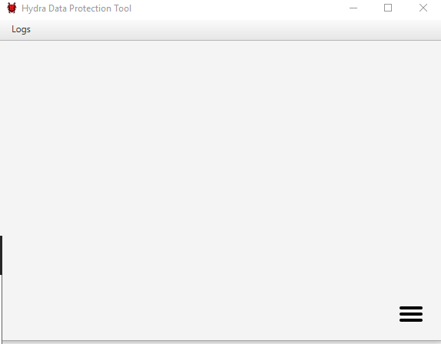

Just click the menu button which is represented by the three bars at the lower right corner. And the system’s functionality will appear.

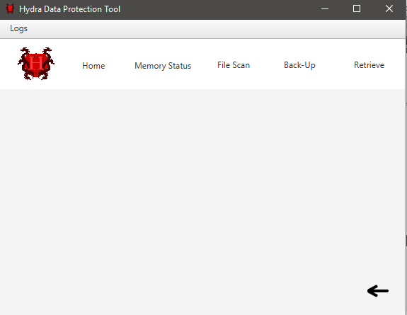

When choosing the home button, the information about the tool will appear.

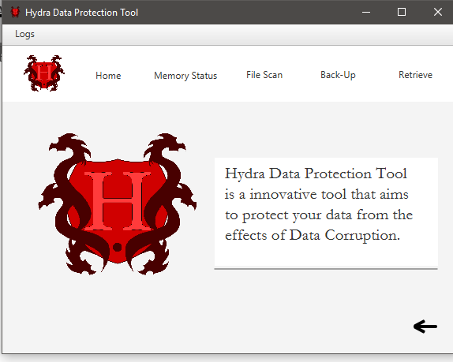

The memory status button would monitor the available storage space of the flash drive.

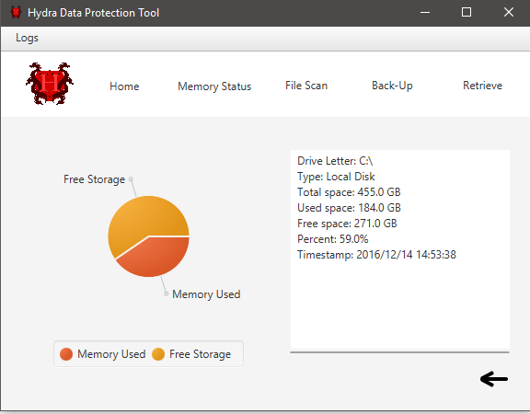

In the file scan interface, you can choose to scan for corruption or to repair the detected corrupted data.

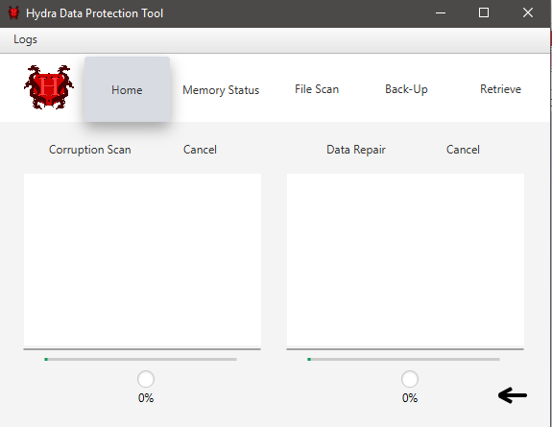

The back-up interface has buttons for different text-files, once the button is pressed, real-time back-up will be issued on that file.

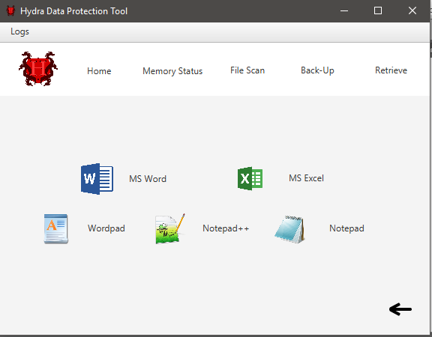

The retrieve interface allows you to monitor the back-up files in the system and retrieve them.

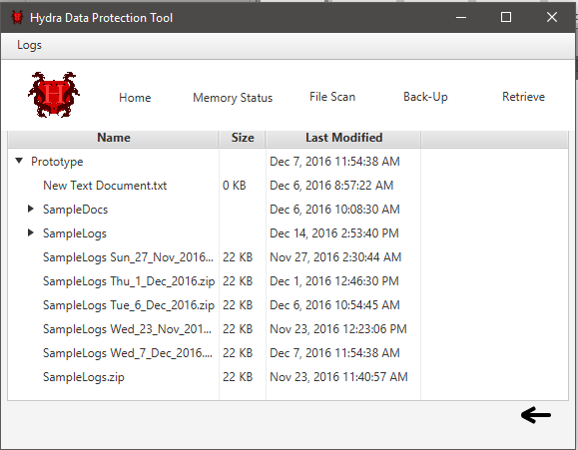

## Project Status Reports

### Status Report – September 24, 2016



**Project Status Report**



**Project Name:** Data Corruption Recovery

**Department:** SoCit

**Focus Area:** Data corruption backup and recovery

**Product/Process:**



**Prepared By:**

|  |  |
| --- | --- |
| **Document Owner(s)** | **Project/Organization Role** |
| Kent Michael P Miculob | Project analyst / manager |
| Maria Letty Laureta | Project Designer/ Documenter |
| Reginald John Steven Alberca | Project Researcher |

**Project Status Report Version Control**

|  |  |  |  |
| --- | --- | --- | --- |
| **Version** | **Date** | **Author** | **Change Description** |
| 1.0 | 09/21/2016 | Kent Michael Miculob | Document created |
|  |  |  |  |
|  |  |  |  |

**PROJECT STATUS REPORT PURPOSE**

The Project Status Report is a document that may be used to record the weekly progress of the group project. This is used to formally document every task or details that has done during each week of the project making.



**PROJECT STATUS REPORT TEMPLATE**

Project Status Report Details

The focus of this project is to record each milestones and module created during the past week.

* Project Prototype
  + This project prototype needs to be done, so that series of test can be done to measure its capabilities and look for bugs.
  + There was a progress in making the project prototype, there are only two critical functions that requires an attention
  + The project milestone’s failure wouldn’t deal huge impact since there was progress made during the vacation period.
* There is no budget required as for the moment.
* The current risk right now is, not finding a way on how to synchronize two files.
* The group doesn’t have issues as for the moment.
* The group will ensure that each week will have a progress that would give an impact to the overall outcome of the project.

**Project Status Report Template**

|  |  |  |
| --- | --- | --- |
| Project Name | | |
| Prepared By:  Kent Michael Miculob | Date:  **09/21/2016** | Reporting Period:  09/21/2016 to 09/28/2016 |
| Project Overall Status:  As for the current situation, the project prototype is 80% finished. | | |
| Project Summary:  The project progressed during the vacation as a result of the effort of the team. | | |
| **Milestone Deliverables performance reporting over last period**   |  |  |  |  | | --- | --- | --- | --- | | **Milestone Deliverables** | **Due Date** | **% Completed** | **Deliverable Status** | | Milestone 1 | | | | | * Consultant Request Form | 09/26/2016 | 100% |  | | * Adviser Request Form | 09/26/2016 | 100% |  | | * Scanning Module | 09/26/2016 | 50% |  | | Milestone 2 | | | | | * Back –up Module | 09/26/2016 | 70% |  | | * Retrieve Module | 09/26/2016 | 70% |  | | * Synchronization Module | 09/26/2016 | 50% |  | | | |
| **Milestone Deliverables scheduled for completion over next period**   |  |  |  |  | | --- | --- | --- | --- | | **Milestone Deliverables** | **Due Date** | **% Completed** | **Deliverable Status** | | Milestone 1 | | | | | * Back-up Module Testing | 10/03/2016 |  |  | | * Retrieve Module Testing | 10/03/2016 |  |  | | * Synchronization Module Testing | 10/03/2016 |  |  | | Milestone 2 | | | | | * Prototype Evaluation | 10/03/2016 |  |  | | * Prototype Debugging | 10/03/2016 |  |  | | * Prototype Flourishing | 10/03/2016 |  |  | | | |
| **Project impact of milestone success or failure for project remainder**   |  |  | | --- | --- | | [Replace this text with a description of milestone and potential scope changes.] | [Replace this text with a brief description of any changes to the project schedule required as a result of the amended milestone(s).] | | | |
| **Project** **Budget/Financial Status**   |  |  |  |  | | --- | --- | --- | --- | | **Budget Item** | **Planned Budget** | **Actual Cost** | **Variance/Explanation** | |  |  |  |  | |  |  |  |  | | | |
| **Project Risk Management Status**   |  |  |  |  |  | | --- | --- | --- | --- | --- | | **Risk and Description** | **Risk Chance** | **Risk Impact** | **Risk Priority** | **Change from Last Review** | | Solutions on Synchronization aren’t found yet.   * Synchronization Module. | High | High | High | No change was made yet since this is the first review. | | Solutions on real-time backup aren’t solved yet.   * Real-time back up module | High | High | High | No change was made yet since this is the first review. | | | |
| **Project Issue Management Status**   |  |  |  |  |  | | --- | --- | --- | --- | --- | | **Issue and Description** | **Project Impact** | **Target Due Date** | **Issue Status** | **Issue Resolution** | | Laziness of each group member | High | 09/26/2016 | closed | Each member is given an individual task that if combined, will complete the project. | | Lack of knowledge of each member on the subject matter | High | 09/26/2016 | open | Each member are given a field to study and is required to share the knowledge to the team. | | | |
| **Project Recommendations**   |  | | --- | | [Replace this text with a brief statement for the Steering Committee, Project Sponsor, or Senior Manager to consider or endorse. Other questions to consider for review with key project stakeholders are:   * Will the project be completed on time and on budget?  * Will the project deliverables be completed within acceptable quality levels?  * Are scope change requests being managed successfully?  * Are project issues and risks being addressed successfully and mitigated?  * Are all customer concerns being addressed successfully?] | | | |
| **Objectives for Next Project Status Review**   |  | | --- | | The project has a good progress during the week, and this could make them finished the project earlier than expected. It will give them the advantage to add some features, if find necessary. | | | |
| **Related Project Information**   |  | | --- | | [Replace this text with an attachment or link to other relevant information that can be included with this project status report. Examples include:   * Budget Report Summary  * Issue Record Report  * Scope Change Report  * Project Work Plan  * Project Metrics/Statistics  * Quality Management Review.] | | | |



**PROJECT STATUS REPORT A****PPROVALS**

**Prepared by** \_\_\_\_\_\_\_\_\_\_\_\_\_\_\_\_\_\_\_\_\_\_\_\_\_\_\_\_\_\_\_\_\_\_

Kent Michael Miculob  
 Project Manager

**Approved by** \_\_\_\_\_\_\_\_\_\_\_\_\_\_\_\_\_\_\_\_\_\_\_\_\_\_\_\_\_\_\_\_\_\_

Mr. Justin Pineda  
 Project Adviser



**APPENDICES**

**Document Guidelines**

1. [Project Title](http://projects2.apc.edu.ph/wiki/index.php/Project_-_Data_corruption_recovery_-_116" \l "Project_Title)
2. [Project Members](http://projects2.apc.edu.ph/wiki/index.php/Project_-_Data_corruption_recovery_-_116#Project_Members)
   * [2.1 Project Consultant](http://projects2.apc.edu.ph/wiki/index.php/Project_-_Data_corruption_recovery_-_116#Project_Consultant)
   * [2.2 Project Adviser](http://projects2.apc.edu.ph/wiki/index.php/Project_-_Data_corruption_recovery_-_116#Project_Adviser)
   * [2.3 Project Team](http://projects2.apc.edu.ph/wiki/index.php/Project_-_Data_corruption_recovery_-_116#Project_Team)
   * [2.4 Abstract](http://projects2.apc.edu.ph/wiki/index.php/Project_-_Data_corruption_recovery_-_116#Abstract)
3. [3 III.List of Figures, List of Tables, List of Notations](http://projects2.apc.edu.ph/wiki/index.php/Project_-_Data_corruption_recovery_-_116#III.List_of_Figures.2C_List_of_Tables.2C_List_of_Notations)
4. [4 I. Introduction](http://projects2.apc.edu.ph/wiki/index.php/Project_-_Data_corruption_recovery_-_116#I.__Introduction)
   * [4.1 Background of the Problem](http://projects2.apc.edu.ph/wiki/index.php/Project_-_Data_corruption_recovery_-_116#Background_of_the_Problem)
     + [4.1.1 System Model of File Repair](http://projects2.apc.edu.ph/wiki/index.php/Project_-_Data_corruption_recovery_-_116#System_Model_of_File_Repair)
   * [4.2 Statement of the Problem](http://projects2.apc.edu.ph/wiki/index.php/Project_-_Data_corruption_recovery_-_116#Statement_of_the_Problem)
   * [4.3 Objectives](http://projects2.apc.edu.ph/wiki/index.php/Project_-_Data_corruption_recovery_-_116#Objectives)
     + [4.3.1 General](http://projects2.apc.edu.ph/wiki/index.php/Project_-_Data_corruption_recovery_-_116#General)
     + [4.3.2 Specific](http://projects2.apc.edu.ph/wiki/index.php/Project_-_Data_corruption_recovery_-_116#Specific)
   * [4.4 Significance](http://projects2.apc.edu.ph/wiki/index.php/Project_-_Data_corruption_recovery_-_116#Significance)
   * [4.5 Scope and Limitations](http://projects2.apc.edu.ph/wiki/index.php/Project_-_Data_corruption_recovery_-_116#Scope_and_Limitations)
   * [4.6 System Model](http://projects2.apc.edu.ph/wiki/index.php/Project_-_Data_corruption_recovery_-_116#System_Model)
5. [5 II. Related Literature/Related Studies](http://projects2.apc.edu.ph/wiki/index.php/Project_-_Data_corruption_recovery_-_116#II.__Related_Literature.2FRelated_Studies)
6. [6 III. Technical Background](http://projects2.apc.edu.ph/wiki/index.php/Project_-_Data_corruption_recovery_-_116#III.__Technical_Background)
7. [7 IV. Design and Methodology](http://projects2.apc.edu.ph/wiki/index.php/Project_-_Data_corruption_recovery_-_116#IV.__Design_and_Methodology)
8. [8 V. Results and Discussions](http://projects2.apc.edu.ph/wiki/index.php/Project_-_Data_corruption_recovery_-_116#V._Results_and_Discussions)
9. [9 VI. Conclusions and Recommendations](http://projects2.apc.edu.ph/wiki/index.php/Project_-_Data_corruption_recovery_-_116#VI.__Conclusions_and_Recommendations)
10. [10 VII. Appendices](http://projects2.apc.edu.ph/wiki/index.php/Project_-_Data_corruption_recovery_-_116#VII.__Appendices)
    * [10.1 Project Status Reports](http://projects2.apc.edu.ph/wiki/index.php/Project_-_Data_corruption_recovery_-_116#Project_Status_Reports)
    * [10.2 Flowchart](http://projects2.apc.edu.ph/wiki/index.php/Project_-_Data_corruption_recovery_-_116#Flowchart)
    * [10.3 Event Table](http://projects2.apc.edu.ph/wiki/index.php/Project_-_Data_corruption_recovery_-_116#Event_Table)
    * [10.4 Context Diagram](http://projects2.apc.edu.ph/wiki/index.php/Project_-_Data_corruption_recovery_-_116#Context_Diagram)
    * [10.5 Data Flow Diagram](http://projects2.apc.edu.ph/wiki/index.php/Project_-_Data_corruption_recovery_-_116#Data_Flow_Diagram)
      + [10.5.1 Level 0](http://projects2.apc.edu.ph/wiki/index.php/Project_-_Data_corruption_recovery_-_116#Level_0)
      + [10.5.2 DFD Fragments](http://projects2.apc.edu.ph/wiki/index.php/Project_-_Data_corruption_recovery_-_116#DFD_Fragments)
    * [10.6 Entity-Relationship Diagram](http://projects2.apc.edu.ph/wiki/index.php/Project_-_Data_corruption_recovery_-_116#Entity-Relationship_Diagram)
    * [10.7 Data Dictionary](http://projects2.apc.edu.ph/wiki/index.php/Project_-_Data_corruption_recovery_-_116#Data_Dictionary)
    * [10.8 Class Diagram](http://projects2.apc.edu.ph/wiki/index.php/Project_-_Data_corruption_recovery_-_116#Class_Diagram)
    * [10.9 Object Diagram](http://projects2.apc.edu.ph/wiki/index.php/Project_-_Data_corruption_recovery_-_116#Object_Diagram)
    * [10.10 Use Case Diagram](http://projects2.apc.edu.ph/wiki/index.php/Project_-_Data_corruption_recovery_-_116#Use_Case_Diagram)
    * [10.11 Use Case Full Description](http://projects2.apc.edu.ph/wiki/index.php/Project_-_Data_corruption_recovery_-_116#Use_Case_Full_Description)
    * [10.12 Activity Diagram](http://projects2.apc.edu.ph/wiki/index.php/Project_-_Data_corruption_recovery_-_116#Activity_Diagram)
    * [10.13 Sequence Diagram](http://projects2.apc.edu.ph/wiki/index.php/Project_-_Data_corruption_recovery_-_116#Sequence_Diagram)
    * [10.14 Communication Diagram](http://projects2.apc.edu.ph/wiki/index.php/Project_-_Data_corruption_recovery_-_116#Communication_Diagram)
    * [10.15 State Diagram](http://projects2.apc.edu.ph/wiki/index.php/Project_-_Data_corruption_recovery_-_116#State_Diagram)
    * [10.16 Timing Diagram](http://projects2.apc.edu.ph/wiki/index.php/Project_-_Data_corruption_recovery_-_116#Timing_Diagram)
    * [10.17 Package Diagram](http://projects2.apc.edu.ph/wiki/index.php/Project_-_Data_corruption_recovery_-_116#Package_Diagram)
    * [10.18 Component Diagram](http://projects2.apc.edu.ph/wiki/index.php/Project_-_Data_corruption_recovery_-_116#Component_Diagram)
    * [10.19 Composite Structure Diagram](http://projects2.apc.edu.ph/wiki/index.php/Project_-_Data_corruption_recovery_-_116#Composite_Structure_Diagram)
    * [10.20 Deployment Diagram](http://projects2.apc.edu.ph/wiki/index.php/Project_-_Data_corruption_recovery_-_116#Deployment_Diagram)
    * [10.21 Interaction Overview Diagram](http://projects2.apc.edu.ph/wiki/index.php/Project_-_Data_corruption_recovery_-_116#Interaction_Overview_Diagram)
    * [10.22 System Model](http://projects2.apc.edu.ph/wiki/index.php/Project_-_Data_corruption_recovery_-_116#System_Model_2)
      + [10.22.1 Bibliography](http://projects2.apc.edu.ph/wiki/index.php/Project_-_Data_corruption_recovery_-_116#Bibliography)



### Status Report – October 3, 2016



**Project Status Report**



**Project Name:** Data Corruption Recovery

**Department:** SoCit

**Focus Area:** Data corruption backup and recovery

**Product/Process:**



**Prepared By:**

|  |  |
| --- | --- |
| **Document Owner(s)** | **Project/Organization Role** |
| Kent Michael P Miculob | Project analyst / manager |
| Maria Letty Laureta | Project Designer/ Documenter |
| Reginald John Steven Alberca | Project Researcher |

**Project Status Report Version Control**

|  |  |  |  |
| --- | --- | --- | --- |
| **Version** | **Date** | **Author** | **Change Description** |
| 1.0 | 09/21/2016 | Kent Michael Miculob | Document created |
| 1.1 | **09/30/2016** | Maria Letty Laureta | * Updated Milestone |
|  |  |  |  |

**PROJECT STATUS REPORT PURPOSE**

The Project Status Report is a document that may be used to record the weekly progress of the group project. This is used to formally document every task or details that has done during each week of the project making.



**PROJECT STATUS REPORT TEMPLATE**

**Project Status Report Details**

The focus of this project is to record each milestones and module created during the past week.

* Project Prototype
  + This project prototype needs to be done, so that series of test can be done to measure its capabilities and look for bugs.
  + There was a progress in making the project prototype, there are only two critical functions that requires an attention
  + The project milestone’s failure wouldn’t deal huge impact since there was progress made during the vacation period.
* There is no budget required as for the moment.
* The current risk right now is, not finding a way on how to synchronize two files.
* The group doesn’t have issues as for the moment.
* The group will ensure that each week will have a progress that would give an impact to the overall outcome of the project.

**Project Status Report Template**

|  |  |  |
| --- | --- | --- |
| Project Name | | |
| Prepared By:  Maria Letty Laureta | Date:  **09/30/2016** | Reporting Period:  09/30/2016 to 10/7/2016 |
| Project Overall Status:  As for the current situation, the project prototype is 80% finished. | | |
| Project Summary:  The project progressed during the vacation as a result of the effort of the team. | | |
| **Milestone Deliverables performance reporting over last period**   |  |  |  |  | | --- | --- | --- | --- | | **Milestone Deliverables** | **Due Date** | **% Completed** | **Deliverable Status** | | Milestone 1 | | | | | * Scanning Module | 09/26/2016 | 50% | Behind Schedule | | * Back –up Module | 09/26/2016 | 70% | Behind Schedule | | * Retrieve Module | 09/26/2016 | 70% | Behind Schedule | | Milestone 2 | | | | | * Synchronization Module | 09/26/2016 | 50% | Behind Schedule | |  |  |  |  | |  |  |  |  | | | |
| **Milestone Deliverables scheduled for completion over next period**   |  |  |  |  | | --- | --- | --- | --- | | **Milestone Deliverables** | **Due Date** | **% Completed** | **Deliverable Status** | | Milestone 1 | | | | | * Back-up Module Testing | 10/03/2016 |  |  | | * Retrieve Module Testing | 10/03/2016 |  |  | | * Synchronization Module Testing | 10/03/2016 |  |  | | Milestone 2 | | | | | * Prototype Evaluation | 10/03/2016 |  |  | | * Prototype Debugging | 10/03/2016 |  |  | | * Prototype Flourishing | 10/03/2016 |  |  | | | |
| **Project impact of milestone success or failure for project remainder**   |  |  | | --- | --- | | [Replace this text with a description of milestone and potential scope changes.] | [Replace this text with a brief description of any changes to the project schedule required as a result of the amended milestone(s).] | | | |
| **Project** **Budget/Financial Status**   |  |  |  |  | | --- | --- | --- | --- | | **Budget Item** | **Planned Budget** | **Actual Cost** | **Variance/Explanation** | |  |  |  |  | |  |  |  |  | | | |
| **Project Risk Management Status**   |  |  |  |  |  | | --- | --- | --- | --- | --- | | **Risk and Description** | **Risk Chance** | **Risk Impact** | **Risk Priority** | **Change from Last Review** | | Solutions on Synchronization aren’t found yet.   * Synchronization Module. | High | High | High | No change was made yet since this is the first review. | | Solutions on real-time backup aren’t solved yet.   * Real-time back up module | High | High | High | No change was made yet since this is the first review. | | | |
| **Project Issue Management Status**   |  |  |  |  |  | | --- | --- | --- | --- | --- | | **Issue and Description** | **Project Impact** | **Target Due Date** | **Issue Status** | **Issue Resolution** | | Laziness of each group member | High | 10/07/2016 | closed | Each member is given an individual task that if combined, will complete the project. | | Lack of knowledge of each member on the subject matter | High | 10/07/2016 | open | Each member are given a field to study and is required to share the knowledge to the team. | | | |
| **Project Recommendations**   |  | | --- | | [Replace this text with a brief statement for the Steering Committee, Project Sponsor, or Senior Manager to consider or endorse. Other questions to consider for review with key project stakeholders are:   * Will the project be completed on time and on budget? * Will the project deliverables be completed within acceptable quality levels? * Are scope change requests being managed successfully? * Are project issues and risks being addressed successfully and mitigated? * Are all customer concerns being addressed successfully?] | | | |
| **Objectives for Next Project Status Review**   |  | | --- | | The project has a good progress during the week, and this could make them finished the project earlier than expected. It will give them the advantage to add some features, if find necessary. | | | |
| **Related Project Information**   |  | | --- | | [Replace this text with an attachment or link to other relevant information that can be included with this project status report. Examples include:   * Budget Report Summary * Issue Record Report * Scope Change Report * Project Work Plan * Project Metrics/Statistics * Quality Management Review.] | | | |



**PROJECT STATUS REPORT APPROVALS**

**Prepared by** \_\_\_\_\_\_\_\_\_\_\_\_\_\_\_\_\_\_\_\_\_\_\_\_\_\_\_\_\_\_\_\_\_\_

Kent Michael Miculob  
 Project Manager

**Approved by** \_\_\_\_\_\_\_\_\_\_\_\_\_\_\_\_\_\_\_\_\_\_\_\_\_\_\_\_\_\_\_\_\_\_

Mr. Justin Pineda  
 Project Adviser



**APPENDICES**

**Document Guidelines**

1. [Project Title](http://projects2.apc.edu.ph/wiki/index.php/Project_-_Data_corruption_recovery_-_116#Project_Title)
2. [Project Members](http://projects2.apc.edu.ph/wiki/index.php/Project_-_Data_corruption_recovery_-_116#Project_Members)
   * [2.1 Project Consultant](http://projects2.apc.edu.ph/wiki/index.php/Project_-_Data_corruption_recovery_-_116#Project_Consultant)
   * [2.2 Project Adviser](http://projects2.apc.edu.ph/wiki/index.php/Project_-_Data_corruption_recovery_-_116#Project_Adviser)
   * [2.3 Project Team](http://projects2.apc.edu.ph/wiki/index.php/Project_-_Data_corruption_recovery_-_116#Project_Team)
   * [2.4 Abstract](http://projects2.apc.edu.ph/wiki/index.php/Project_-_Data_corruption_recovery_-_116#Abstract)
3. [3 III.List of Figures, List of Tables, List of Notations](http://projects2.apc.edu.ph/wiki/index.php/Project_-_Data_corruption_recovery_-_116#III.List_of_Figures.2C_List_of_Tables.2C_List_of_Notations)
4. [4 I. Introduction](http://projects2.apc.edu.ph/wiki/index.php/Project_-_Data_corruption_recovery_-_116#I.__Introduction)
   * [4.1 Background of the Problem](http://projects2.apc.edu.ph/wiki/index.php/Project_-_Data_corruption_recovery_-_116#Background_of_the_Problem)
     + [4.1.1 System Model of File Repair](http://projects2.apc.edu.ph/wiki/index.php/Project_-_Data_corruption_recovery_-_116#System_Model_of_File_Repair)
   * [4.2 Statement of the Problem](http://projects2.apc.edu.ph/wiki/index.php/Project_-_Data_corruption_recovery_-_116#Statement_of_the_Problem)
   * [4.3 Objectives](http://projects2.apc.edu.ph/wiki/index.php/Project_-_Data_corruption_recovery_-_116#Objectives)
     + [4.3.1 General](http://projects2.apc.edu.ph/wiki/index.php/Project_-_Data_corruption_recovery_-_116#General)
     + [4.3.2 Specific](http://projects2.apc.edu.ph/wiki/index.php/Project_-_Data_corruption_recovery_-_116#Specific)
   * [4.4 Significance](http://projects2.apc.edu.ph/wiki/index.php/Project_-_Data_corruption_recovery_-_116#Significance)
   * [4.5 Scope and Limitations](http://projects2.apc.edu.ph/wiki/index.php/Project_-_Data_corruption_recovery_-_116#Scope_and_Limitations)
   * [4.6 System Model](http://projects2.apc.edu.ph/wiki/index.php/Project_-_Data_corruption_recovery_-_116#System_Model)
5. [5 II. Related Literature/Related Studies](http://projects2.apc.edu.ph/wiki/index.php/Project_-_Data_corruption_recovery_-_116#II.__Related_Literature.2FRelated_Studies)
6. [6 III. Technical Background](http://projects2.apc.edu.ph/wiki/index.php/Project_-_Data_corruption_recovery_-_116#III.__Technical_Background)
7. [7 IV. Design and Methodology](http://projects2.apc.edu.ph/wiki/index.php/Project_-_Data_corruption_recovery_-_116#IV.__Design_and_Methodology)
8. [8 V. Results and Discussions](http://projects2.apc.edu.ph/wiki/index.php/Project_-_Data_corruption_recovery_-_116#V._Results_and_Discussions)
9. [9 VI. Conclusions and Recommendations](http://projects2.apc.edu.ph/wiki/index.php/Project_-_Data_corruption_recovery_-_116#VI.__Conclusions_and_Recommendations)
10. [10 VII. Appendices](http://projects2.apc.edu.ph/wiki/index.php/Project_-_Data_corruption_recovery_-_116#VII.__Appendices)
    * [10.1 Project Status Reports](http://projects2.apc.edu.ph/wiki/index.php/Project_-_Data_corruption_recovery_-_116#Project_Status_Reports)
    * [10.2 Flowchart](http://projects2.apc.edu.ph/wiki/index.php/Project_-_Data_corruption_recovery_-_116#Flowchart)
    * [10.3 Event Table](http://projects2.apc.edu.ph/wiki/index.php/Project_-_Data_corruption_recovery_-_116#Event_Table)
    * [10.4 Context Diagram](http://projects2.apc.edu.ph/wiki/index.php/Project_-_Data_corruption_recovery_-_116#Context_Diagram)
    * [10.5 Data Flow Diagram](http://projects2.apc.edu.ph/wiki/index.php/Project_-_Data_corruption_recovery_-_116#Data_Flow_Diagram)
      + [10.5.1 Level 0](http://projects2.apc.edu.ph/wiki/index.php/Project_-_Data_corruption_recovery_-_116#Level_0)
      + [10.5.2 DFD Fragments](http://projects2.apc.edu.ph/wiki/index.php/Project_-_Data_corruption_recovery_-_116#DFD_Fragments)
    * [10.6 Entity-Relationship Diagram](http://projects2.apc.edu.ph/wiki/index.php/Project_-_Data_corruption_recovery_-_116#Entity-Relationship_Diagram)
    * [10.7 Data Dictionary](http://projects2.apc.edu.ph/wiki/index.php/Project_-_Data_corruption_recovery_-_116#Data_Dictionary)
    * [10.8 Class Diagram](http://projects2.apc.edu.ph/wiki/index.php/Project_-_Data_corruption_recovery_-_116#Class_Diagram)
    * [10.9 Object Diagram](http://projects2.apc.edu.ph/wiki/index.php/Project_-_Data_corruption_recovery_-_116#Object_Diagram)
    * [10.10 Use Case Diagram](http://projects2.apc.edu.ph/wiki/index.php/Project_-_Data_corruption_recovery_-_116#Use_Case_Diagram)
    * [10.11 Use Case Full Description](http://projects2.apc.edu.ph/wiki/index.php/Project_-_Data_corruption_recovery_-_116#Use_Case_Full_Description)
    * [10.12 Activity Diagram](http://projects2.apc.edu.ph/wiki/index.php/Project_-_Data_corruption_recovery_-_116#Activity_Diagram)
    * [10.13 Sequence Diagram](http://projects2.apc.edu.ph/wiki/index.php/Project_-_Data_corruption_recovery_-_116#Sequence_Diagram)
    * [10.14 Communication Diagram](http://projects2.apc.edu.ph/wiki/index.php/Project_-_Data_corruption_recovery_-_116#Communication_Diagram)
    * [10.15 State Diagram](http://projects2.apc.edu.ph/wiki/index.php/Project_-_Data_corruption_recovery_-_116#State_Diagram)
    * [10.16 Timing Diagram](http://projects2.apc.edu.ph/wiki/index.php/Project_-_Data_corruption_recovery_-_116#Timing_Diagram)
    * [10.17 Package Diagram](http://projects2.apc.edu.ph/wiki/index.php/Project_-_Data_corruption_recovery_-_116#Package_Diagram)
    * [10.18 Component Diagram](http://projects2.apc.edu.ph/wiki/index.php/Project_-_Data_corruption_recovery_-_116#Component_Diagram)
    * [10.19 Composite Structure Diagram](http://projects2.apc.edu.ph/wiki/index.php/Project_-_Data_corruption_recovery_-_116#Composite_Structure_Diagram)
    * [10.20 Deployment Diagram](http://projects2.apc.edu.ph/wiki/index.php/Project_-_Data_corruption_recovery_-_116#Deployment_Diagram)
    * [10.21 Interaction Overview Diagram](http://projects2.apc.edu.ph/wiki/index.php/Project_-_Data_corruption_recovery_-_116#Interaction_Overview_Diagram)
    * [10.22 System Model](http://projects2.apc.edu.ph/wiki/index.php/Project_-_Data_corruption_recovery_-_116#System_Model_2)
      + [10.22.1 Bibliography](http://projects2.apc.edu.ph/wiki/index.php/Project_-_Data_corruption_recovery_-_116#Bibliography)



### Status Report – October 10, 2016



**Project Status Report**



**Project Name:** Data Corruption Recovery

**Department:** SoCit

**Focus Area:** Data corruption backup and recovery

**Product/Process:**



**Prepared By:**

|  |  |
| --- | --- |
| **Document Owner(s)** | **Project/Organization Role** |
| Kent Michael P Miculob | Project Analyst / manager |
| Maria Letty Laureta | Project Designer/ Editor |
| Reginald John Steven Alberca | Project Researcher |

**Project Status Report Version Control**

|  |  |  |  |
| --- | --- | --- | --- |
| **Version** | **Date** | **Author** | **Change Description** |
| 1.0 | 09/21/2016 | Kent Michael Miculob | Document created |
| 1.1 | **09/30/2016** | Maria Letty Laureta | * Updated Milestone |
| 1.2 | 10/06/2016 | Maria Letty Laureta | * Updated the whole document |

**PROJECT STATUS REPORT PURPOSE**

The Project Status Report is a document that may be used to record the weekly progress of the group project. This is used to formally document every task or details that has done during each week of the project making.



**PROJECT STATUS REPORT TEMPLATE**

**Project Status Report Details**

The focus of this project is to record each milestones and module created during the past week.

* Project Prototype
  + This project prototype needs to be done, so that series of test can be done to measure its capabilities and look for bugs.
  + There was a progress in making the project prototype, there are only two critical functions that requires an attention
  + The project milestone’s failure wouldn’t deal huge impact since there was progress made during the vacation period.
* There is no budget required as for the moment.
* The current risk right now is, not finding a way on how to synchronize two files.
* The group doesn’t have issues as for the moment.
* The group will ensure that each week will have a progress that would give an impact to the overall outcome of the project.

**Project Status Report Template**

|  |  |  |
| --- | --- | --- |
| Project Name | | |
| Prepared By:  Maria Letty Laureta | Date:  **10/06/2016** | Reporting Period: 10/06/2016 to 10/14/2016 |
| Project Overall Status:  As for the current situation, the project prototype is 90% finished. | | |
| Project Summary:  The project still checking for the debugs of the system. | | |
| **Milestone Deliverables performance reporting over last period**   |  |  |  |  | | --- | --- | --- | --- | | **Milestone Deliverables** | **Due Date** | **% Completed** | **Deliverable Status** | | Milestone 1 | | | | | * Back-up Module Testing | 10/11/2016 | 30% | Behind Schedule | | * Retrieve Module Testing | 10/11/2016 | 30% | Behind Schedule | | * Synchronization Module Testing | 10/11/2016 | 10% | Behind Schedule | | Milestone 2 | | | | | * Prototype Evaluation | 10/11/2016 | 10% | Behind Schedule | | * Prototype Debugging | 10/11/2016 | 10% | Behind Schedule | | * Prototype Flourishing | 10/11/2016 | 10% | Behind Schedule | | | |
| **Milestone Deliverables scheduled for completion over next period**   |  |  |  |  | | --- | --- | --- | --- | | **Milestone Deliverables** | **Due Date** | **% Completed** | **Deliverable Status** | | Milestone 1 | | | | | * Vision and Scope Document | 10/13/2016 |  | On Schedule | | * Statement of Work Document | 10/13/2016 |  | On Schedule | | * Project Document | 10/13/2016 |  | On Schedule | | Milestone 2 | | | | |  |  |  |  | |  |  |  |  | |  |  |  |  | | | |
| **Project impact of milestone success or failure for project remainder**   |  |  | | --- | --- | | Every milestone is made up of innovating and debugging the system project. | Every process milestone has been done, the result is depending on the outcome of the system if there should be fix or none. | | | |
| **Project** **Budget/Financial Status**   |  |  |  |  | | --- | --- | --- | --- | | **Budget Item** | **Planned Budget** | **Actual Cost** | **Variance/Explanation** | |  |  |  |  | |  |  |  |  | | | |
| **Project Risk Management Status**   |  |  |  |  |  | | --- | --- | --- | --- | --- | | **Risk and Description** | **Risk Chance** | **Risk Impact** | **Risk Priority** | **Change from Last Review** | | Solutions on Synchronization aren’t found yet.   * Synchronization Module. | High | High | High | No change was made yet since this is the first review. | | Solutions on real-time backup aren’t solved yet.   * Real-time back up module | High | High | High | No change was made yet since this is the first review. | | | |
| **Project Issue Management Status**   |  |  |  |  |  | | --- | --- | --- | --- | --- | | **Issue and Description** | **Project Impact** | **Target Due Date** | **Issue Status** | **Issue Resolution** | | Lack of knowledge of each member on the subject matter | High | 10/14/2016 | open | Each member is given a field to study and is required to share the knowledge to the team. | |  |  |  |  |  | | | |
| **Project Recommendations**   |  | | --- | | [Replace this text with a brief statement for the Steering Committee, Project Sponsor, or Senior Manager to consider or endorse. Other questions to consider for review with key project stakeholders are:   * Will the project be completed on time and on budget? * Will the project deliverables be completed within acceptable quality levels? * Are scope change requests being managed successfully? * Are project issues and risks being addressed successfully and mitigated? * Are all customer concerns being addressed successfully?] | | | |
| **Objectives for Next Project Status Review**   |  | | --- | | The project has a good progress during the week, and this could make them finished the project earlier than expected. It will give them the advantage to add some features, if find necessary. | | | |
| **Related Project Information**   |  | | --- | | [Replace this text with an attachment or link to other relevant information that can be included with this project status report. Examples include:   * Budget Report Summary * Issue Record Report * Scope Change Report * Project Work Plan * Project Metrics/Statistics * Quality Management Review.] | | | |



**PROJECT STATUS REPORT APPROVALS**

**Prepared by** \_\_\_\_\_\_\_\_\_\_\_\_\_\_\_\_\_\_\_\_\_\_\_\_\_\_\_\_\_\_\_\_\_\_

Kent Michael Miculob  
 Project Manager

**Approved by** \_\_\_\_\_\_\_\_\_\_\_\_\_\_\_\_\_\_\_\_\_\_\_\_\_\_\_\_\_\_\_\_\_\_

Mr. Justin Pineda  
 Project Adviser



**APPENDICES**

**Document Guidelines**

1. [Project Title](http://projects2.apc.edu.ph/wiki/index.php/Project_-_Data_corruption_recovery_-_116#Project_Title)
2. [Project Members](http://projects2.apc.edu.ph/wiki/index.php/Project_-_Data_corruption_recovery_-_116#Project_Members)
   * [2.1 Project Consultant](http://projects2.apc.edu.ph/wiki/index.php/Project_-_Data_corruption_recovery_-_116#Project_Consultant)
   * [2.2 Project Adviser](http://projects2.apc.edu.ph/wiki/index.php/Project_-_Data_corruption_recovery_-_116#Project_Adviser)
   * [2.3 Project Team](http://projects2.apc.edu.ph/wiki/index.php/Project_-_Data_corruption_recovery_-_116#Project_Team)
   * [2.4 Abstract](http://projects2.apc.edu.ph/wiki/index.php/Project_-_Data_corruption_recovery_-_116#Abstract)
3. [3 III.List of Figures, List of Tables, List of Notations](http://projects2.apc.edu.ph/wiki/index.php/Project_-_Data_corruption_recovery_-_116#III.List_of_Figures.2C_List_of_Tables.2C_List_of_Notations)
4. [4 I. Introduction](http://projects2.apc.edu.ph/wiki/index.php/Project_-_Data_corruption_recovery_-_116#I.__Introduction)
   * [4.1 Background of the Problem](http://projects2.apc.edu.ph/wiki/index.php/Project_-_Data_corruption_recovery_-_116#Background_of_the_Problem)
     + [4.1.1 System Model of File Repair](http://projects2.apc.edu.ph/wiki/index.php/Project_-_Data_corruption_recovery_-_116#System_Model_of_File_Repair)
   * [4.2 Statement of the Problem](http://projects2.apc.edu.ph/wiki/index.php/Project_-_Data_corruption_recovery_-_116#Statement_of_the_Problem)
   * [4.3 Objectives](http://projects2.apc.edu.ph/wiki/index.php/Project_-_Data_corruption_recovery_-_116#Objectives)
     + [4.3.1 General](http://projects2.apc.edu.ph/wiki/index.php/Project_-_Data_corruption_recovery_-_116#General)
     + [4.3.2 Specific](http://projects2.apc.edu.ph/wiki/index.php/Project_-_Data_corruption_recovery_-_116#Specific)
   * [4.4 Significance](http://projects2.apc.edu.ph/wiki/index.php/Project_-_Data_corruption_recovery_-_116#Significance)
   * [4.5 Scope and Limitations](http://projects2.apc.edu.ph/wiki/index.php/Project_-_Data_corruption_recovery_-_116#Scope_and_Limitations)
   * [4.6 System Model](http://projects2.apc.edu.ph/wiki/index.php/Project_-_Data_corruption_recovery_-_116#System_Model)
5. [5 II. Related Literature/Related Studies](http://projects2.apc.edu.ph/wiki/index.php/Project_-_Data_corruption_recovery_-_116#II.__Related_Literature.2FRelated_Studies)
6. [6 III. Technical Background](http://projects2.apc.edu.ph/wiki/index.php/Project_-_Data_corruption_recovery_-_116#III.__Technical_Background)
7. [7 IV. Design and Methodology](http://projects2.apc.edu.ph/wiki/index.php/Project_-_Data_corruption_recovery_-_116#IV.__Design_and_Methodology)
8. [8 V. Results and Discussions](http://projects2.apc.edu.ph/wiki/index.php/Project_-_Data_corruption_recovery_-_116#V._Results_and_Discussions)
9. [9 VI. Conclusions and Recommendations](http://projects2.apc.edu.ph/wiki/index.php/Project_-_Data_corruption_recovery_-_116#VI.__Conclusions_and_Recommendations)
10. [10 VII. Appendices](http://projects2.apc.edu.ph/wiki/index.php/Project_-_Data_corruption_recovery_-_116#VII.__Appendices)
    * [10.1 Project Status Reports](http://projects2.apc.edu.ph/wiki/index.php/Project_-_Data_corruption_recovery_-_116#Project_Status_Reports)
    * [10.2 Flowchart](http://projects2.apc.edu.ph/wiki/index.php/Project_-_Data_corruption_recovery_-_116#Flowchart)
    * [10.3 Event Table](http://projects2.apc.edu.ph/wiki/index.php/Project_-_Data_corruption_recovery_-_116#Event_Table)
    * [10.4 Context Diagram](http://projects2.apc.edu.ph/wiki/index.php/Project_-_Data_corruption_recovery_-_116#Context_Diagram)
    * [10.5 Data Flow Diagram](http://projects2.apc.edu.ph/wiki/index.php/Project_-_Data_corruption_recovery_-_116#Data_Flow_Diagram)
      + [10.5.1 Level 0](http://projects2.apc.edu.ph/wiki/index.php/Project_-_Data_corruption_recovery_-_116#Level_0)
      + [10.5.2 DFD Fragments](http://projects2.apc.edu.ph/wiki/index.php/Project_-_Data_corruption_recovery_-_116#DFD_Fragments)
    * [10.6 Entity-Relationship Diagram](http://projects2.apc.edu.ph/wiki/index.php/Project_-_Data_corruption_recovery_-_116#Entity-Relationship_Diagram)
    * [10.7 Data Dictionary](http://projects2.apc.edu.ph/wiki/index.php/Project_-_Data_corruption_recovery_-_116#Data_Dictionary)
    * [10.8 Class Diagram](http://projects2.apc.edu.ph/wiki/index.php/Project_-_Data_corruption_recovery_-_116#Class_Diagram)
    * [10.9 Object Diagram](http://projects2.apc.edu.ph/wiki/index.php/Project_-_Data_corruption_recovery_-_116#Object_Diagram)
    * [10.10 Use Case Diagram](http://projects2.apc.edu.ph/wiki/index.php/Project_-_Data_corruption_recovery_-_116#Use_Case_Diagram)
    * [10.11 Use Case Full Description](http://projects2.apc.edu.ph/wiki/index.php/Project_-_Data_corruption_recovery_-_116#Use_Case_Full_Description)
    * [10.12 Activity Diagram](http://projects2.apc.edu.ph/wiki/index.php/Project_-_Data_corruption_recovery_-_116#Activity_Diagram)
    * [10.13 Sequence Diagram](http://projects2.apc.edu.ph/wiki/index.php/Project_-_Data_corruption_recovery_-_116#Sequence_Diagram)
    * [10.14 Communication Diagram](http://projects2.apc.edu.ph/wiki/index.php/Project_-_Data_corruption_recovery_-_116#Communication_Diagram)
    * [10.15 State Diagram](http://projects2.apc.edu.ph/wiki/index.php/Project_-_Data_corruption_recovery_-_116#State_Diagram)
    * [10.16 Timing Diagram](http://projects2.apc.edu.ph/wiki/index.php/Project_-_Data_corruption_recovery_-_116#Timing_Diagram)
    * [10.17 Package Diagram](http://projects2.apc.edu.ph/wiki/index.php/Project_-_Data_corruption_recovery_-_116#Package_Diagram)
    * [10.18 Component Diagram](http://projects2.apc.edu.ph/wiki/index.php/Project_-_Data_corruption_recovery_-_116#Component_Diagram)
    * [10.19 Composite Structure Diagram](http://projects2.apc.edu.ph/wiki/index.php/Project_-_Data_corruption_recovery_-_116#Composite_Structure_Diagram)
    * [10.20 Deployment Diagram](http://projects2.apc.edu.ph/wiki/index.php/Project_-_Data_corruption_recovery_-_116#Deployment_Diagram)
    * [10.21 Interaction Overview Diagram](http://projects2.apc.edu.ph/wiki/index.php/Project_-_Data_corruption_recovery_-_116#Interaction_Overview_Diagram)
    * [10.22 System Model](http://projects2.apc.edu.ph/wiki/index.php/Project_-_Data_corruption_recovery_-_116#System_Model_2)
      + [10.22.1 Bibliography](http://projects2.apc.edu.ph/wiki/index.php/Project_-_Data_corruption_recovery_-_116#Bibliography)



### Status Report – October 17, 2016



**Project Status Report**



**Project Name:** Data Corruption Recovery

**Department:** SoCit

**Focus Area:** Data corruption backup and recovery

**Product/Process:**



**Prepared By:**

|  |  |
| --- | --- |
| **Document Owner(s)** | **Project/Organization Role** |
| Kent Michael P Miculob | Project Analyst / Manager / Developer |
| Maria Letty Laureta | Project Designer/ Documenter / Developer |
| Reginald John Steven Alberca | Project Researcher |

**Project Status Report Version Control**

|  |  |  |  |
| --- | --- | --- | --- |
| **Version** | **Date** | **Author** | **Change Description** |
| 1.0 | 09/21/2016 | Kent Michael Miculob | Document created |
| 1.1 | **09/30/2016** | Maria Letty Laureta | Update Milestone |
| 1.2 | 10/07/2016 | Maria Letty Laureta | Update the document |
| 1.3 | 10/17/2016 | Kent Michael Miculob | Update and summarize weekly activity |

**PROJECT STATUS REPORT PURPOSE**

The Project Status Report is a document that may be used to record the weekly progress of the group project. This is used to formally document every task or details that has done during each week of the project making.



**PROJECT STATUS REPORT TEMPLATE**

**Project Status Report Details**

The focus of this project is to record each milestones and module created during the past week.

* Project Prototype
  + This project prototype needs to be done, so that series of test can be done to measure its capabilities and look for bugs.
  + There was a progress in making the project prototype, there are only two critical functions that requires an attention
  + The project milestone’s failure wouldn’t deal huge impact since there was progress made during the vacation period.
* There is no budget required as for the moment.
* The current risk right now is, not finding a way on how to synchronize two files.
* The group doesn’t have issues as for the moment.
* The group will ensure that each week will have a progress that would give an impact to the overall outcome of the project.

**Project Status Report Template**

|  |  |  |
| --- | --- | --- |
| Project Name | | |
| Prepared By:  Kent Michael Micuob | Date:  **10/16/2016** | Reporting Period:  10/07/2016 to 10/17/2016 |
| Project Overall Status:  As for the current situation, the project prototype is 80% finished. Still researching for ways to establish real-time back up capability. | | |
| Project Summary:  The project’s team developer is currently in a time constraint since there are different requirements needed to pass on other subjects. | | |
| **Milestone Deliverables performance reporting over last period**   |  |  |  |  | | --- | --- | --- | --- | | **Milestone Deliverables** | **Due Date** | **% Completed** | **Deliverable Status** | | Milestone 1 | | | | | * Scope and Vision Document | 10/13/16 | 100% | On schedule | | * Statement of Work Document | 10/13/16 | 100% | On schedule | | * Project Documentation | 10/13/16 | 100% | On schedule | | Milestone 2 | | | | |  |  |  |  | |  |  |  |  | |  |  |  |  | | | |
| **Milestone Deliverables scheduled for completion over next period**   |  |  |  |  | | --- | --- | --- | --- | | **Milestone Deliverables** | **Due Date** | **% Completed** | **Deliverable Status** | | Milestone 1 | | | | | * Project Prototype completion | 10/26/16 | 80% |  | | * Final System creation | 10/26/16 |  |  | | * Final System design | 10/26/16 |  |  | | Milestone 2 | | | | | Final System development | 10/26/16 |  |  | |  |  |  |  | |  |  |  |  | | | |
| **Project impact of milestone success or failure for project remainder**   |  |  | | --- | --- | | [Replace this text with a description of milestone and potential scope changes.] | [Replace this text with a brief description of any changes to the project schedule required as a result of the amended milestone(s).] | | | |
| **Project** **Budget/Financial Status**   |  |  |  |  | | --- | --- | --- | --- | | **Budget Item** | **Planned Budget** | **Actual Cost** | **Variance/Explanation** | |  |  |  |  | |  |  |  |  | | | |
| **Project Risk Management Status**   |  |  |  |  |  | | --- | --- | --- | --- | --- | | **Risk and Description** | **Risk Chance** | **Risk Impact** | **Risk Priority** | **Change from Last Review** | | Haven’t established real-time back up module. | High | High | High | No change was made yet since this is the first review. | | Doesn’t have the design for the final system. | Medium | High | High | No change was made yet since this is the first review. | | | |
| **Project Issue Management Status**   |  |  |  |  |  | | --- | --- | --- | --- | --- | | **Issue and Description** | **Project Impact** | **Target Due Date** | **Issue Status** | **Issue Resolution** | | Laziness of each group member | High | 09/26/2016 | closed | Each member is given an individual task that if combined, will complete the project. | | Lack of knowledge of each member on the subject matter | High | 09/26/2016 | open | Each member is given a field to study and is required to share the knowledge to the team. | | | |
| **Project Recommendations**   |  | | --- | | [Replace this text with a brief statement for the Steering Committee, Project Sponsor, or Senior Manager to consider or endorse. Other questions to consider for review with key project stakeholders are:   * Will the project be completed on time and on budget? * Will the project deliverables be completed within acceptable quality levels? * Are scope change requests being managed successfully? * Are project issues and risks being addressed successfully and mitigated? * Are all customer concerns being addressed successfully?] | | | |
| **Objectives for Next Project Status Review**   |  | | --- | | The project has a good progress during the week, and this could make them finished the project earlier than expected. It will give them the advantage to add some features, if find necessary. | | | |
| **Related Project Information**   |  | | --- | | [Replace this text with an attachment or link to other relevant information that can be included with this project status report. Examples include:   * Budget Report Summary * Issue Record Report * Scope Change Report * Project Work Plan * Project Metrics/Statistics * Quality Management Review.] | | | |



**PROJECT STATUS REPORT APPROVALS**

**Prepared by** \_\_\_\_\_\_\_\_\_\_\_\_\_\_\_\_\_\_\_\_\_\_\_\_\_\_\_\_\_\_\_\_\_\_

Kent Michael Miculob  
 Project Manager

**Approved by** \_\_\_\_\_\_\_\_\_\_\_\_\_\_\_\_\_\_\_\_\_\_\_\_\_\_\_\_\_\_\_\_\_\_

Mr. Justin Pineda  
 Project Adviser



**APPENDICES**

**Document Guidelines**

1. [Project Title](http://projects2.apc.edu.ph/wiki/index.php/Project_-_Data_corruption_recovery_-_116#Project_Title)
2. [Project Members](http://projects2.apc.edu.ph/wiki/index.php/Project_-_Data_corruption_recovery_-_116#Project_Members)
   * [2.1 Project Consultant](http://projects2.apc.edu.ph/wiki/index.php/Project_-_Data_corruption_recovery_-_116#Project_Consultant)
   * [2.2 Project Adviser](http://projects2.apc.edu.ph/wiki/index.php/Project_-_Data_corruption_recovery_-_116#Project_Adviser)
   * [2.3 Project Team](http://projects2.apc.edu.ph/wiki/index.php/Project_-_Data_corruption_recovery_-_116#Project_Team)
   * [2.4 Abstract](http://projects2.apc.edu.ph/wiki/index.php/Project_-_Data_corruption_recovery_-_116#Abstract)
3. [3 III.List of Figures, List of Tables, List of Notations](http://projects2.apc.edu.ph/wiki/index.php/Project_-_Data_corruption_recovery_-_116#III.List_of_Figures.2C_List_of_Tables.2C_List_of_Notations)
4. [4 I. Introduction](http://projects2.apc.edu.ph/wiki/index.php/Project_-_Data_corruption_recovery_-_116#I.__Introduction)
   * [4.1 Background of the Problem](http://projects2.apc.edu.ph/wiki/index.php/Project_-_Data_corruption_recovery_-_116#Background_of_the_Problem)
     + [4.1.1 System Model of File Repair](http://projects2.apc.edu.ph/wiki/index.php/Project_-_Data_corruption_recovery_-_116#System_Model_of_File_Repair)
   * [4.2 Statement of the Problem](http://projects2.apc.edu.ph/wiki/index.php/Project_-_Data_corruption_recovery_-_116#Statement_of_the_Problem)
   * [4.3 Objectives](http://projects2.apc.edu.ph/wiki/index.php/Project_-_Data_corruption_recovery_-_116#Objectives)
     + [4.3.1 General](http://projects2.apc.edu.ph/wiki/index.php/Project_-_Data_corruption_recovery_-_116#General)
     + [4.3.2 Specific](http://projects2.apc.edu.ph/wiki/index.php/Project_-_Data_corruption_recovery_-_116#Specific)
   * [4.4 Significance](http://projects2.apc.edu.ph/wiki/index.php/Project_-_Data_corruption_recovery_-_116#Significance)
   * [4.5 Scope and Limitations](http://projects2.apc.edu.ph/wiki/index.php/Project_-_Data_corruption_recovery_-_116#Scope_and_Limitations)
   * [4.6 System Model](http://projects2.apc.edu.ph/wiki/index.php/Project_-_Data_corruption_recovery_-_116#System_Model)
5. [5 II. Related Literature/Related Studies](http://projects2.apc.edu.ph/wiki/index.php/Project_-_Data_corruption_recovery_-_116#II.__Related_Literature.2FRelated_Studies)
6. [6 III. Technical Background](http://projects2.apc.edu.ph/wiki/index.php/Project_-_Data_corruption_recovery_-_116#III.__Technical_Background)
7. [7 IV. Design and Methodology](http://projects2.apc.edu.ph/wiki/index.php/Project_-_Data_corruption_recovery_-_116#IV.__Design_and_Methodology)
8. [8 V. Results and Discussions](http://projects2.apc.edu.ph/wiki/index.php/Project_-_Data_corruption_recovery_-_116#V._Results_and_Discussions)
9. [9 VI. Conclusions and Recommendations](http://projects2.apc.edu.ph/wiki/index.php/Project_-_Data_corruption_recovery_-_116#VI.__Conclusions_and_Recommendations)
10. [10 VII. Appendices](http://projects2.apc.edu.ph/wiki/index.php/Project_-_Data_corruption_recovery_-_116#VII.__Appendices)
    * [10.1 Project Status Reports](http://projects2.apc.edu.ph/wiki/index.php/Project_-_Data_corruption_recovery_-_116#Project_Status_Reports)
    * [10.2 Flowchart](http://projects2.apc.edu.ph/wiki/index.php/Project_-_Data_corruption_recovery_-_116#Flowchart)
    * [10.3 Event Table](http://projects2.apc.edu.ph/wiki/index.php/Project_-_Data_corruption_recovery_-_116#Event_Table)
    * [10.4 Context Diagram](http://projects2.apc.edu.ph/wiki/index.php/Project_-_Data_corruption_recovery_-_116#Context_Diagram)
    * [10.5 Data Flow Diagram](http://projects2.apc.edu.ph/wiki/index.php/Project_-_Data_corruption_recovery_-_116#Data_Flow_Diagram)
      + [10.5.1 Level 0](http://projects2.apc.edu.ph/wiki/index.php/Project_-_Data_corruption_recovery_-_116#Level_0)
      + [10.5.2 DFD Fragments](http://projects2.apc.edu.ph/wiki/index.php/Project_-_Data_corruption_recovery_-_116#DFD_Fragments)
    * [10.6 Entity-Relationship Diagram](http://projects2.apc.edu.ph/wiki/index.php/Project_-_Data_corruption_recovery_-_116#Entity-Relationship_Diagram)
    * [10.7 Data Dictionary](http://projects2.apc.edu.ph/wiki/index.php/Project_-_Data_corruption_recovery_-_116#Data_Dictionary)
    * [10.8 Class Diagram](http://projects2.apc.edu.ph/wiki/index.php/Project_-_Data_corruption_recovery_-_116#Class_Diagram)
    * [10.9 Object Diagram](http://projects2.apc.edu.ph/wiki/index.php/Project_-_Data_corruption_recovery_-_116#Object_Diagram)
    * [10.10 Use Case Diagram](http://projects2.apc.edu.ph/wiki/index.php/Project_-_Data_corruption_recovery_-_116#Use_Case_Diagram)
    * [10.11 Use Case Full Description](http://projects2.apc.edu.ph/wiki/index.php/Project_-_Data_corruption_recovery_-_116#Use_Case_Full_Description)
    * [10.12 Activity Diagram](http://projects2.apc.edu.ph/wiki/index.php/Project_-_Data_corruption_recovery_-_116#Activity_Diagram)
    * [10.13 Sequence Diagram](http://projects2.apc.edu.ph/wiki/index.php/Project_-_Data_corruption_recovery_-_116#Sequence_Diagram)
    * [10.14 Communication Diagram](http://projects2.apc.edu.ph/wiki/index.php/Project_-_Data_corruption_recovery_-_116#Communication_Diagram)
    * [10.15 State Diagram](http://projects2.apc.edu.ph/wiki/index.php/Project_-_Data_corruption_recovery_-_116#State_Diagram)
    * [10.16 Timing Diagram](http://projects2.apc.edu.ph/wiki/index.php/Project_-_Data_corruption_recovery_-_116#Timing_Diagram)
    * [10.17 Package Diagram](http://projects2.apc.edu.ph/wiki/index.php/Project_-_Data_corruption_recovery_-_116#Package_Diagram)
    * [10.18 Component Diagram](http://projects2.apc.edu.ph/wiki/index.php/Project_-_Data_corruption_recovery_-_116#Component_Diagram)
    * [10.19 Composite Structure Diagram](http://projects2.apc.edu.ph/wiki/index.php/Project_-_Data_corruption_recovery_-_116#Composite_Structure_Diagram)
    * [10.20 Deployment Diagram](http://projects2.apc.edu.ph/wiki/index.php/Project_-_Data_corruption_recovery_-_116#Deployment_Diagram)
    * [10.21 Interaction Overview Diagram](http://projects2.apc.edu.ph/wiki/index.php/Project_-_Data_corruption_recovery_-_116#Interaction_Overview_Diagram)
    * [10.22 System Model](http://projects2.apc.edu.ph/wiki/index.php/Project_-_Data_corruption_recovery_-_116#System_Model_2)
      + [10.22.1 Bibliography](http://projects2.apc.edu.ph/wiki/index.php/Project_-_Data_corruption_recovery_-_116#Bibliography)



### Status Report – October 24, 2016



**Project Status Report**



**Project Name:** Data Corruption Recovery

**Department:** SoCit

**Focus Area:** Data corruption backup and recovery

**Product/Process:**



**Prepared By:**

|  |  |
| --- | --- |
| **Document Owner(s)** | **Project/Organization Role** |
| Kent Michael P Miculob | Project Analyst / Manager / Developer |
| Maria Letty Laureta | Project Designer/ Documenter / Developer |
| Reginald John Steven Alberca | Project Researcher |

**Project Status Report Version Control**

|  |  |  |  |
| --- | --- | --- | --- |
| **Version** | **Date** | **Author** | **Change Description** |
| 1.0 | 09/21/2016 | Kent Michael Miculob | Document created |
| 1.1 | **09/30/2016** | Maria Letty Laureta | Update Milestone |
| 1.2 | 10/07/2016 | Maria Letty Laureta | Update the document |
| 1.3 | 10/17/2016 | Kent Michael Miculob | Update and summarize weekly activity |
| 1.4 | 10/24/2016 | Maria Letty Laureta |  |

**PROJECT STATUS REPORT PURPOSE**

The Project Status Report is a document that may be used to record the weekly progress of the group project. This is used to formally document every task or details that has done during each week of the project making.



**PROJECT STATUS REPORT TEMPLATE**

**Project Status Report Details**

The focus of this project is to record each milestones and module created during the past week.

* Project Prototype
  + This project prototype needs to be done, so that series of test can be done to measure its capabilities and look for bugs.
  + There was a progress in making the project prototype, there are only two critical functions that requires an attention
  + The project milestone’s failure wouldn’t deal huge impact since there was progress made during the vacation period.
* There is no budget required as for the moment.
* The current risk right now is, not finding a way on how to synchronize two files.
* The group doesn’t have issues as for the moment.
* The group will ensure that each week will have a progress that would give an impact to the overall outcome of the project.

**Project Status Report Template**

|  |  |  |
| --- | --- | --- |
| Project Name | | |
| Prepared By:  Maria Letty Laureta | Date:  **10/24/2016** | Reporting Period:  10/17/2016 to 10/24/2016 |
| Project Overall Status:  For the current status of the project, the prototype is still on 80% and researching for the open source software that we can study. | | |
| Project Summary:  The project’s team developer is currently in a time constraint since there are different requirements needed to pass on other subjects. | | |
| **Milestone Deliverables performance reporting over last period**   |  |  |  |  | | --- | --- | --- | --- | | **Milestone Deliverables** | **Due Date** | **% Completed** | **Deliverable Status** | | Milestone 1 | | | | | * Project Prototype completion | 10/26/16 | 80% |  | | * Final System Creation | 10/26/16 |  |  | | * Final System Design | 10/26/16 |  |  | | Milestone 2 | | | | | * Final System Development | 10/26/16 |  |  | |  |  |  |  | |  |  |  |  | | | |
| **Milestone Deliverables scheduled for completion over next period**   |  |  |  |  | | --- | --- | --- | --- | | **Milestone Deliverables** | **Due Date** | **% Completed** | **Deliverable Status** | | Milestone 1 | | | | | * Checking for Bugs | 11/10/16 |  |  | | * System Evaluation | 11/15/16 |  |  | | * System Testing | 11/15/16 |  |  | | Milestone 2 | | | | |  |  |  |  | |  |  |  |  | |  |  |  |  | | | |
| **Project impact of milestone success or failure for project remainder**   |  |  |  | | --- | --- | --- | | Every milestone is made up of innovating and debugging the system project. | Every process milestone has been done, the result is depending on the outcome of the system if there should be fix or none. | [Replace this text with a brief description of any changes to the project schedule required as a result of the amended milestone(s).] | | | |
| **Project** **Budget/Financial Status**   |  |  |  |  | | --- | --- | --- | --- | | **Budget Item** | **Planned Budget** | **Actual Cost** | **Variance/Explanation** | |  |  |  |  | |  |  |  |  | | | |
| **Project Risk Management Status**   |  |  |  |  |  | | --- | --- | --- | --- | --- | | **Risk and Description** | **Risk Chance** | **Risk Impact** | **Risk Priority** | **Change from Last Review** | | Can’t find a continuous data protection open source software | Medium | High | High | No change was made yet since this is the first review. | | System might not finish on the target date | Medium | High | High | No change was made yet since this is the first review. | | | |
| **Project Issue Management Status**   |  |  |  |  |  | | --- | --- | --- | --- | --- | | **Issue and Description** | **Project Impact** | **Target Due Date** | **Issue Status** | **Issue Resolution** | | Lack of knowledge of each member on the subject matter. | High | 09/26/2016 | open | Each member is given a field to study and is required to share the knowledge to the team. | | Every member’s time constraint due to other projects to be pass. | High | 09/26/2016 | open | Each member should have established time management to be able to finish the project on target date. | | | |
| **Project Recommendations**   |  | | --- | | [Replace this text with a brief statement for the Steering Committee, Project Sponsor, or Senior Manager to consider or endorse. Other questions to consider for review with key project stakeholders are:   * Will the project be completed on time and on budget? * Will the project deliverables be completed within acceptable quality levels? * Are scope change requests being managed successfully? * Are project issues and risks being addressed successfully and mitigated? * Are all customer concerns being addressed successfully?] | | | |
| **Objectives for Next Project Status Review**   |  | | --- | | The project has a good progress during the week, and this could make them finished the project earlier than expected. It will give them the advantage to add some features, if find necessary. | | | |
| **Related Project Information**   |  | | --- | | [Replace this text with an attachment or link to other relevant information that can be included with this project status report. Examples include:   * Budget Report Summary * Issue Record Report * Scope Change Report * Project Work Plan * Project Metrics/Statistics * Quality Management Review.] | | | |



**PROJECT STATUS REPORT APPROVALS**

**Prepared by** \_\_\_\_\_\_\_\_\_\_\_\_\_\_\_\_\_\_\_\_\_\_\_\_\_\_\_\_\_\_\_\_\_\_

Kent Michael Miculob  
 Project Manager

**Approved by** \_\_\_\_\_\_\_\_\_\_\_\_\_\_\_\_\_\_\_\_\_\_\_\_\_\_\_\_\_\_\_\_\_\_

Mr. Justin Pineda  
 Project Adviser



**APPENDICES**

**Document Guidelines**

1. [Project Title](http://projects2.apc.edu.ph/wiki/index.php/Project_-_Data_corruption_recovery_-_116#Project_Title)
2. [Project Members](http://projects2.apc.edu.ph/wiki/index.php/Project_-_Data_corruption_recovery_-_116#Project_Members)
   * [2.1 Project Consultant](http://projects2.apc.edu.ph/wiki/index.php/Project_-_Data_corruption_recovery_-_116#Project_Consultant)
   * [2.2 Project Adviser](http://projects2.apc.edu.ph/wiki/index.php/Project_-_Data_corruption_recovery_-_116#Project_Adviser)
   * [2.3 Project Team](http://projects2.apc.edu.ph/wiki/index.php/Project_-_Data_corruption_recovery_-_116#Project_Team)
   * [2.4 Abstract](http://projects2.apc.edu.ph/wiki/index.php/Project_-_Data_corruption_recovery_-_116#Abstract)
3. [3 III.List of Figures, List of Tables, List of Notations](http://projects2.apc.edu.ph/wiki/index.php/Project_-_Data_corruption_recovery_-_116#III.List_of_Figures.2C_List_of_Tables.2C_List_of_Notations)
4. [4 I. Introduction](http://projects2.apc.edu.ph/wiki/index.php/Project_-_Data_corruption_recovery_-_116#I.__Introduction)
   * [4.1 Background of the Problem](http://projects2.apc.edu.ph/wiki/index.php/Project_-_Data_corruption_recovery_-_116#Background_of_the_Problem)
     + [4.1.1 System Model of File Repair](http://projects2.apc.edu.ph/wiki/index.php/Project_-_Data_corruption_recovery_-_116#System_Model_of_File_Repair)
   * [4.2 Statement of the Problem](http://projects2.apc.edu.ph/wiki/index.php/Project_-_Data_corruption_recovery_-_116#Statement_of_the_Problem)
   * [4.3 Objectives](http://projects2.apc.edu.ph/wiki/index.php/Project_-_Data_corruption_recovery_-_116#Objectives)
     + [4.3.1 General](http://projects2.apc.edu.ph/wiki/index.php/Project_-_Data_corruption_recovery_-_116#General)
     + [4.3.2 Specific](http://projects2.apc.edu.ph/wiki/index.php/Project_-_Data_corruption_recovery_-_116#Specific)
   * [4.4 Significance](http://projects2.apc.edu.ph/wiki/index.php/Project_-_Data_corruption_recovery_-_116#Significance)
   * [4.5 Scope and Limitations](http://projects2.apc.edu.ph/wiki/index.php/Project_-_Data_corruption_recovery_-_116#Scope_and_Limitations)
   * [4.6 System Model](http://projects2.apc.edu.ph/wiki/index.php/Project_-_Data_corruption_recovery_-_116#System_Model)
5. [5 II. Related Literature/Related Studies](http://projects2.apc.edu.ph/wiki/index.php/Project_-_Data_corruption_recovery_-_116#II.__Related_Literature.2FRelated_Studies)
6. [6 III. Technical Background](http://projects2.apc.edu.ph/wiki/index.php/Project_-_Data_corruption_recovery_-_116#III.__Technical_Background)
7. [7 IV. Design and Methodology](http://projects2.apc.edu.ph/wiki/index.php/Project_-_Data_corruption_recovery_-_116#IV.__Design_and_Methodology)
8. [8 V. Results and Discussions](http://projects2.apc.edu.ph/wiki/index.php/Project_-_Data_corruption_recovery_-_116#V._Results_and_Discussions)
9. [9 VI. Conclusions and Recommendations](http://projects2.apc.edu.ph/wiki/index.php/Project_-_Data_corruption_recovery_-_116#VI.__Conclusions_and_Recommendations)
10. [10 VII. Appendices](http://projects2.apc.edu.ph/wiki/index.php/Project_-_Data_corruption_recovery_-_116#VII.__Appendices)
    * [10.1 Project Status Reports](http://projects2.apc.edu.ph/wiki/index.php/Project_-_Data_corruption_recovery_-_116#Project_Status_Reports)
    * [10.2 Flowchart](http://projects2.apc.edu.ph/wiki/index.php/Project_-_Data_corruption_recovery_-_116#Flowchart)
    * [10.3 Event Table](http://projects2.apc.edu.ph/wiki/index.php/Project_-_Data_corruption_recovery_-_116#Event_Table)
    * [10.4 Context Diagram](http://projects2.apc.edu.ph/wiki/index.php/Project_-_Data_corruption_recovery_-_116#Context_Diagram)
    * [10.5 Data Flow Diagram](http://projects2.apc.edu.ph/wiki/index.php/Project_-_Data_corruption_recovery_-_116#Data_Flow_Diagram)
      + [10.5.1 Level 0](http://projects2.apc.edu.ph/wiki/index.php/Project_-_Data_corruption_recovery_-_116#Level_0)
      + [10.5.2 DFD Fragments](http://projects2.apc.edu.ph/wiki/index.php/Project_-_Data_corruption_recovery_-_116#DFD_Fragments)
    * [10.6 Entity-Relationship Diagram](http://projects2.apc.edu.ph/wiki/index.php/Project_-_Data_corruption_recovery_-_116#Entity-Relationship_Diagram)
    * [10.7 Data Dictionary](http://projects2.apc.edu.ph/wiki/index.php/Project_-_Data_corruption_recovery_-_116#Data_Dictionary)
    * [10.8 Class Diagram](http://projects2.apc.edu.ph/wiki/index.php/Project_-_Data_corruption_recovery_-_116#Class_Diagram)
    * [10.9 Object Diagram](http://projects2.apc.edu.ph/wiki/index.php/Project_-_Data_corruption_recovery_-_116#Object_Diagram)
    * [10.10 Use Case Diagram](http://projects2.apc.edu.ph/wiki/index.php/Project_-_Data_corruption_recovery_-_116#Use_Case_Diagram)
    * [10.11 Use Case Full Description](http://projects2.apc.edu.ph/wiki/index.php/Project_-_Data_corruption_recovery_-_116#Use_Case_Full_Description)
    * [10.12 Activity Diagram](http://projects2.apc.edu.ph/wiki/index.php/Project_-_Data_corruption_recovery_-_116#Activity_Diagram)
    * [10.13 Sequence Diagram](http://projects2.apc.edu.ph/wiki/index.php/Project_-_Data_corruption_recovery_-_116#Sequence_Diagram)
    * [10.14 Communication Diagram](http://projects2.apc.edu.ph/wiki/index.php/Project_-_Data_corruption_recovery_-_116#Communication_Diagram)
    * [10.15 State Diagram](http://projects2.apc.edu.ph/wiki/index.php/Project_-_Data_corruption_recovery_-_116#State_Diagram)
    * [10.16 Timing Diagram](http://projects2.apc.edu.ph/wiki/index.php/Project_-_Data_corruption_recovery_-_116#Timing_Diagram)
    * [10.17 Package Diagram](http://projects2.apc.edu.ph/wiki/index.php/Project_-_Data_corruption_recovery_-_116#Package_Diagram)
    * [10.18 Component Diagram](http://projects2.apc.edu.ph/wiki/index.php/Project_-_Data_corruption_recovery_-_116#Component_Diagram)
    * [10.19 Composite Structure Diagram](http://projects2.apc.edu.ph/wiki/index.php/Project_-_Data_corruption_recovery_-_116#Composite_Structure_Diagram)
    * [10.20 Deployment Diagram](http://projects2.apc.edu.ph/wiki/index.php/Project_-_Data_corruption_recovery_-_116#Deployment_Diagram)
    * [10.21 Interaction Overview Diagram](http://projects2.apc.edu.ph/wiki/index.php/Project_-_Data_corruption_recovery_-_116#Interaction_Overview_Diagram)
    * [10.22 System Model](http://projects2.apc.edu.ph/wiki/index.php/Project_-_Data_corruption_recovery_-_116#System_Model_2)
      + [10.22.1 Bibliography](http://projects2.apc.edu.ph/wiki/index.php/Project_-_Data_corruption_recovery_-_116#Bibliography)



### Status Report – November 14, 2016



**Project Status Report**



**Project Name:** Data Corruption Recovery

**Department:** SoCit

**Focus Area:** Data corruption backup and recovery

**Product/Process:**



**Prepared By:**

|  |  |
| --- | --- |
| **Document Owner(s)** | **Project/Organization Role** |
| Kent Michael P Miculob | Project Analyst / Manager / Developer |
|  |  |
| Maria Letty Laureta | Project Designer/ Documenter / Developer |
|  |  |
| Reginald John Steven Alberca | Project Researcher |
|  |  |

**Project Status Report Version Control**

|  |  |  |  |  |  |  |  |  |  |  |  |
| --- | --- | --- | --- | --- | --- | --- | --- | --- | --- | --- | --- |
|  | **Version** |  |  | **Date** |  |  | **Author** |  |  | **Change Description** |  |
|  |  |  |  |  |  |  | Kent Michael | |  |  |  |
| 1.0 | |  | 09/21/2016 | |  |  | Miculob | |  | Document created | |
|  | |  |  | |  |  |  | |  |  | |
| 1.1 | |  | **09/30/2016** | |  |  | Maria Letty Laureta | |  | Update Milestone | |
|  | |  |  | |  |  |  | |  |  | |
| 1.2 | |  | 10/07/2016 | |  |  | Maria Letty Laureta | |  | Update the document | |
|  |  |  |  |  |  |  |  | |  |  |  |
|  |  |  |  |  |  |  | Kent Michael | |  |  |  |
| 1.3 | |  | 10/17/2016 | |  |  | Miculob | |  | Update and summarize weekly activity | |
|  | |  |  | |  |  |  | |  |  |  |
| 1.4 | |  | 10/24/2016 | |  |  | Maria Letty Laureta | |  |  |  |
|  |  |  |  |  |  |  |  | |  |  |  |
|  |  |  |  |  |  |  | Kent Michael | |  |  |  |
| 1.5 | |  | 10/31/2016 | |  |  | Miculob | |  | Progress description and Monitoring | |
|  |  |  |  |  |  |  |  |  |  |  |  |

**PROJECT STATUS REPORT PURPOSE**

The Project Status Report is a document that may be used to record the weekly progress of the group project. This is used to formally document every task or details that has done during each week of the project making.



**PROJECT STATUS REPORT TEMPLATE**

**Project Status Report Details**

The focus of this project is to record each milestones and module created during the past week.

Project Prototype

o This project prototype needs to be done, so that series of test can be done to measure its capabilities and look for bugs.

o There was a progress in making the project prototype, there are only two critical functions that requires an attention

o The project milestone’s failure wouldn’t deal huge impact since there was progress made during the vacation period.

There is no budget required as for the moment.

The current risk right now is, not finding a way on how to synchronize two files.

The group doesn’t have issues as for the moment.

The group will ensure that each week will have a progress that would give an impact to the overall outcome of the project.

**Project Status Report Template**



**Project Name**

|  |  |  |
| --- | --- | --- |
| Prepared By: | Date: | Reporting Period: |
| Kent Michael Miculob | **11/14/2016** | **11/7/2016** to **11/14/2016** |
|  |  |  |

Project Overall Status:

The project has been doing well since the last iteration, though further development should be monitored.

Project Summary:

The project’s team developer is currently in a time constraint since there are different requirements needed to pass on other subjects.

**Milestone Deliverables performance reporting over last period**

|  |  |  |  |  |  |  |  |  |  |  |  |  |  |  |
| --- | --- | --- | --- | --- | --- | --- | --- | --- | --- | --- | --- | --- | --- | --- |
|  |  | **Milestone Deliverables** | |  |  | **Due Date** |  |  | **% Completed** |  |  | **Deliverable Status** |  |  |
|  |  | Milestone 1 | | |  |  |  |  |  |  |  |  |  |  |
|  |  |  |  | |  | |  |  | |  |  |  | |  |
|  |  |  | Checking For Bugs | | 11/20/16 | |  | 30% | |  |  | On schedule | |  |
|  |  |  |  | |  | |  |  | |  |  |  | |  |
|  |  |  | System Evaluation | | 11/25/16 | |  | 50% | |  |  | On schedule | |  |
|  |  |  |  | |  | |  |  | |  |  |  | |  |
|  |  |  | System Testing | | 11/25/16 | |  | 70% | |  |  | On schedule | |  |
|  |  |  | | |  |  |  |  |  |  |  |  |  |  |
|  |  | Milestone 2 | | |  |  |  |  |  |  |  |  |  |  |
|  |  |  |  | |  | |  |  | |  |  |  | |  |
|  |  |  | Final System | | 11/26/16 | |  | 20% | |  |  | On schedule | |  |
|  |  |  | Development | |  |  |  |  |  |  |  |  |  |  |
|  |  |  |  |  |  |  |  |  |  |  |  |  |  |  |
|  |  |  |  |  |  |  |  |  |  |  |  |  |  |  |
|  |  |  |  |  |  |  |  |  |  |  |  |  |  |  |
|  |  |  |  |  |  |  |  |  |  |  |  |  |  |  |
|  |  | | | |  | | |  | | |  | | |  |
|  |  | | | | | | | | | | | | |  |
|  | **Milestone Deliverables scheduled for completion over next period** | | | | | | | | | | | | |  |
|  |  |  | | |  |  | |  |  | |  |  | |  |
|  |  | **Milestone Deliverables** | |  |  | **Due Date** |  |  | **% Completed** |  |  | **Deliverable Status** |  |  |
|  |  | Milestone 1 | | |  |  |  |  |  |  |  |  |  |  |
|  |  |  |  | |  | |  |  |  |  |  |  |  |  |
|  |  |  | File Hashing | | 12/01/16 | |  |  |  |  |  |  |  |  |
|  |  |  |  | |  | |  |  |  |  |  |  |  |  |
|  |  |  | Data corruption scanning | | 12/01/16 | |  |  |  |  |  |  |  |  |
|  |  |  |  | |  | |  |  |  |  |  |  |  |  |
|  |  |  | Data corruption fixing. | | 12/01/16 | |  |  |  |  |  |  |  |  |
|  |  |  |  |  |  |  |  |  |  |  |  |  |  |  |



Milestone 2

**Project impact of milestone success or failure for project remainder**



Every milestone is made up of innovating and debugging the system project.

Every process milestone has been done, the result is depending on the outcome of the system if there should be fix or none.

**Project Budget/Financial Status**



|  |  |  |  |
| --- | --- | --- | --- |
|  | **Planned** |  |  |
| **Budget Item** | **Budget** | **Actual Cost** | **Variance/Explanation** |



**Project Risk Management Status**

|  |  |  |  |  |  |  |  |  |  |  |  |  |  |
| --- | --- | --- | --- | --- | --- | --- | --- | --- | --- | --- | --- | --- | --- |
|  |  |  | **Risk** |  |  | **Risk** |  |  | **Risk** |  |  |  |  |
|  |  |  |  |  |  |  |  |  |  |  |
|  | **Risk and Description** |  | **Chance** |  |  | **Impact** |  |  | **Priority** |  | **Change from Last Review** |  |  |
|  | Hashing algorithm |  | High | |  | High | |  | High | | The group’s trying to |  |  |
|  | needs to be |  |  |  |  |  |  |  |  |  | manage time for this |  |  |
|  | established with the |  |  |  |  |  |  |  |  |  | solution. |  |  |
|  | limited time |  |  |  |  |  |  |  |  |  |  |  |  |
|  |  |  | | |  |  |  |  |  |  |  |  |  |
|  |  |  |  |  |  |  |  |  |  |  |  |  |  |
|  |  | | | |  |  |  |  |  |  |  |  |  |
|  | **Project Issue Management Status** | | | |  |  |  |  |  |  |  |  |  |
|  |  |  |  | |  |  | |  |  | |  |  |  |
|  |  |  | **Project** |  |  | **Target** | |  | **Issue** |  |  |  |  |
|  | **Issue and Description** |  | **Impact** |  |  | **Due Date** | |  | **Status** |  | **Issue Resolution** |  |  |
|  | Time management |  | High | | 11/8/16 | |  |  | closed | | Each member is given an |  |  |
|  |  |  |  |  |  |  |  |  |  |  | individual task that if |  |  |
|  |  |  |  |  |  |  |  |  |  |  | combined, will complete the |  |  |
|  |  |  |  |  |  |  |  |  |  |  | project. |  |  |
|  |  |  |  |  |  |  |  |  |  |  |  |  |  |
|  |  |  |  |  |  |  |  |  |  |  |  |  |  |

**Project Recommendations**



[Replace this text with a brief statement for the Steering Committee, Project Sponsor, or Senior Manager to consider or endorse. Other questions to consider for review with key project stakeholders are:

Will the project be completed on time and on budget?

Will the project deliverables be completed within acceptable quality levels? Are scope change requests being managed successfully?

Are project issues and risks being addressed successfully and mitigated? Are all customer concerns being addressed successfully?]

**Objectives for Next Project Status Review**



The project has a good progress during the week, and this could make them finished the project earlier than expected. It will give them the advantage to add some features, if find necessary.

**Related Project Information**



[Replace this text with an attachment or link to other relevant information that can be included with this project status report. Examples include:

Budget Report Summary Issue Record Report

Scope Change Report Project Work Plan

Project Metrics/Statistics

Quality Management Review.]





**PROJECT STATUS REPORT APPROVALS**

**Prepared by** \_\_\_\_\_\_\_\_\_\_\_\_\_\_\_\_\_\_\_\_\_\_\_\_\_\_\_\_\_\_\_\_\_\_

Kent Michael Miculob  
 Project Manager

**Approved by** \_\_\_\_\_\_\_\_\_\_\_\_\_\_\_\_\_\_\_\_\_\_\_\_\_\_\_\_\_\_\_\_\_\_

Mr. Justin Pineda  
 Project Adviser

**APPENDICES**

**Document Guidelines**

1. [Project Title](http://projects2.apc.edu.ph/wiki/index.php/Project_-_Data_corruption_recovery_-_116#Project_Title)
2. [Project Members](http://projects2.apc.edu.ph/wiki/index.php/Project_-_Data_corruption_recovery_-_116#Project_Members)

o [2.1 Project Consultant](http://projects2.apc.edu.ph/wiki/index.php/Project_-_Data_corruption_recovery_-_116#Project_Consultant)

o [2.2 Project Adviser](http://projects2.apc.edu.ph/wiki/index.php/Project_-_Data_corruption_recovery_-_116#Project_Adviser)

o [2.3 Project Team](http://projects2.apc.edu.ph/wiki/index.php/Project_-_Data_corruption_recovery_-_116#Project_Team)

o [2.4 Abstract](http://projects2.apc.edu.ph/wiki/index.php/Project_-_Data_corruption_recovery_-_116#Abstract)

1. [3 III.List of Figures, List of Tables, List of Notations](http://projects2.apc.edu.ph/wiki/index.php/Project_-_Data_corruption_recovery_-_116#III.List_of_Figures.2C_List_of_Tables.2C_List_of_Notations)
2. [4 I. Introduction](http://projects2.apc.edu.ph/wiki/index.php/Project_-_Data_corruption_recovery_-_116#I.__Introduction)
3. [4.1 Background of the Problem](http://projects2.apc.edu.ph/wiki/index.php/Project_-_Data_corruption_recovery_-_116#Background_of_the_Problem)
   * [4.1.1 System Model of File Repair](http://projects2.apc.edu.ph/wiki/index.php/Project_-_Data_corruption_recovery_-_116#System_Model_of_File_Repair) o [4.2 Statement of the Problem](http://projects2.apc.edu.ph/wiki/index.php/Project_-_Data_corruption_recovery_-_116#Statement_of_the_Problem)

o [4.3 Objectives](http://projects2.apc.edu.ph/wiki/index.php/Project_-_Data_corruption_recovery_-_116#Objectives)

* + [4.3.1 General](http://projects2.apc.edu.ph/wiki/index.php/Project_-_Data_corruption_recovery_-_116#General)
  + [4.3.2 Specific](http://projects2.apc.edu.ph/wiki/index.php/Project_-_Data_corruption_recovery_-_116#Specific)

o [4.4 Significance](http://projects2.apc.edu.ph/wiki/index.php/Project_-_Data_corruption_recovery_-_116#Significance)

o [4.5 Scope and Limitations](http://projects2.apc.edu.ph/wiki/index.php/Project_-_Data_corruption_recovery_-_116#Scope_and_Limitations)

o [4.6 System Model](http://projects2.apc.edu.ph/wiki/index.php/Project_-_Data_corruption_recovery_-_116#System_Model)

1. [5 II. Related Literature/Related Studies](http://projects2.apc.edu.ph/wiki/index.php/Project_-_Data_corruption_recovery_-_116#II.__Related_Literature.2FRelated_Studies)
2. [6 III. Technical Background](http://projects2.apc.edu.ph/wiki/index.php/Project_-_Data_corruption_recovery_-_116#III.__Technical_Background)
3. [7 IV. Design and Methodology](http://projects2.apc.edu.ph/wiki/index.php/Project_-_Data_corruption_recovery_-_116#IV.__Design_and_Methodology)
4. [8 V. Results and Discussions](http://projects2.apc.edu.ph/wiki/index.php/Project_-_Data_corruption_recovery_-_116#V._Results_and_Discussions)
5. [9 VI. Conclusions and Recommendations](http://projects2.apc.edu.ph/wiki/index.php/Project_-_Data_corruption_recovery_-_116#VI.__Conclusions_and_Recommendations)
6. [10 VII. Appendices](http://projects2.apc.edu.ph/wiki/index.php/Project_-_Data_corruption_recovery_-_116#VII.__Appendices)

o [10.1 Project Status Reports](http://projects2.apc.edu.ph/wiki/index.php/Project_-_Data_corruption_recovery_-_116#Project_Status_Reports)

o [10.2 Flowchart](http://projects2.apc.edu.ph/wiki/index.php/Project_-_Data_corruption_recovery_-_116#Flowchart)

o [10.3 Event Table](http://projects2.apc.edu.ph/wiki/index.php/Project_-_Data_corruption_recovery_-_116#Event_Table)

o [10.4 Context Diagram](http://projects2.apc.edu.ph/wiki/index.php/Project_-_Data_corruption_recovery_-_116#Context_Diagram)

1. [10.5 Data Flow Diagram](http://projects2.apc.edu.ph/wiki/index.php/Project_-_Data_corruption_recovery_-_116#Data_Flow_Diagram)
   * [10.5.1 Level 0](http://projects2.apc.edu.ph/wiki/index.php/Project_-_Data_corruption_recovery_-_116#Level_0)
   * [10.5.2 DFD Fragments](http://projects2.apc.edu.ph/wiki/index.php/Project_-_Data_corruption_recovery_-_116#DFD_Fragments) o [10.6 Entity-Relationship Diagram](http://projects2.apc.edu.ph/wiki/index.php/Project_-_Data_corruption_recovery_-_116#Entity-Relationship_Diagram) o [10.7 Data Dictionary](http://projects2.apc.edu.ph/wiki/index.php/Project_-_Data_corruption_recovery_-_116#Data_Dictionary)

o [10.8 Class Diagram](http://projects2.apc.edu.ph/wiki/index.php/Project_-_Data_corruption_recovery_-_116#Class_Diagram) o [10.9 Object Diagram](http://projects2.apc.edu.ph/wiki/index.php/Project_-_Data_corruption_recovery_-_116#Object_Diagram)

o [10.10 Use Case Diagram](http://projects2.apc.edu.ph/wiki/index.php/Project_-_Data_corruption_recovery_-_116#Use_Case_Diagram)

o [10.11 Use Case Full Description](http://projects2.apc.edu.ph/wiki/index.php/Project_-_Data_corruption_recovery_-_116#Use_Case_Full_Description) o [10.12 Activity Diagram](http://projects2.apc.edu.ph/wiki/index.php/Project_-_Data_corruption_recovery_-_116#Activity_Diagram)

o [10.13 Sequence Diagram](http://projects2.apc.edu.ph/wiki/index.php/Project_-_Data_corruption_recovery_-_116#Sequence_Diagram)

o [10.14 Communication Diagram](http://projects2.apc.edu.ph/wiki/index.php/Project_-_Data_corruption_recovery_-_116#Communication_Diagram) o [10.15 State Diagram](http://projects2.apc.edu.ph/wiki/index.php/Project_-_Data_corruption_recovery_-_116#State_Diagram)

o [10.16 Timing Diagram](http://projects2.apc.edu.ph/wiki/index.php/Project_-_Data_corruption_recovery_-_116#Timing_Diagram) o [10.17 Package Diagram](http://projects2.apc.edu.ph/wiki/index.php/Project_-_Data_corruption_recovery_-_116#Package_Diagram)

o [10.18 Component Diagram](http://projects2.apc.edu.ph/wiki/index.php/Project_-_Data_corruption_recovery_-_116#Component_Diagram)

o [10.19 Composite Structure Diagram](http://projects2.apc.edu.ph/wiki/index.php/Project_-_Data_corruption_recovery_-_116#Composite_Structure_Diagram) o [10.20 Deployment Diagram](http://projects2.apc.edu.ph/wiki/index.php/Project_-_Data_corruption_recovery_-_116#Deployment_Diagram)

o [10.21 Interaction Overview Diagram](http://projects2.apc.edu.ph/wiki/index.php/Project_-_Data_corruption_recovery_-_116#Interaction_Overview_Diagram)



### Status Report – November 21, 2016



**Project Status Report**



**Project Name:** Data Corruption Recovery

**Department:** SoCit

**Focus Area:** Data corruption backup and recovery

**Product/Process:**



**Prepared By:**

|  |  |
| --- | --- |
| **Document Owner(s)** | **Project/Organization Role** |
| Kent Michael P Miculob | Project Analyst / Manager / Developer |
| Maria Letty Laureta | Project Designer/ Documenter / Developer |
| Reginald John Steven Alberca | Project Researcher |

**Project Status Report Version Control**

|  |  |  |  |
| --- | --- | --- | --- |
| **Version** | **Date** | **Author** | **Change Description** |
| 1.0 | 09/21/2016 | Kent Michael Miculob | Document created |
| 1.1 | **09/30/2016** | Maria Letty Laureta | Update Milestone |
| 1.2 | 10/07/2016 | Maria Letty Laureta | Update the document |
| 1.3 | 10/17/2016 | Kent Michael Miculob | Update and summarize weekly activity |
| 1.4 | 10/24/2016 | Maria Letty Laureta |  |
| 1.5 | 11/14/2016 | Kent Michael Miculob | Progress description and Monitoring |
| 1.6 | 11/21/2016 | Maria Letty Laureta | Updates the percentage of each milestone |

**PROJECT STATUS REPORT PURPOSE**

The Project Status Report is a document that may be used to record the weekly progress of the group project. This is used to formally document every task or details that has done during each week of the project making.



**PROJECT STATUS REPORT TEMPLATE**

**Project Status Report Details**

The focus of this project is to record each milestones and module created during the past week.

* Project Prototype
  + This project prototype needs to be done, so that series of test can be done to measure its capabilities and look for bugs.
  + There was a progress in making the project prototype, there are only two critical functions that requires an attention
  + The project milestone’s failure wouldn’t deal huge impact since there was progress made during the vacation period.
* There is no budget required as for the moment.
* The current risk right now is, not finding a way on how to synchronize two files.
* The group doesn’t have issues as for the moment.
* The group will ensure that each week will have a progress that would give an impact to the overall outcome of the project.

**Project Status Report Template**

|  |  |  |
| --- | --- | --- |
| Project Name | | |
| Prepared By:  Maria Letty Laureta | Date:  **11/21/2016** | Reporting Period:  11/14/2016 to 11/21/2016 |
| Project Overall Status:  The project has been doing well since the last iteration, though further development should be monitored. | | |
| Project Summary:  The project’s team developers are currently working on the Scan and Repair function. | | |
| **Milestone Deliverables performance reporting over last period**   |  |  |  |  | | --- | --- | --- | --- | | **Milestone Deliverables** | **Due Date** | **% Completed** | **Deliverable Status** | | Milestone 1 | | | | | * Checking For Bugs | 11/25/16 | 35% | On schedule | | * System Evaluation | 11/25/16 | 50% | On schedule | | * System Testing | 11/25/16 | 70% | On schedule | | Milestone 2 | | | | | * Final System Development | 11/26/16 | 40% | On schedule | |  |  |  |  | |  |  |  |  | | | |
| **Milestone Deliverables scheduled for completion over next period**   |  |  |  |  | | --- | --- | --- | --- | | **Milestone Deliverables** | **Due Date** | **% Completed** | **Deliverable Status** | | Milestone 1 | | | | | * File Hashing | 12/01/16 | 5% |  | | * Data corruption scanning | 12/01/16 | 5% |  | | * Data corruption fixing. | 12/01/16 | 5% |  | | Milestone 2 | | | | | * Interface redesign | 12/02/16 |  |  | | * Embedding System to Flash Drive | 12/03/16 |  |  | |  |  |  |  | | | |
| **Project impact of milestone success or failure for project remainder**   |  |  |  | | --- | --- | --- | | Every milestone is made up of innovating and debugging the system project. | Every process milestone has been done, the result is depending on the outcome of the system if there should be fix or none. | [Replace this text with a brief description of any changes to the project schedule required as a result of the amended milestone(s).] | | | |
| **Project** **Budget/Financial Status**   |  |  |  |  | | --- | --- | --- | --- | | **Budget Item** | **Planned Budget** | **Actual Cost** | **Variance/Explanation** | | Flash Drive | 300-350 | 320 | We will use it as a tool where we can embed our system. | |  |  |  |  | | | |
| **Project Risk Management Status**   |  |  |  |  |  | | --- | --- | --- | --- | --- | | **Risk and Description** | **Risk Chance** | **Risk Impact** | **Risk Priority** | **Change from Last Review** | | Hashing algorithm needs to be established with the limited time | High | High | High | The group’s trying to manage time for this solution. | | Fixing algorithm needs to be established with the limited time | High | High | High | The group’s trying to manage time for this solution. | | | |
| **Project Issue Management Status**   |  |  |  |  |  | | --- | --- | --- | --- | --- | | **Issue and Description** | **Project Impact** | **Target Due Date** | **Issue Status** | **Issue Resolution** | | Time management | High | 11/8/16 | closed | Each member is given an individual task that if combined, will complete the project. | |  |  |  |  |  | | | |
| **Project Recommendations**   |  | | --- | | [Replace this text with a brief statement for the Steering Committee, Project Sponsor, or Senior Manager to consider or endorse. Other questions to consider for review with key project stakeholders are:   * Will the project be completed on time and on budget? * Will the project deliverables be completed within acceptable quality levels? * Are scope change requests being managed successfully? * Are project issues and risks being addressed successfully and mitigated? * Are all customer concerns being addressed successfully?] | | | |
| **Objectives for Next Project Status Review**   |  | | --- | | The project has a good progress during the week, and this could make them finished the project earlier than expected. It will give them the advantage to add some features, if find necessary. | | | |
| **Related Project Information**   |  | | --- | | [Replace this text with an attachment or link to other relevant information that can be included with this project status report. Examples include:   * Budget Report Summary * Issue Record Report * Scope Change Report * Project Work Plan * Project Metrics/Statistics * Quality Management Review.] | | | |



**PROJECT STATUS REPORT APPROVALS**

**Prepared by** \_\_\_\_\_\_\_\_\_\_\_\_\_\_\_\_\_\_\_\_\_\_\_\_\_\_\_\_\_\_\_\_\_\_

Kent Michael Miculob  
 Project Manager

**Approved by** \_\_\_\_\_\_\_\_\_\_\_\_\_\_\_\_\_\_\_\_\_\_\_\_\_\_\_\_\_\_\_\_\_\_

Mr. Justin Pineda  
 Project Adviser



**APPENDICES**

**Document Guidelines**

* [1 Project Title](http://projects2.apc.edu.ph/wiki/index.php/Project_-_Data_corruption_recovery_-_116#Project_Title)
* [2 Project Members](http://projects2.apc.edu.ph/wiki/index.php/Project_-_Data_corruption_recovery_-_116#Project_Members)
  + [2.1 Project Professor](http://projects2.apc.edu.ph/wiki/index.php/Project_-_Data_corruption_recovery_-_116#Project_Professor)
  + [2.2 Project Adviser](http://projects2.apc.edu.ph/wiki/index.php/Project_-_Data_corruption_recovery_-_116#Project_Adviser)
  + [2.3 Project Team](http://projects2.apc.edu.ph/wiki/index.php/Project_-_Data_corruption_recovery_-_116#Project_Team)
  + [2.4 Project Consultant](http://projects2.apc.edu.ph/wiki/index.php/Project_-_Data_corruption_recovery_-_116#Project_Consultant)
* [3 Abstract](http://projects2.apc.edu.ph/wiki/index.php/Project_-_Data_corruption_recovery_-_116#Abstract)
* [4 List of Figures, List of Tables, List of Notations](http://projects2.apc.edu.ph/wiki/index.php/Project_-_Data_corruption_recovery_-_116#List_of_Figures.2C_List_of_Tables.2C_List_of_Notations)
* [5 Introduction](http://projects2.apc.edu.ph/wiki/index.php/Project_-_Data_corruption_recovery_-_116#Introduction)
  + [5.1 Background of the Problem](http://projects2.apc.edu.ph/wiki/index.php/Project_-_Data_corruption_recovery_-_116#Background_of_the_Problem)
  + [5.2 Statement of the Problem](http://projects2.apc.edu.ph/wiki/index.php/Project_-_Data_corruption_recovery_-_116#Statement_of_the_Problem)
  + [5.3 Project Context](http://projects2.apc.edu.ph/wiki/index.php/Project_-_Data_corruption_recovery_-_116#Project_Context)
  + [5.4 Purpose and Description](http://projects2.apc.edu.ph/wiki/index.php/Project_-_Data_corruption_recovery_-_116#Purpose_and_Description)
  + [5.5 Objectives](http://projects2.apc.edu.ph/wiki/index.php/Project_-_Data_corruption_recovery_-_116#Objectives)
    - [5.5.1 General Objectives](http://projects2.apc.edu.ph/wiki/index.php/Project_-_Data_corruption_recovery_-_116#General_Objectives)
    - [5.5.2 Specific Objectives](http://projects2.apc.edu.ph/wiki/index.php/Project_-_Data_corruption_recovery_-_116#Specific_Objectives)
  + [5.6 Significance](http://projects2.apc.edu.ph/wiki/index.php/Project_-_Data_corruption_recovery_-_116#Significance)
  + [5.7 Scope and Limitations](http://projects2.apc.edu.ph/wiki/index.php/Project_-_Data_corruption_recovery_-_116#Scope_and_Limitations)
* [6 Related Literature](http://projects2.apc.edu.ph/wiki/index.php/Project_-_Data_corruption_recovery_-_116#Related_Literature)
* [7 Technical Background](http://projects2.apc.edu.ph/wiki/index.php/Project_-_Data_corruption_recovery_-_116#Technical_Background)
* [8 Results and Discussion](http://projects2.apc.edu.ph/wiki/index.php/Project_-_Data_corruption_recovery_-_116#Results_and_Discussion)
* [9 Conclusion and Recommendations](http://projects2.apc.edu.ph/wiki/index.php/Project_-_Data_corruption_recovery_-_116#Conclusion_and_Recommendations)
* [10 Vision and Scope](http://projects2.apc.edu.ph/wiki/index.php/Project_-_Data_corruption_recovery_-_116#Vision_and_Scope)
  + [10.1 Business Requirements](http://projects2.apc.edu.ph/wiki/index.php/Project_-_Data_corruption_recovery_-_116#Business_Requirements)
    - [10.1.1 Background](http://projects2.apc.edu.ph/wiki/index.php/Project_-_Data_corruption_recovery_-_116#Background)
    - [10.1.2 Business Opportunity](http://projects2.apc.edu.ph/wiki/index.php/Project_-_Data_corruption_recovery_-_116#Business_Opportunity)
    - [10.1.3 Business Objectives and Success Criteria](http://projects2.apc.edu.ph/wiki/index.php/Project_-_Data_corruption_recovery_-_116#Business_Objectives_and_Success_Criteria)
    - [10.1.4 Customer or Market Needs](http://projects2.apc.edu.ph/wiki/index.php/Project_-_Data_corruption_recovery_-_116#Customer_or_Market_Needs)
    - [10.1.5 Business Risks](http://projects2.apc.edu.ph/wiki/index.php/Project_-_Data_corruption_recovery_-_116#Business_Risks)
  + [10.2 Vision of the Solution](http://projects2.apc.edu.ph/wiki/index.php/Project_-_Data_corruption_recovery_-_116#Vision_of_the_Solution)
    - [10.2.1 Vision Statement](http://projects2.apc.edu.ph/wiki/index.php/Project_-_Data_corruption_recovery_-_116#Vision_Statement)
    - [10.2.2 Major Features](http://projects2.apc.edu.ph/wiki/index.php/Project_-_Data_corruption_recovery_-_116#Major_Features)
    - [10.2.3 Assumption and Dependencies](http://projects2.apc.edu.ph/wiki/index.php/Project_-_Data_corruption_recovery_-_116#Assumption_and_Dependencies)
  + [10.3 Scope and Limitations](http://projects2.apc.edu.ph/wiki/index.php/Project_-_Data_corruption_recovery_-_116#Scope_and_Limitations_2)
    - [10.3.1 Scope and Initial Release](http://projects2.apc.edu.ph/wiki/index.php/Project_-_Data_corruption_recovery_-_116#Scope_and_Initial_Release)
    - [10.3.2 Scope of Subsequent Releases](http://projects2.apc.edu.ph/wiki/index.php/Project_-_Data_corruption_recovery_-_116#Scope_of_Subsequent_Releases)
  + [10.4 Business Context](http://projects2.apc.edu.ph/wiki/index.php/Project_-_Data_corruption_recovery_-_116#Business_Context)
    - [10.4.1 Stakeholders Profiles](http://projects2.apc.edu.ph/wiki/index.php/Project_-_Data_corruption_recovery_-_116#Stakeholders_Profiles)
    - [10.4.2 Project Priorities](http://projects2.apc.edu.ph/wiki/index.php/Project_-_Data_corruption_recovery_-_116#Project_Priorities)
    - [10.4.3 Operating Environment](http://projects2.apc.edu.ph/wiki/index.php/Project_-_Data_corruption_recovery_-_116#Operating_Environment)
* [11 Statement of Work](http://projects2.apc.edu.ph/wiki/index.php/Project_-_Data_corruption_recovery_-_116#Statement_of_Work)
  + [11.1 Introduction/Background](http://projects2.apc.edu.ph/wiki/index.php/Project_-_Data_corruption_recovery_-_116#Introduction.2FBackground)
  + [11.2 Scope of Work](http://projects2.apc.edu.ph/wiki/index.php/Project_-_Data_corruption_recovery_-_116#Scope_of_Work)
  + [11.3 Period of Performance](http://projects2.apc.edu.ph/wiki/index.php/Project_-_Data_corruption_recovery_-_116#Period_of_Performance)
  + [11.4 Place of Performance](http://projects2.apc.edu.ph/wiki/index.php/Project_-_Data_corruption_recovery_-_116#Place_of_Performance)
  + [11.5 Work Requirements](http://projects2.apc.edu.ph/wiki/index.php/Project_-_Data_corruption_recovery_-_116#Work_Requirements)
  + [11.6 Schedule/Milestone](http://projects2.apc.edu.ph/wiki/index.php/Project_-_Data_corruption_recovery_-_116#Schedule.2FMilestone)
  + [11.7 Acceptance Criteria](http://projects2.apc.edu.ph/wiki/index.php/Project_-_Data_corruption_recovery_-_116#Acceptance_Criteria)
* [12 Appendices](http://projects2.apc.edu.ph/wiki/index.php/Project_-_Data_corruption_recovery_-_116#Appendices)
  + [12.1 Project Status Reports](http://projects2.apc.edu.ph/wiki/index.php/Project_-_Data_corruption_recovery_-_116#Project_Status_Reports)
  + [12.2 Flowchart](http://projects2.apc.edu.ph/wiki/index.php/Project_-_Data_corruption_recovery_-_116#Flowchart)
  + [12.3 Event Table](http://projects2.apc.edu.ph/wiki/index.php/Project_-_Data_corruption_recovery_-_116#Event_Table)
  + [12.4 Context Diagram](http://projects2.apc.edu.ph/wiki/index.php/Project_-_Data_corruption_recovery_-_116#Context_Diagram)
  + [12.5 Data Flow Diagram](http://projects2.apc.edu.ph/wiki/index.php/Project_-_Data_corruption_recovery_-_116#Data_Flow_Diagram)
    - [12.5.1 Level 0](http://projects2.apc.edu.ph/wiki/index.php/Project_-_Data_corruption_recovery_-_116#Level_0)
    - [12.5.2 DFD Fragments](http://projects2.apc.edu.ph/wiki/index.php/Project_-_Data_corruption_recovery_-_116#DFD_Fragments)
  + [12.6 Entity-Relationship Diagram](http://projects2.apc.edu.ph/wiki/index.php/Project_-_Data_corruption_recovery_-_116#Entity-Relationship_Diagram)
  + [12.7 Data Dictionary](http://projects2.apc.edu.ph/wiki/index.php/Project_-_Data_corruption_recovery_-_116#Data_Dictionary)
  + [12.8 Class Diagram](http://projects2.apc.edu.ph/wiki/index.php/Project_-_Data_corruption_recovery_-_116#Class_Diagram)
  + [12.9 Object Diagram](http://projects2.apc.edu.ph/wiki/index.php/Project_-_Data_corruption_recovery_-_116#Object_Diagram)
  + [12.10 Use Case Diagram](http://projects2.apc.edu.ph/wiki/index.php/Project_-_Data_corruption_recovery_-_116#Use_Case_Diagram)
  + [12.11 Use Case Full Description](http://projects2.apc.edu.ph/wiki/index.php/Project_-_Data_corruption_recovery_-_116#Use_Case_Full_Description)
  + [12.12 Activity Diagram](http://projects2.apc.edu.ph/wiki/index.php/Project_-_Data_corruption_recovery_-_116#Activity_Diagram)
  + [12.13 Sequence Diagram](http://projects2.apc.edu.ph/wiki/index.php/Project_-_Data_corruption_recovery_-_116#Sequence_Diagram)
  + [12.14 Communication Diagram](http://projects2.apc.edu.ph/wiki/index.php/Project_-_Data_corruption_recovery_-_116#Communication_Diagram)
  + [12.15 State Diagram](http://projects2.apc.edu.ph/wiki/index.php/Project_-_Data_corruption_recovery_-_116#State_Diagram)
  + [12.16 Timing Diagram](http://projects2.apc.edu.ph/wiki/index.php/Project_-_Data_corruption_recovery_-_116#Timing_Diagram)
  + [12.17 Package Diagram](http://projects2.apc.edu.ph/wiki/index.php/Project_-_Data_corruption_recovery_-_116#Package_Diagram)
  + [12.18 Component Diagram](http://projects2.apc.edu.ph/wiki/index.php/Project_-_Data_corruption_recovery_-_116#Component_Diagram)
  + [12.19 Composite Structure Diagram](http://projects2.apc.edu.ph/wiki/index.php/Project_-_Data_corruption_recovery_-_116#Composite_Structure_Diagram)
  + [12.20 Deployment Diagram](http://projects2.apc.edu.ph/wiki/index.php/Project_-_Data_corruption_recovery_-_116#Deployment_Diagram)
  + [12.21 System Model](http://projects2.apc.edu.ph/wiki/index.php/Project_-_Data_corruption_recovery_-_116#System_Model)
  + [12.22 Work Breakdown Schedule (WBS)](http://projects2.apc.edu.ph/wiki/index.php/Project_-_Data_corruption_recovery_-_116#Work_Breakdown_Schedule_.28WBS.29)
    - [12.22.1 Bibliography](http://projects2.apc.edu.ph/wiki/index.php/Project_-_Data_corruption_recovery_-_116#Bibliography)



### Status Report – November 28, 2016



**Project Status Report**



**Project Name:** Hydra Back-up and Recovery Tool

**Department:** SoCit

**Focus Area:** Data corruption backup and recovery

**Product/Process:**



**Prepared By:**

|  |  |
| --- | --- |
| **Document Owner(s)** | **Project/Organization Role** |
| Kent Michael P Miculob | Project Analyst / Manager / Developer |
| Maria Letty Laureta | Project Designer/ Documenter / Developer |
| Reginald John Steven Alberca | Project Researcher |

**Project Status Report Version Control**

|  |  |  |  |
| --- | --- | --- | --- |
| **Version** | **Date** | **Author** | **Change Description** |
| 1.0 | 09/21/2016 | Kent Michael Miculob | Document created |
| 1.1 | **09/30/2016** | Maria Letty Laureta | Update Milestone |
| 1.2 | 10/07/2016 | Maria Letty Laureta | Update the document |
| 1.3 | 10/17/2016 | Kent Michael Miculob | Update and summarize weekly activity |
| 1.4 | 10/24/2016 | Maria Letty Laureta |  |
| 1.5 | 11/14/2016 | Kent Michael Miculob | Progress description and Monitoring |
| 1.6 | 11/21/2016 | Maria Letty Laureta | Updates the percentage of each milestone |
| 1.7 | 11/28/2016 | Maria Letty Laureta | Updates some parts of the document |

**PROJECT STATUS REPORT PURPOSE**

The Project Status Report is a document that may be used to record the weekly progress of the group project. This is used to formally document every task or details that has done during each week of the project making.



**PROJECT STATUS REPORT TEMPLATE**

**Project Status Report Details**

The focus of this project is to record each milestones and module created during the past week.

* Project Prototype
  + This project prototype needs to be done, so that series of test can be done to measure its capabilities and look for bugs.
  + There was a progress in making the project prototype, there are only two critical functions that requires an attention
  + The project milestone’s failure wouldn’t deal huge impact since there was progress made during the vacation period.
* There is no budget required as for the moment.
* The current risk right now is, not finding a way on how to synchronize two files.
* The group doesn’t have issues as for the moment.
* The group will ensure that each week will have a progress that would give an impact to the overall outcome of the project.

**Project Status Report Template**

|  |  |  |
| --- | --- | --- |
| Project Name | | |
| Prepared By:  Maria Letty Laureta | Date:  **11/28/2016** | Reporting Period:  11/21/2016 to 11/28/2016 |
| Project Overall Status:  The project has been doing well since the last iteration, though further development should be monitored and the documents are still on process. | | |
| Project Summary:  The project’s team developers are still currently working on the functionalities of the system. The team decided to change the name of the system. | | |
| **Milestone Deliverables performance reporting over last period**   |  |  |  |  | | --- | --- | --- | --- | | **Milestone Deliverables** | **Due Date** | **% Completed** | **Deliverable Status** | | Milestone 1 | | | | | * System Renaming | 11/28/16 | 100% | On schedule | | * File Hashing | 12/01/16 | 10% | On schedule | | * Data corruption scanning | 12/01/16 | 15% | On schedule | | Milestone 2 | | | | 12/01/16 | 15% | On schedule | | * Data corruption fixing. | 12/01/16 | 15% | On schedule | | * Interface redesign | 12/02/16 | 5% | On schedule | | * Embedding System to Flash Drive | 12/03/16 |  |  | | | |
| **Milestone Deliverables scheduled for completion over next period**   |  |  |  |  | | --- | --- | --- | --- | | **Milestone Deliverables** | **Due Date** | **% Completed** | **Deliverable Status** | | Milestone 1 | | | | | * Change Management Plan Document | 12/02/16 | 90% |  | | * Quality Plan Document | 12/02/16 | 50% |  | | * Software Requirements Specification Document | 12/02/16 | 40% |  | | Milestone 2 | | | | | * User/Admin Manual | 12/05/16 |  |  | | * Final Document | 12/05/16 |  |  | |  |  |  |  | | | |
| **Project impact of milestone success or failure for project remainder**   |  |  |  | | --- | --- | --- | | Every milestone is made up of innovating and debugging the system project. | Every process milestone has been done, the result is depending on the outcome of the system if there should be fix or none | [Replace this text with a brief description of any changes to the project schedule required as a result of the amended milestone(s).] | | | |
| **Project** **Budget/Financial Status**   |  |  |  |  | | --- | --- | --- | --- | | **Budget Item** | **Planned Budget** | **Actual Cost** | **Variance/Explanation** | | Flash Drive | 300-350 | 320 | We will use it as a tool where we can embed our system. | |  |  |  |  | | | |
| **Project Risk Management Status**   |  |  |  |  |  | | --- | --- | --- | --- | --- | | **Risk and Description** | **Risk Chance** | **Risk Impact** | **Risk Priority** | **Change from Last Review** | | Not able to embed the system to the Flash Drive. | High | High | High | The group’s trying to manage time for this solution. | | Fixing algorithm needs to be established with the limited time | High | High | High | The group’s trying to manage time for this solution. | | | |
| **Project Issue Management Status**   |  |  |  |  |  | | --- | --- | --- | --- | --- | | **Issue and Description** | **Project Impact** | **Target Due Date** | **Issue Status** | **Issue Resolution** | | Not able to finish some milestone on time due to other subject’s projects | High | 12/05/16 | Open |  | |  |  |  |  |  | | | |
| **Project Recommendations**   |  | | --- | | [Replace this text with a brief statement for the Steering Committee, Project Sponsor, or Senior Manager to consider or endorse. Other questions to consider for review with key project stakeholders are:   * Will the project be completed on time and on budget? * Will the project deliverables be completed within acceptable quality levels? * Are scope change requests being managed successfully? * Are project issues and risks being addressed successfully and mitigated? * Are all customer concerns being addressed successfully?] | | | |
| **Objectives for Next Project Status Review**   |  | | --- | | The project has a good progress during the week, and this could make them finished the project earlier than expected. It will give them the advantage to add some features, if find necessary. | | | |
| **Related Project Information**   |  | | --- | | [Replace this text with an attachment or link to other relevant information that can be included with this project status report. Examples include:   * Budget Report Summary * Issue Record Report * Scope Change Report * Project Work Plan * Project Metrics/Statistics * Quality Management Review.] | | | |



**PROJECT STATUS REPORT APPROVALS**

**Prepared by** \_\_\_\_\_\_\_\_\_\_\_\_\_\_\_\_\_\_\_\_\_\_\_\_\_\_\_\_\_\_\_\_\_\_

Kent Michael Miculob  
 Project Manager

**Approved by** \_\_\_\_\_\_\_\_\_\_\_\_\_\_\_\_\_\_\_\_\_\_\_\_\_\_\_\_\_\_\_\_\_\_

Mr. Justin Pineda  
 Project Adviser



**APPENDICES**

**Document Guidelines**

* [1 Project Title](http://projects2.apc.edu.ph/wiki/index.php/Project_-_Data_corruption_recovery_-_116#Project_Title)
* [2 Project Members](http://projects2.apc.edu.ph/wiki/index.php/Project_-_Data_corruption_recovery_-_116#Project_Members)
  + [2.1 Project Professor](http://projects2.apc.edu.ph/wiki/index.php/Project_-_Data_corruption_recovery_-_116#Project_Professor)
  + [2.2 Project Adviser](http://projects2.apc.edu.ph/wiki/index.php/Project_-_Data_corruption_recovery_-_116#Project_Adviser)
  + [2.3 Project Team](http://projects2.apc.edu.ph/wiki/index.php/Project_-_Data_corruption_recovery_-_116#Project_Team)
  + [2.4 Project Consultant](http://projects2.apc.edu.ph/wiki/index.php/Project_-_Data_corruption_recovery_-_116#Project_Consultant)
* [3 Abstract](http://projects2.apc.edu.ph/wiki/index.php/Project_-_Data_corruption_recovery_-_116#Abstract)
* [4 List of Figures, List of Tables, List of Notations](http://projects2.apc.edu.ph/wiki/index.php/Project_-_Data_corruption_recovery_-_116#List_of_Figures.2C_List_of_Tables.2C_List_of_Notations)
* [5 Introduction](http://projects2.apc.edu.ph/wiki/index.php/Project_-_Data_corruption_recovery_-_116#Introduction)
  + [5.1 Background of the Problem](http://projects2.apc.edu.ph/wiki/index.php/Project_-_Data_corruption_recovery_-_116#Background_of_the_Problem)
  + [5.2 Statement of the Problem](http://projects2.apc.edu.ph/wiki/index.php/Project_-_Data_corruption_recovery_-_116#Statement_of_the_Problem)
  + [5.3 Project Context](http://projects2.apc.edu.ph/wiki/index.php/Project_-_Data_corruption_recovery_-_116#Project_Context)
  + [5.4 Purpose and Description](http://projects2.apc.edu.ph/wiki/index.php/Project_-_Data_corruption_recovery_-_116#Purpose_and_Description)
  + [5.5 Objectives](http://projects2.apc.edu.ph/wiki/index.php/Project_-_Data_corruption_recovery_-_116#Objectives)
    - [5.5.1 General Objectives](http://projects2.apc.edu.ph/wiki/index.php/Project_-_Data_corruption_recovery_-_116#General_Objectives)
    - [5.5.2 Specific Objectives](http://projects2.apc.edu.ph/wiki/index.php/Project_-_Data_corruption_recovery_-_116#Specific_Objectives)
  + [5.6 Significance](http://projects2.apc.edu.ph/wiki/index.php/Project_-_Data_corruption_recovery_-_116#Significance)
  + [5.7 Scope and Limitations](http://projects2.apc.edu.ph/wiki/index.php/Project_-_Data_corruption_recovery_-_116#Scope_and_Limitations)
* [6 Related Literature](http://projects2.apc.edu.ph/wiki/index.php/Project_-_Data_corruption_recovery_-_116#Related_Literature)
* [7 Technical Background](http://projects2.apc.edu.ph/wiki/index.php/Project_-_Data_corruption_recovery_-_116#Technical_Background)
* [8 Results and Discussion](http://projects2.apc.edu.ph/wiki/index.php/Project_-_Data_corruption_recovery_-_116#Results_and_Discussion)
* [9 Conclusion and Recommendations](http://projects2.apc.edu.ph/wiki/index.php/Project_-_Data_corruption_recovery_-_116#Conclusion_and_Recommendations)
* [10 Vision and Scope](http://projects2.apc.edu.ph/wiki/index.php/Project_-_Data_corruption_recovery_-_116#Vision_and_Scope)
  + [10.1 Business Requirements](http://projects2.apc.edu.ph/wiki/index.php/Project_-_Data_corruption_recovery_-_116#Business_Requirements)
    - [10.1.1 Background](http://projects2.apc.edu.ph/wiki/index.php/Project_-_Data_corruption_recovery_-_116#Background)
    - [10.1.2 Business Opportunity](http://projects2.apc.edu.ph/wiki/index.php/Project_-_Data_corruption_recovery_-_116#Business_Opportunity)
    - [10.1.3 Business Objectives and Success Criteria](http://projects2.apc.edu.ph/wiki/index.php/Project_-_Data_corruption_recovery_-_116#Business_Objectives_and_Success_Criteria)
    - [10.1.4 Customer or Market Needs](http://projects2.apc.edu.ph/wiki/index.php/Project_-_Data_corruption_recovery_-_116#Customer_or_Market_Needs)
    - [10.1.5 Business Risks](http://projects2.apc.edu.ph/wiki/index.php/Project_-_Data_corruption_recovery_-_116#Business_Risks)
  + [10.2 Vision of the Solution](http://projects2.apc.edu.ph/wiki/index.php/Project_-_Data_corruption_recovery_-_116#Vision_of_the_Solution)
    - [10.2.1 Vision Statement](http://projects2.apc.edu.ph/wiki/index.php/Project_-_Data_corruption_recovery_-_116#Vision_Statement)
    - [10.2.2 Major Features](http://projects2.apc.edu.ph/wiki/index.php/Project_-_Data_corruption_recovery_-_116#Major_Features)
    - [10.2.3 Assumption and Dependencies](http://projects2.apc.edu.ph/wiki/index.php/Project_-_Data_corruption_recovery_-_116#Assumption_and_Dependencies)
  + [10.3 Scope and Limitations](http://projects2.apc.edu.ph/wiki/index.php/Project_-_Data_corruption_recovery_-_116#Scope_and_Limitations_2)
    - [10.3.1 Scope and Initial Release](http://projects2.apc.edu.ph/wiki/index.php/Project_-_Data_corruption_recovery_-_116#Scope_and_Initial_Release)
    - [10.3.2 Scope of Subsequent Releases](http://projects2.apc.edu.ph/wiki/index.php/Project_-_Data_corruption_recovery_-_116#Scope_of_Subsequent_Releases)
  + [10.4 Business Context](http://projects2.apc.edu.ph/wiki/index.php/Project_-_Data_corruption_recovery_-_116#Business_Context)
    - [10.4.1 Stakeholders Profiles](http://projects2.apc.edu.ph/wiki/index.php/Project_-_Data_corruption_recovery_-_116#Stakeholders_Profiles)
    - [10.4.2 Project Priorities](http://projects2.apc.edu.ph/wiki/index.php/Project_-_Data_corruption_recovery_-_116#Project_Priorities)
    - [10.4.3 Operating Environment](http://projects2.apc.edu.ph/wiki/index.php/Project_-_Data_corruption_recovery_-_116#Operating_Environment)
* [11 Statement of Work](http://projects2.apc.edu.ph/wiki/index.php/Project_-_Data_corruption_recovery_-_116#Statement_of_Work)
  + [11.1 Introduction/Background](http://projects2.apc.edu.ph/wiki/index.php/Project_-_Data_corruption_recovery_-_116#Introduction.2FBackground)
  + [11.2 Scope of Work](http://projects2.apc.edu.ph/wiki/index.php/Project_-_Data_corruption_recovery_-_116#Scope_of_Work)
  + [11.3 Period of Performance](http://projects2.apc.edu.ph/wiki/index.php/Project_-_Data_corruption_recovery_-_116#Period_of_Performance)
  + [11.4 Place of Performance](http://projects2.apc.edu.ph/wiki/index.php/Project_-_Data_corruption_recovery_-_116#Place_of_Performance)
  + [11.5 Work Requirements](http://projects2.apc.edu.ph/wiki/index.php/Project_-_Data_corruption_recovery_-_116#Work_Requirements)
  + [11.6 Schedule/Milestone](http://projects2.apc.edu.ph/wiki/index.php/Project_-_Data_corruption_recovery_-_116#Schedule.2FMilestone)
  + [11.7 Acceptance Criteria](http://projects2.apc.edu.ph/wiki/index.php/Project_-_Data_corruption_recovery_-_116#Acceptance_Criteria)
* [12 Appendices](http://projects2.apc.edu.ph/wiki/index.php/Project_-_Data_corruption_recovery_-_116#Appendices)
  + [12.1 Project Status Reports](http://projects2.apc.edu.ph/wiki/index.php/Project_-_Data_corruption_recovery_-_116#Project_Status_Reports)
  + [12.2 Flowchart](http://projects2.apc.edu.ph/wiki/index.php/Project_-_Data_corruption_recovery_-_116#Flowchart)
  + [12.3 Event Table](http://projects2.apc.edu.ph/wiki/index.php/Project_-_Data_corruption_recovery_-_116#Event_Table)
  + [12.4 Context Diagram](http://projects2.apc.edu.ph/wiki/index.php/Project_-_Data_corruption_recovery_-_116#Context_Diagram)
  + [12.5 Data Flow Diagram](http://projects2.apc.edu.ph/wiki/index.php/Project_-_Data_corruption_recovery_-_116#Data_Flow_Diagram)
    - [12.5.1 Level 0](http://projects2.apc.edu.ph/wiki/index.php/Project_-_Data_corruption_recovery_-_116#Level_0)
    - [12.5.2 DFD Fragments](http://projects2.apc.edu.ph/wiki/index.php/Project_-_Data_corruption_recovery_-_116#DFD_Fragments)
  + [12.6 Entity-Relationship Diagram](http://projects2.apc.edu.ph/wiki/index.php/Project_-_Data_corruption_recovery_-_116#Entity-Relationship_Diagram)
  + [12.7 Data Dictionary](http://projects2.apc.edu.ph/wiki/index.php/Project_-_Data_corruption_recovery_-_116#Data_Dictionary)
  + [12.8 Class Diagram](http://projects2.apc.edu.ph/wiki/index.php/Project_-_Data_corruption_recovery_-_116#Class_Diagram)
  + [12.9 Object Diagram](http://projects2.apc.edu.ph/wiki/index.php/Project_-_Data_corruption_recovery_-_116#Object_Diagram)
  + [12.10 Use Case Diagram](http://projects2.apc.edu.ph/wiki/index.php/Project_-_Data_corruption_recovery_-_116#Use_Case_Diagram)
  + [12.11 Use Case Full Description](http://projects2.apc.edu.ph/wiki/index.php/Project_-_Data_corruption_recovery_-_116#Use_Case_Full_Description)
  + [12.12 Activity Diagram](http://projects2.apc.edu.ph/wiki/index.php/Project_-_Data_corruption_recovery_-_116#Activity_Diagram)
  + [12.13 Sequence Diagram](http://projects2.apc.edu.ph/wiki/index.php/Project_-_Data_corruption_recovery_-_116#Sequence_Diagram)
  + [12.14 Communication Diagram](http://projects2.apc.edu.ph/wiki/index.php/Project_-_Data_corruption_recovery_-_116#Communication_Diagram)
  + [12.15 State Diagram](http://projects2.apc.edu.ph/wiki/index.php/Project_-_Data_corruption_recovery_-_116#State_Diagram)
  + [12.16 Timing Diagram](http://projects2.apc.edu.ph/wiki/index.php/Project_-_Data_corruption_recovery_-_116#Timing_Diagram)
  + [12.17 Package Diagram](http://projects2.apc.edu.ph/wiki/index.php/Project_-_Data_corruption_recovery_-_116#Package_Diagram)
  + [12.18 Component Diagram](http://projects2.apc.edu.ph/wiki/index.php/Project_-_Data_corruption_recovery_-_116#Component_Diagram)
  + [12.19 Composite Structure Diagram](http://projects2.apc.edu.ph/wiki/index.php/Project_-_Data_corruption_recovery_-_116#Composite_Structure_Diagram)
  + [12.20 Deployment Diagram](http://projects2.apc.edu.ph/wiki/index.php/Project_-_Data_corruption_recovery_-_116#Deployment_Diagram)
  + [12.21 System Model](http://projects2.apc.edu.ph/wiki/index.php/Project_-_Data_corruption_recovery_-_116#System_Model)
  + [12.22 Work Breakdown Schedule (WBS)](http://projects2.apc.edu.ph/wiki/index.php/Project_-_Data_corruption_recovery_-_116#Work_Breakdown_Schedule_.28WBS.29)
    - [12.22.1 Bibliography](http://projects2.apc.edu.ph/wiki/index.php/Project_-_Data_corruption_recovery_-_116#Bibliography)



### Status Report – December 5, 2016



**Project Status Report**



**Project Name:** Hydra Data Protection Tool

**Department:** SoCit

**Focus Area:** Data corruption backup and recovery

**Product/Process:**



**Prepared By:**

|  |  |
| --- | --- |
| **Document Owner(s)** | **Project/Organization Role** |
| Kent Michael P Miculob | Project Analyst / Manager / Developer |
| Maria Letty Laureta | Project Designer/ Documenter / Developer |
| Reginald John Steven Alberca | Project Researcher |

**Project Status Report Version Control**

|  |  |  |  |
| --- | --- | --- | --- |
| **Version** | **Date** | **Author** | **Change Description** |
| 1.0 | 09/21/2016 | Kent Michael Miculob | Document created |
| 1.1 | **09/30/2016** | Maria Letty Laureta | Update Milestone |
| 1.2 | 10/07/2016 | Maria Letty Laureta | Update the document |
| 1.3 | 10/17/2016 | Kent Michael Miculob | Update and summarize weekly activity |
| 1.4 | 10/24/2016 | Maria Letty Laureta |  |
| 1.5 | 11/14/2016 | Kent Michael Miculob | Progress description and Monitoring |
| 1.6 | 11/21/2016 | Maria Letty Laureta | Updates the percentage of each milestone |
| 1.7 | 11/28/2016 | Maria Letty Laureta | Updates some parts of the document |
| 1.8 | 12/05/16 | Maria Letty Laureta | Updates Milestone |

**PROJECT STATUS REPORT PURPOSE**

The Project Status Report is a document that may be used to record the weekly progress of the group project. This is used to formally document every task or details that has done during each week of the project making.



**PROJECT STATUS REPORT TEMPLATE**

**Project Status Report Details**

The focus of this project is to record each milestones and module created during the past week.

* Project Prototype
  + This project prototype needs to be done, so that series of test can be done to measure its capabilities and look for bugs.
  + There was a progress in making the project prototype, there are only two critical functions that requires an attention
  + The project milestone’s failure wouldn’t deal huge impact since there was progress made during the vacation period.
* There is no budget required as for the moment.
* The current risk right now is, not finding a way on how to synchronize two files.
* The group doesn’t have issues as for the moment.
* The group will ensure that each week will have a progress that would give an impact to the overall outcome of the project.

**Project Status Report Template**

|  |  |  |
| --- | --- | --- |
| Project Name | | |
| Prepared By:  Maria Letty Laureta | Date:  **12/05/2016** | Reporting Period:  11/28/2016 to 12/05/2016 |
| Project Overall Status:  The project is still working on the system and the document is almost done. | | |
| Project Summary:  The system and the final document are almost done on the target date. | | |
| **Milestone Deliverables performance reporting over last period**   |  |  |  |  | | --- | --- | --- | --- | | **Milestone Deliverables** | **Due Date** | **% Completed** | **Deliverable Status** | | Milestone 1 | | | | | * Change Management Plan Document | 12/02/16 | 100% | On Schedule | | * Quality Plan Document | 12/02/16 | 100% | On Schedule | | * Software Requirements Specification Document | 12/02/16 | 100% | On Schedule | | Milestone 2 | | | | 12/01/16 | 15% | On schedule | | * Project Logo | 12/02/16 | 100% | On Schedule | | * Final Algorithm | 12/05/16 | 90% |  | | * Final Design | 12/05/16 | 90% |  | | | |
| **Milestone Deliverables scheduled for completion over next period**   |  |  |  |  | | --- | --- | --- | --- | | **Milestone Deliverables** | **Due Date** | **% Completed** | **Deliverable Status** | | Milestone 1 | | | | | * Final System | 12/05/16 | 90% |  | | * Final Document | 12/05/16 | 95% |  | | * User Manual | 12/09/16 | 50% |  | | Milestone 2 | | | | |  |  |  |  | |  |  |  |  | |  |  |  |  | | | |
| **Project impact of milestone success or failure for project remainder**   |  |  |  | | --- | --- | --- | | Every milestone is made up of innovating and debugging the system project. | Every process milestone has been done, the result is depending on the outcome of the system if there should be fix or none. | [Replace this text with a brief description of any changes to the project schedule required as a result of the amended milestone(s).] | | | |
| **Project** **Budget/Financial Status**   |  |  |  |  | | --- | --- | --- | --- | | **Budget Item** | **Planned Budget** | **Actual Cost** | **Variance/Explanation** | | Flash Drive | 300-350 | 320 | We will use it as a tool where we can embed our system. | |  |  |  |  | | | |
| **Project Risk Management Status**   |  |  |  |  |  | | --- | --- | --- | --- | --- | | **Risk and Description** | **Risk Chance** | **Risk Impact** | **Risk Priority** | **Change from Last Review** | | Not able to embed the system to the Flash Drive. | High | High | High | The group’s trying to manage time for this solution. | | Fixing algorithm needs to be established with the limited time | High | High | High | The group’s trying to manage time for this solution. | | | |
| **Project Issue Management Status**   |  |  |  |  |  | | --- | --- | --- | --- | --- | | **Issue and Description** | **Project Impact** | **Target Due Date** | **Issue Status** | **Issue Resolution** | | Not able to finish some milestone on time due to other subject’s projects | High | 12/05/16 | Open |  | |  |  |  |  |  | | | |
| **Project Recommendations**   |  | | --- | | [Replace this text with a brief statement for the Steering Committee, Project Sponsor, or Senior Manager to consider or endorse. Other questions to consider for review with key project stakeholders are:   * Will the project be completed on time and on budget? * Will the project deliverables be completed within acceptable quality levels? * Are scope change requests being managed successfully? * Are project issues and risks being addressed successfully and mitigated? * Are all customer concerns being addressed successfully?] | | | |
| **Objectives for Next Project Status Review**   |  | | --- | | The project has a good progress during the week, and this could make them finished the project earlier than expected. It will give them the advantage to add some features, if find necessary. | | | |
| **Related Project Information**   |  | | --- | | [Replace this text with an attachment or link to other relevant information that can be included with this project status report. Examples include:   * Budget Report Summary * Issue Record Report * Scope Change Report * Project Work Plan * Project Metrics/Statistics * Quality Management Review.] | | | |



**PROJECT STATUS REPORT APPROVALS**

**Prepared by** \_\_\_\_\_\_\_\_\_\_\_\_\_\_\_\_\_\_\_\_\_\_\_\_\_\_\_\_\_\_\_\_\_\_

Kent Michael Miculob  
 Project Manager

**Approved by** \_\_\_\_\_\_\_\_\_\_\_\_\_\_\_\_\_\_\_\_\_\_\_\_\_\_\_\_\_\_\_\_\_\_

Mr. Justin Pineda  
 Project Adviser



**APPENDICES**

**Document Guidelines**

* [1 Project Title](http://projects2.apc.edu.ph/wiki/index.php/Project_-_Data_corruption_recovery_-_116#Project_Title)
* [2 Project Members](http://projects2.apc.edu.ph/wiki/index.php/Project_-_Data_corruption_recovery_-_116#Project_Members)
  + [2.1 Project Professor](http://projects2.apc.edu.ph/wiki/index.php/Project_-_Data_corruption_recovery_-_116#Project_Professor)
  + [2.2 Project Adviser](http://projects2.apc.edu.ph/wiki/index.php/Project_-_Data_corruption_recovery_-_116#Project_Adviser)
  + [2.3 Project Team](http://projects2.apc.edu.ph/wiki/index.php/Project_-_Data_corruption_recovery_-_116#Project_Team)
  + [2.4 Project Consultant](http://projects2.apc.edu.ph/wiki/index.php/Project_-_Data_corruption_recovery_-_116#Project_Consultant)
* [3 Abstract](http://projects2.apc.edu.ph/wiki/index.php/Project_-_Data_corruption_recovery_-_116#Abstract)
* [4 List of Figures, List of Tables, List of Notations](http://projects2.apc.edu.ph/wiki/index.php/Project_-_Data_corruption_recovery_-_116#List_of_Figures.2C_List_of_Tables.2C_List_of_Notations)
* [5 Introduction](http://projects2.apc.edu.ph/wiki/index.php/Project_-_Data_corruption_recovery_-_116#Introduction)
  + [5.1 Background of the Problem](http://projects2.apc.edu.ph/wiki/index.php/Project_-_Data_corruption_recovery_-_116#Background_of_the_Problem)
  + [5.2 Statement of the Problem](http://projects2.apc.edu.ph/wiki/index.php/Project_-_Data_corruption_recovery_-_116#Statement_of_the_Problem)
  + [5.3 Project Context](http://projects2.apc.edu.ph/wiki/index.php/Project_-_Data_corruption_recovery_-_116#Project_Context)
  + [5.4 Purpose and Description](http://projects2.apc.edu.ph/wiki/index.php/Project_-_Data_corruption_recovery_-_116#Purpose_and_Description)
  + [5.5 Objectives](http://projects2.apc.edu.ph/wiki/index.php/Project_-_Data_corruption_recovery_-_116#Objectives)
    - [5.5.1 General Objectives](http://projects2.apc.edu.ph/wiki/index.php/Project_-_Data_corruption_recovery_-_116#General_Objectives)
    - [5.5.2 Specific Objectives](http://projects2.apc.edu.ph/wiki/index.php/Project_-_Data_corruption_recovery_-_116#Specific_Objectives)
  + [5.6 Significance](http://projects2.apc.edu.ph/wiki/index.php/Project_-_Data_corruption_recovery_-_116#Significance)
  + [5.7 Scope and Limitations](http://projects2.apc.edu.ph/wiki/index.php/Project_-_Data_corruption_recovery_-_116#Scope_and_Limitations)
* [6 Related Literature](http://projects2.apc.edu.ph/wiki/index.php/Project_-_Data_corruption_recovery_-_116#Related_Literature)
* [7 Technical Background](http://projects2.apc.edu.ph/wiki/index.php/Project_-_Data_corruption_recovery_-_116#Technical_Background)
* [8 Results and Discussion](http://projects2.apc.edu.ph/wiki/index.php/Project_-_Data_corruption_recovery_-_116#Results_and_Discussion)
* [9 Conclusion and Recommendations](http://projects2.apc.edu.ph/wiki/index.php/Project_-_Data_corruption_recovery_-_116#Conclusion_and_Recommendations)
* [10 Vision and Scope](http://projects2.apc.edu.ph/wiki/index.php/Project_-_Data_corruption_recovery_-_116#Vision_and_Scope)
  + [10.1 Business Requirements](http://projects2.apc.edu.ph/wiki/index.php/Project_-_Data_corruption_recovery_-_116#Business_Requirements)
    - [10.1.1 Background](http://projects2.apc.edu.ph/wiki/index.php/Project_-_Data_corruption_recovery_-_116#Background)
    - [10.1.2 Business Opportunity](http://projects2.apc.edu.ph/wiki/index.php/Project_-_Data_corruption_recovery_-_116#Business_Opportunity)
    - [10.1.3 Business Objectives and Success Criteria](http://projects2.apc.edu.ph/wiki/index.php/Project_-_Data_corruption_recovery_-_116#Business_Objectives_and_Success_Criteria)
    - [10.1.4 Customer or Market Needs](http://projects2.apc.edu.ph/wiki/index.php/Project_-_Data_corruption_recovery_-_116#Customer_or_Market_Needs)
    - [10.1.5 Business Risks](http://projects2.apc.edu.ph/wiki/index.php/Project_-_Data_corruption_recovery_-_116#Business_Risks)
  + [10.2 Vision of the Solution](http://projects2.apc.edu.ph/wiki/index.php/Project_-_Data_corruption_recovery_-_116#Vision_of_the_Solution)
    - [10.2.1 Vision Statement](http://projects2.apc.edu.ph/wiki/index.php/Project_-_Data_corruption_recovery_-_116#Vision_Statement)
    - [10.2.2 Major Features](http://projects2.apc.edu.ph/wiki/index.php/Project_-_Data_corruption_recovery_-_116#Major_Features)
    - [10.2.3 Assumption and Dependencies](http://projects2.apc.edu.ph/wiki/index.php/Project_-_Data_corruption_recovery_-_116#Assumption_and_Dependencies)
  + [10.3 Scope and Limitations](http://projects2.apc.edu.ph/wiki/index.php/Project_-_Data_corruption_recovery_-_116#Scope_and_Limitations_2)
    - [10.3.1 Scope and Initial Release](http://projects2.apc.edu.ph/wiki/index.php/Project_-_Data_corruption_recovery_-_116#Scope_and_Initial_Release)
    - [10.3.2 Scope of Subsequent Releases](http://projects2.apc.edu.ph/wiki/index.php/Project_-_Data_corruption_recovery_-_116#Scope_of_Subsequent_Releases)
  + [10.4 Business Context](http://projects2.apc.edu.ph/wiki/index.php/Project_-_Data_corruption_recovery_-_116#Business_Context)
    - [10.4.1 Stakeholders Profiles](http://projects2.apc.edu.ph/wiki/index.php/Project_-_Data_corruption_recovery_-_116#Stakeholders_Profiles)
    - [10.4.2 Project Priorities](http://projects2.apc.edu.ph/wiki/index.php/Project_-_Data_corruption_recovery_-_116#Project_Priorities)
    - [10.4.3 Operating Environment](http://projects2.apc.edu.ph/wiki/index.php/Project_-_Data_corruption_recovery_-_116#Operating_Environment)
* [11 Statement of Work](http://projects2.apc.edu.ph/wiki/index.php/Project_-_Data_corruption_recovery_-_116#Statement_of_Work)
  + [11.1 Introduction/Background](http://projects2.apc.edu.ph/wiki/index.php/Project_-_Data_corruption_recovery_-_116#Introduction.2FBackground)
  + [11.2 Scope of Work](http://projects2.apc.edu.ph/wiki/index.php/Project_-_Data_corruption_recovery_-_116#Scope_of_Work)
  + [11.3 Period of Performance](http://projects2.apc.edu.ph/wiki/index.php/Project_-_Data_corruption_recovery_-_116#Period_of_Performance)
  + [11.4 Place of Performance](http://projects2.apc.edu.ph/wiki/index.php/Project_-_Data_corruption_recovery_-_116#Place_of_Performance)
  + [11.5 Work Requirements](http://projects2.apc.edu.ph/wiki/index.php/Project_-_Data_corruption_recovery_-_116#Work_Requirements)
  + [11.6 Schedule/Milestone](http://projects2.apc.edu.ph/wiki/index.php/Project_-_Data_corruption_recovery_-_116#Schedule.2FMilestone)
  + [11.7 Acceptance Criteria](http://projects2.apc.edu.ph/wiki/index.php/Project_-_Data_corruption_recovery_-_116#Acceptance_Criteria)
* [12 Appendices](http://projects2.apc.edu.ph/wiki/index.php/Project_-_Data_corruption_recovery_-_116#Appendices)
  + [12.1 Project Status Reports](http://projects2.apc.edu.ph/wiki/index.php/Project_-_Data_corruption_recovery_-_116#Project_Status_Reports)
  + [12.2 Flowchart](http://projects2.apc.edu.ph/wiki/index.php/Project_-_Data_corruption_recovery_-_116#Flowchart)
  + [12.3 Event Table](http://projects2.apc.edu.ph/wiki/index.php/Project_-_Data_corruption_recovery_-_116#Event_Table)
  + [12.4 Context Diagram](http://projects2.apc.edu.ph/wiki/index.php/Project_-_Data_corruption_recovery_-_116#Context_Diagram)
  + [12.5 Data Flow Diagram](http://projects2.apc.edu.ph/wiki/index.php/Project_-_Data_corruption_recovery_-_116#Data_Flow_Diagram)
    - [12.5.1 Level 0](http://projects2.apc.edu.ph/wiki/index.php/Project_-_Data_corruption_recovery_-_116#Level_0)
    - [12.5.2 DFD Fragments](http://projects2.apc.edu.ph/wiki/index.php/Project_-_Data_corruption_recovery_-_116#DFD_Fragments)
  + [12.6 Entity-Relationship Diagram](http://projects2.apc.edu.ph/wiki/index.php/Project_-_Data_corruption_recovery_-_116#Entity-Relationship_Diagram)
  + [12.7 Data Dictionary](http://projects2.apc.edu.ph/wiki/index.php/Project_-_Data_corruption_recovery_-_116#Data_Dictionary)
  + [12.8 Class Diagram](http://projects2.apc.edu.ph/wiki/index.php/Project_-_Data_corruption_recovery_-_116#Class_Diagram)
  + [12.9 Object Diagram](http://projects2.apc.edu.ph/wiki/index.php/Project_-_Data_corruption_recovery_-_116#Object_Diagram)
  + [12.10 Use Case Diagram](http://projects2.apc.edu.ph/wiki/index.php/Project_-_Data_corruption_recovery_-_116#Use_Case_Diagram)
  + [12.11 Use Case Full Description](http://projects2.apc.edu.ph/wiki/index.php/Project_-_Data_corruption_recovery_-_116#Use_Case_Full_Description)
  + [12.12 Activity Diagram](http://projects2.apc.edu.ph/wiki/index.php/Project_-_Data_corruption_recovery_-_116#Activity_Diagram)
  + [12.13 Sequence Diagram](http://projects2.apc.edu.ph/wiki/index.php/Project_-_Data_corruption_recovery_-_116#Sequence_Diagram)
  + [12.14 Communication Diagram](http://projects2.apc.edu.ph/wiki/index.php/Project_-_Data_corruption_recovery_-_116#Communication_Diagram)
  + [12.15 State Diagram](http://projects2.apc.edu.ph/wiki/index.php/Project_-_Data_corruption_recovery_-_116#State_Diagram)
  + [12.16 Timing Diagram](http://projects2.apc.edu.ph/wiki/index.php/Project_-_Data_corruption_recovery_-_116#Timing_Diagram)
  + [12.17 Package Diagram](http://projects2.apc.edu.ph/wiki/index.php/Project_-_Data_corruption_recovery_-_116#Package_Diagram)
  + [12.18 Component Diagram](http://projects2.apc.edu.ph/wiki/index.php/Project_-_Data_corruption_recovery_-_116#Component_Diagram)
  + [12.19 Composite Structure Diagram](http://projects2.apc.edu.ph/wiki/index.php/Project_-_Data_corruption_recovery_-_116#Composite_Structure_Diagram)
  + [12.20 Deployment Diagram](http://projects2.apc.edu.ph/wiki/index.php/Project_-_Data_corruption_recovery_-_116#Deployment_Diagram)
  + [12.21 System Model](http://projects2.apc.edu.ph/wiki/index.php/Project_-_Data_corruption_recovery_-_116#System_Model)
  + [12.22 Work Breakdown Schedule (WBS)](http://projects2.apc.edu.ph/wiki/index.php/Project_-_Data_corruption_recovery_-_116#Work_Breakdown_Schedule_.28WBS.29)
    - [12.22.1 Bibliography](http://projects2.apc.edu.ph/wiki/index.php/Project_-_Data_corruption_recovery_-_116#Bibliography)



## Bibliography

Bairavasundaram, L. N.-D.-D. (2008, November). *The ACM Guide to Computing Language.* Retrieved from An Analysis of Data Corruption in Storage Stack: http://dl.acm.org/citation.cfm?id=1416947

*Data Corruption Info.* (2009). Retrieved from Adroit Data Recovery Centre Pte Ltd: http://www.datarecovery.com.sg/data\_recovery/data\_corruption.htm

*Ensuring Data Integrity with Hash Codes.* (n.d.). Retrieved from Microsoft: https://msdn.microsoft.com/en-us/library/f9ax34y5(v=vs.110).aspx

Kishore, A. (2015, February 18). *What is a Checksum and How to Calculate a Checksum.* Retrieved from Online Tech Tips : http://www.online-tech-tips.com/cool-websites/what-is-checksum/

*NT file system; sometimes New Technology File System.* (2008, November). Retrieved from TechTarget: http://searchwindowsserver.techtarget.com/definition/NTFS

Rita. (2004, August 21). *How to Prevent Data Corruption.* Retrieved from Tutorialspoint Simply Easy Learning : http://www.tutorialspoint.com/articles/how-to-prevent-data-corruption

Stepanovska, I. (2015, December). *Data Backup and Storage .* Retrieved from Belight Software: https://www.belightsoft.com/products/resources/databackupandstorage.php

## 